ABC’s Inventory Management System

Test Script

Table of Contents
SPT001- Send Correct Quantity Of Product To The Destination 3
Data Set 1 4
Data Set 2 14
SPT002- Send Incorrect Quantity Of Product To The Destination 25
Data Set 1 25
Data Set 2 36
Data Set 3 47
Data Set 4 57
SPT003 - Send Correct Quantity Of Product By Searching Known Product Item Code To The Destination 66
Data Set 1 67
Data Set 2 79
SPT004 - Send Correct Quantity Of Product By Searching Unknown Product Item Code To The Destination 91
Data Set 1 92
Data Set 2 95
SPT005 – Send Duplicate Product To The Destination 99
Data Set 1 100
Data Set 2 106
SPT006 – Send Product Without Choosing Destination 115
Data Set 1 116
Data Set 2 118

SPT001- Send Correct Quantity Of Product To The Destination
Test Name |  | Send Correct Quantity Of Product To The Destination (Test Case SPT001)
Use Case Tested |  | Send Product
Test Description |  | This test tests if the system can send product items and its normal quantity in current location to destination location.
Pre-Conditions |  | Meta data must exist, product and product details like product item code, location ID and product quantity.
Post-Conditions |  | Sending Products should be sent to the destination, the status of transfer change to “Sending” to wait for the receiver accept it, the quantity of sending product from sending location should be reduced.
Notes |  | This test assumes that the user knows the destination name, product item code.
Result (Pass/Fail/Warning/ Incomplete) |  | Pass
 | Test Step |  | Expected Test Results | P | F
1. | Select Send Product Button from home page |  | Display the Send Product page
2. | Select the destination location |  | Destination location combo box changes to the selected location name | P
3. | Enter the description for this transfer |  | Description text area displays user inputs | P
4. | Select the product item code in the table on the left |  | System waits for hitting the “Add to Cart” Button | P
5. | Click on the “Add To Cart” Button |  | The selected item displayed in the right table (cart table) with default quantity is 1 | P
6. | Double click to the quantity cell in selected cart table |  | System change the cell of double clicked cell to be editable | P
7. | Enter the desirable number |  | System waits for hitting enter key from user. | P
8. | Hit enter key to confirm this edited quantity |  | System waits for adding other product items and hitting the “Send Product” Button | P
9. | After added the desirable items, hit the “Send Product” Button |  | An message pops up to notify that the products in the cart table are sent to the destination.  Reset the interface for working with new transfer. | P

Data Set 1
Test Data Table
Destination Location | Oxford Store
Description | Send Product From Warehouse to Oxford Store
Product Item Code | S1200 | S1100 | Z2100
Quantity | 2 | 3 | 5

Result Screenshots
The screenshots of the result on each test step for each data set are given below:

Step 1
Select the destination location
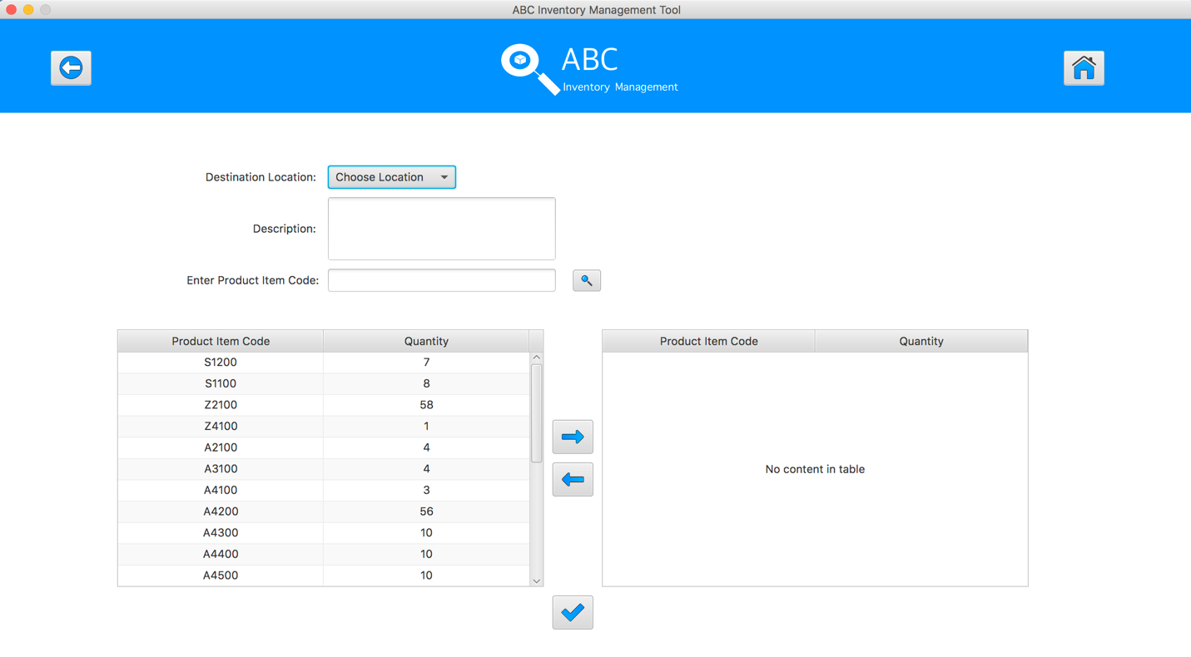
Step 2
Enter the description for this transfer
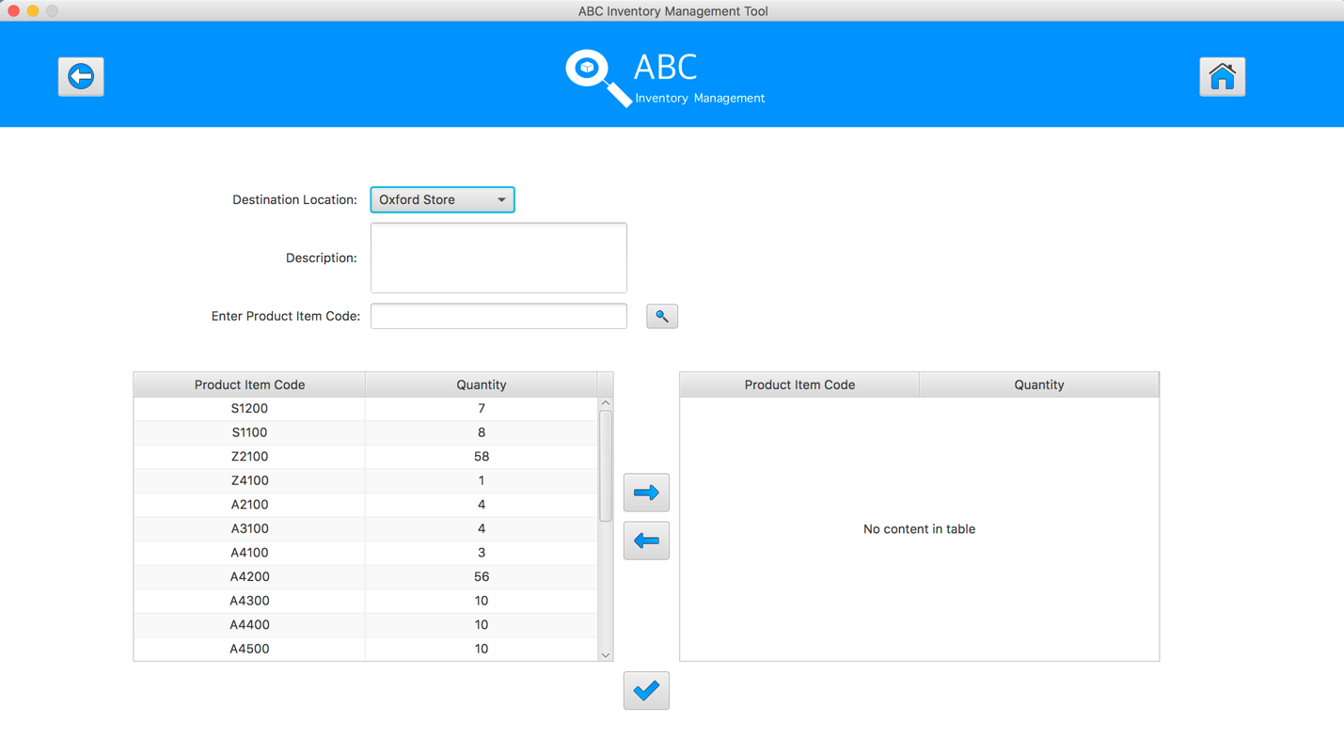
Step 3
Select the product item code in the table on the left
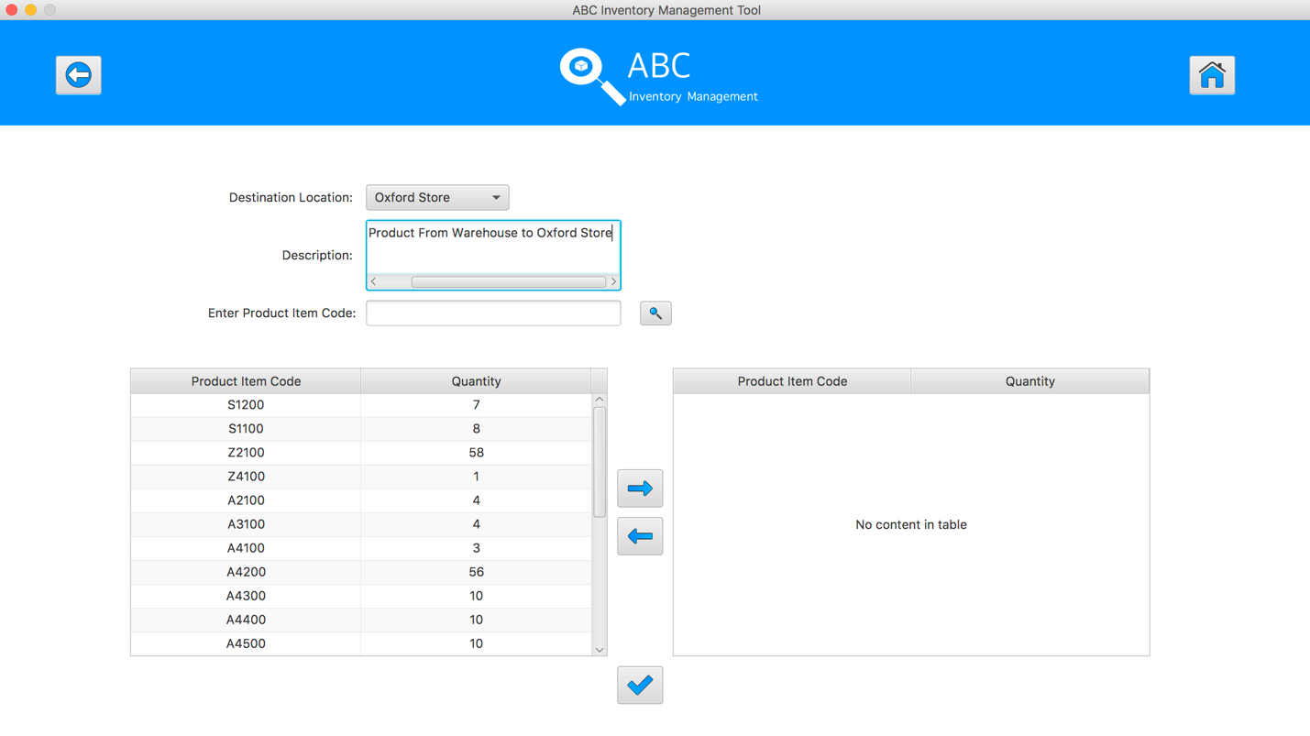
Step 4
Select the product item code in the table on the left
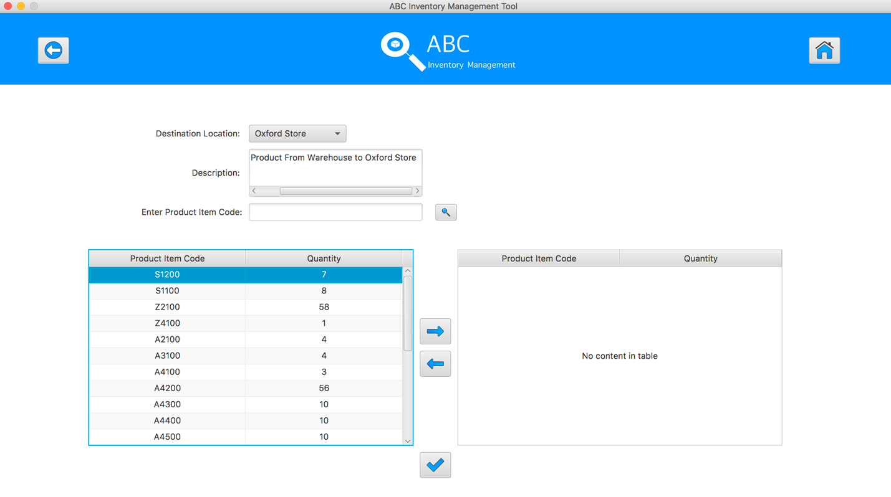
Step 5
Click on the “Add To Cart” Button
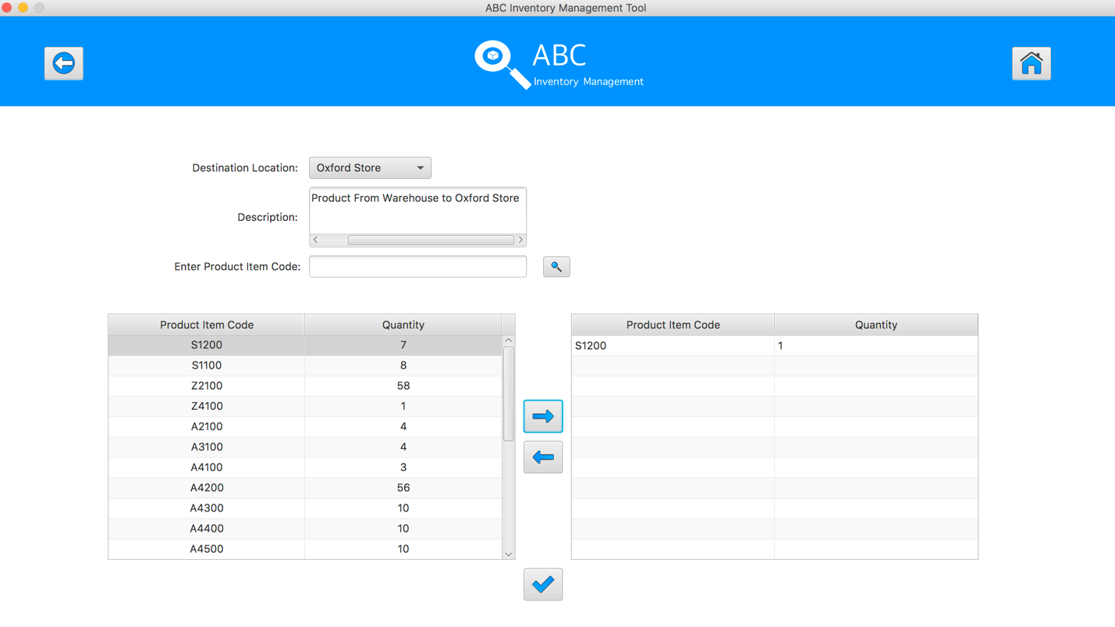
Step 6
Double click to the quantity cell in selected cart table
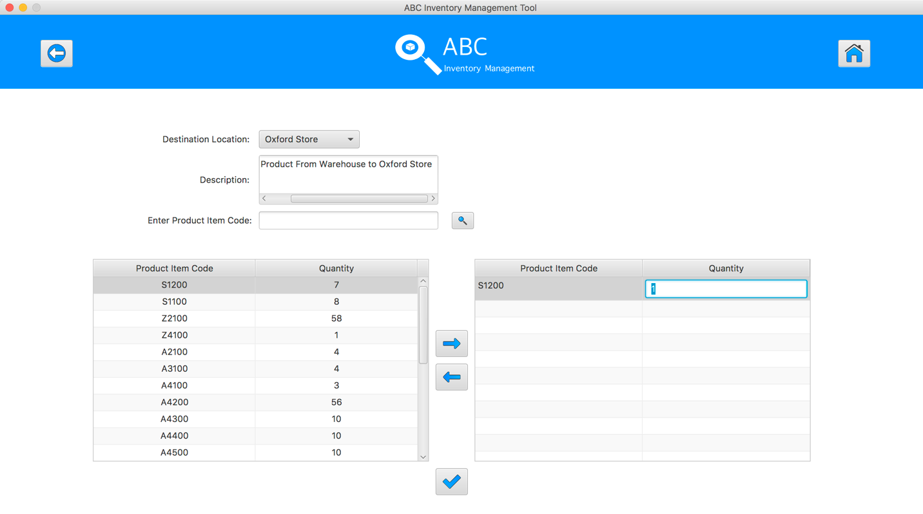
Step 7
Enter the desirable number
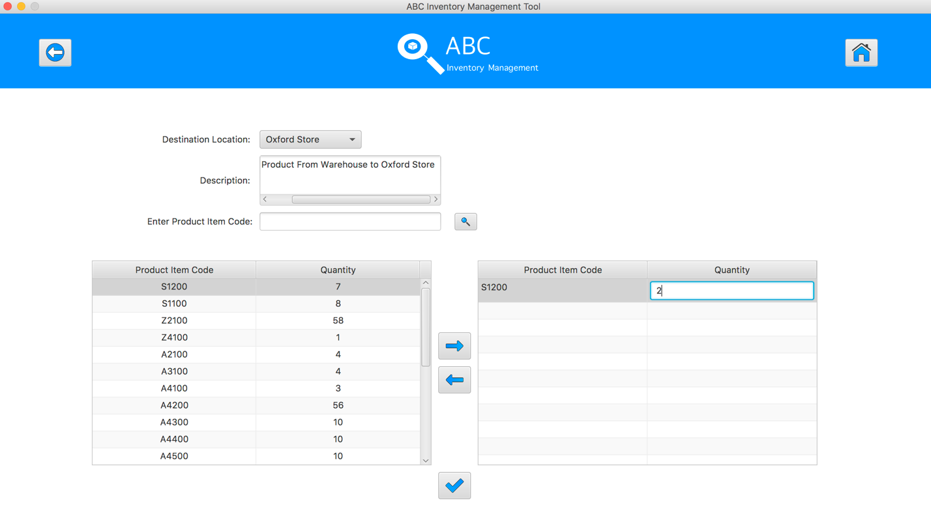
Step 8
Hit enter key to confirm this edited quantity
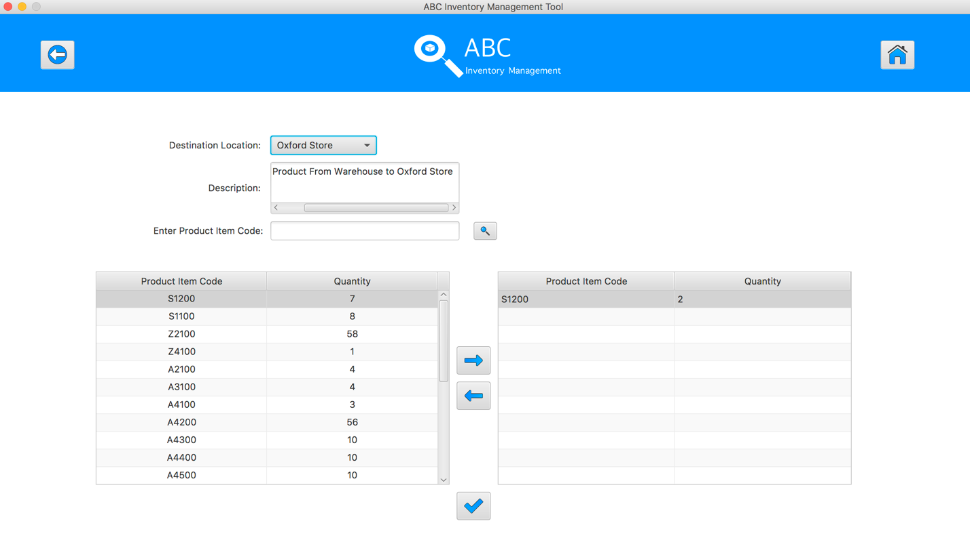
Step 9
Select the product item code in the table on the left
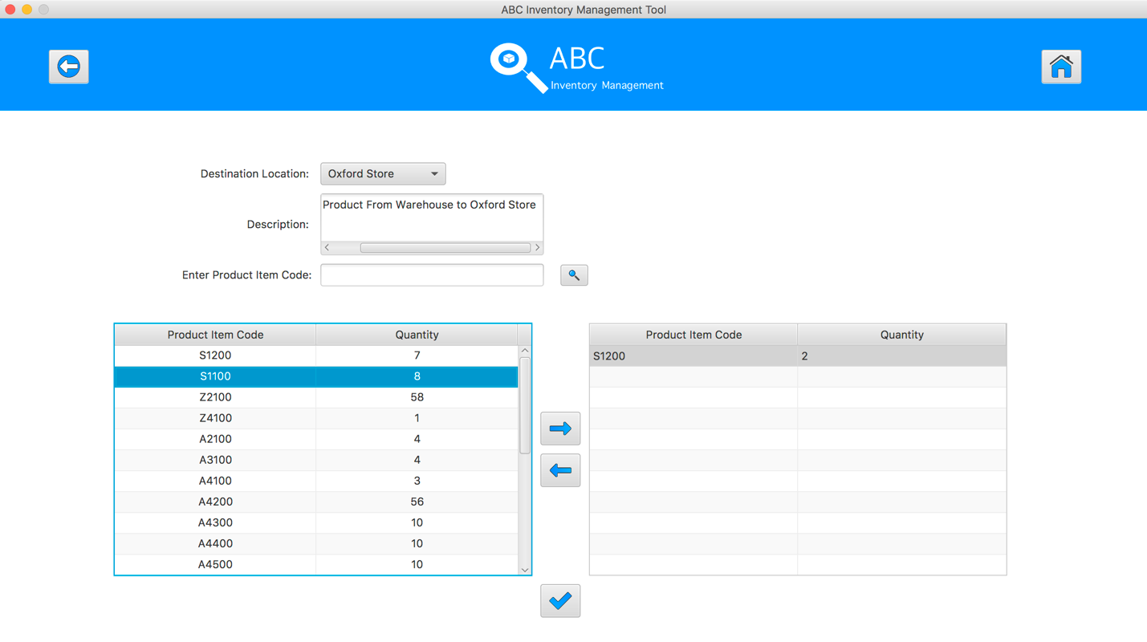
Step 10
Click on the “Add To Cart” Button

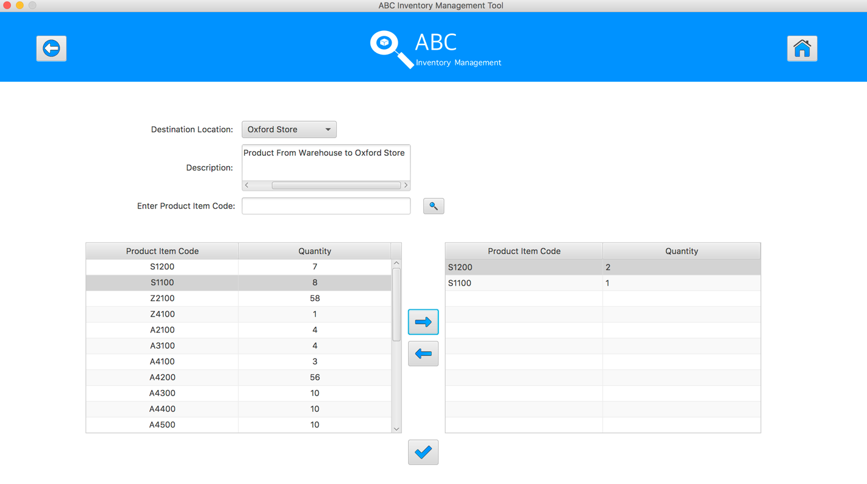
Step 11
Double click to the quantity cell in selected cart table
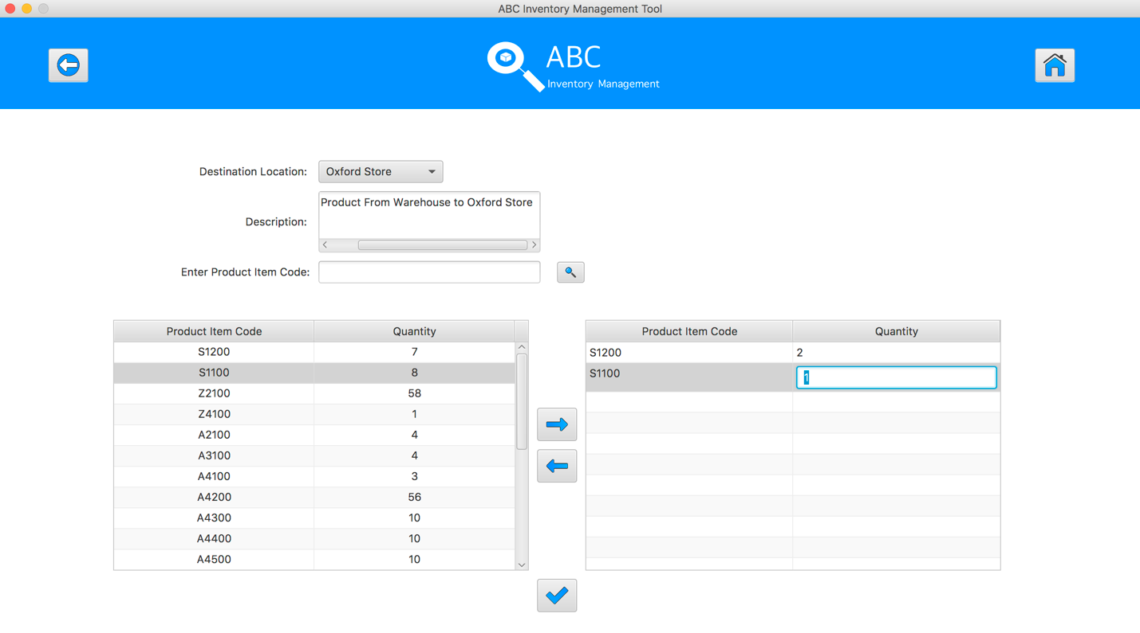
Step 12
Enter the desirable number
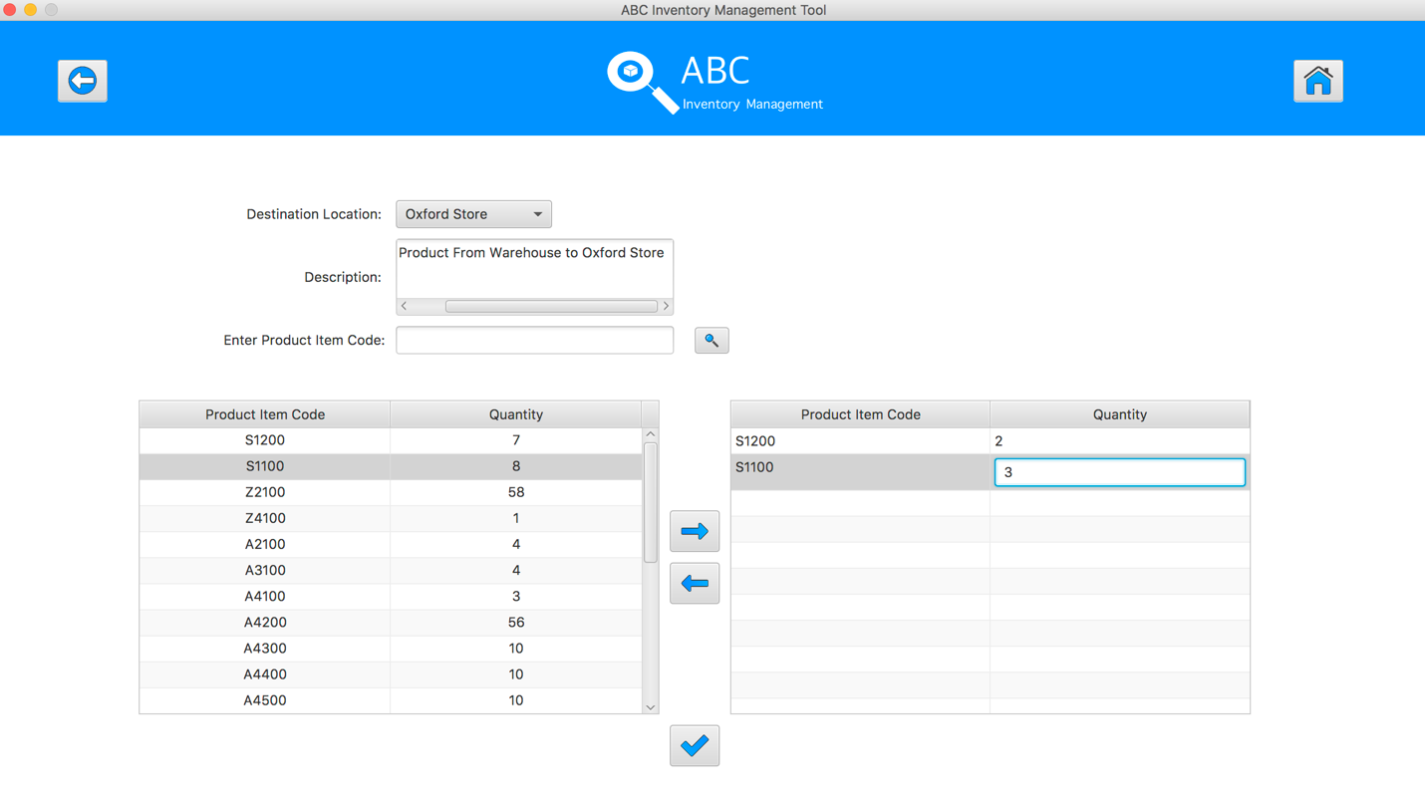
Step 13
Hit enter key to confirm this edited quantity
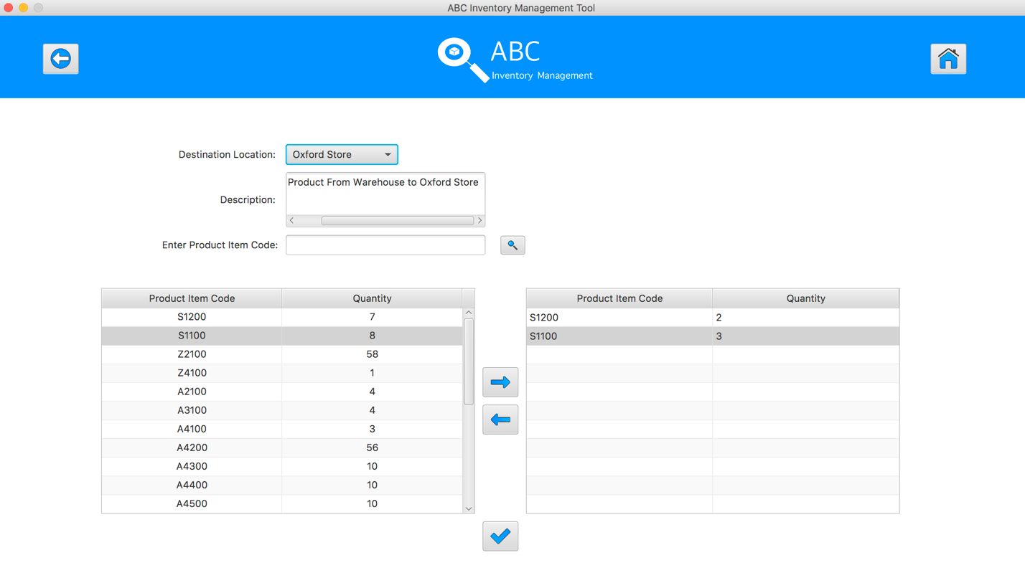
Step 14
Select the product item code in the table on the left

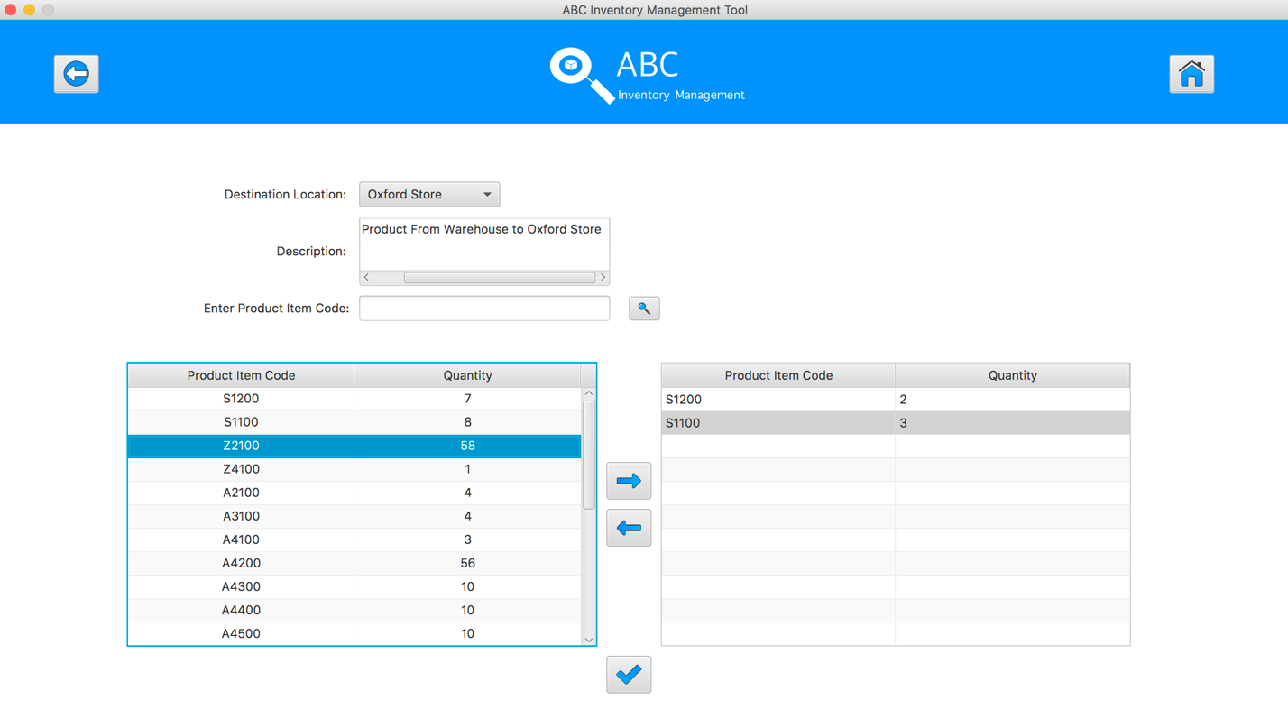
Step 15
Click on the “Add To Cart” Button
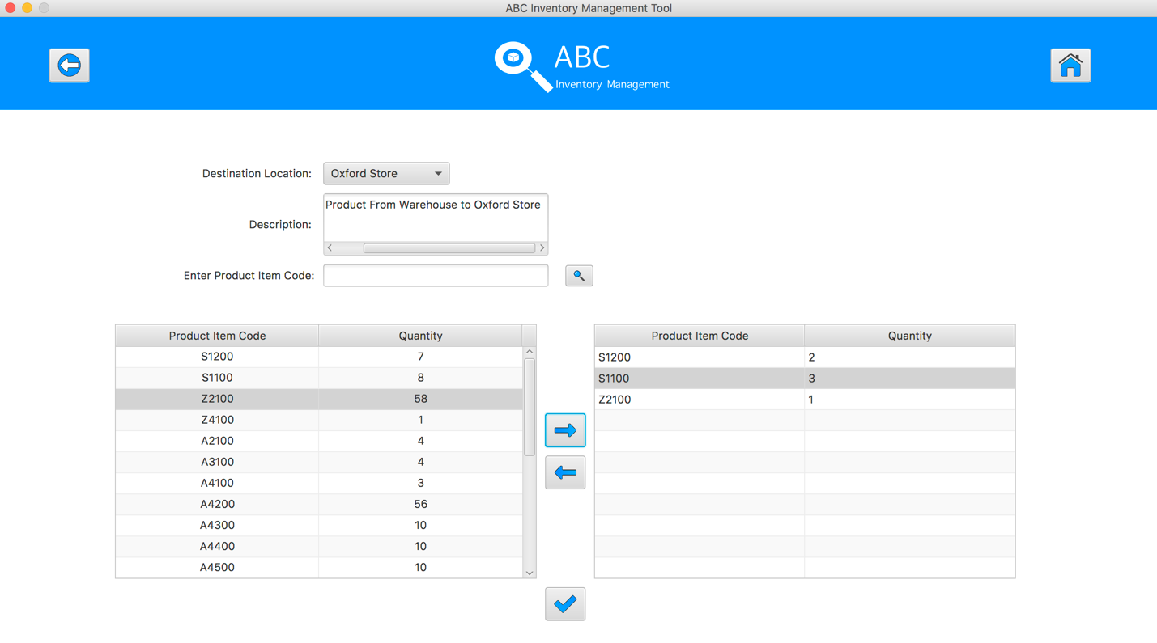
Step 16
Double click to the quantity cell in selected cart table

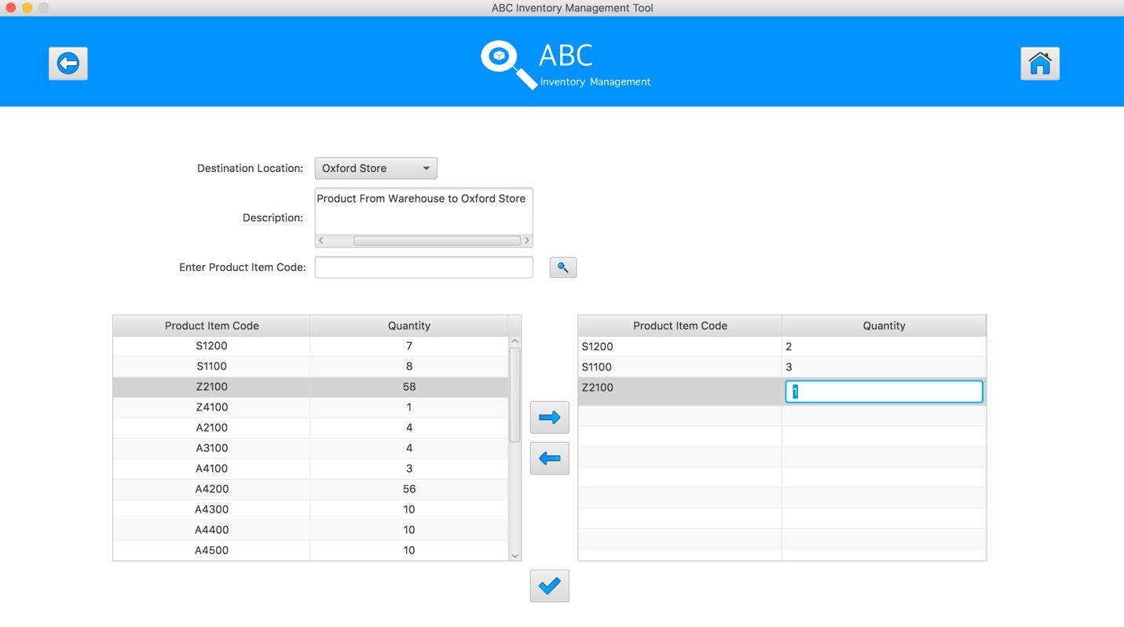
Step 17
Enter the desirable number
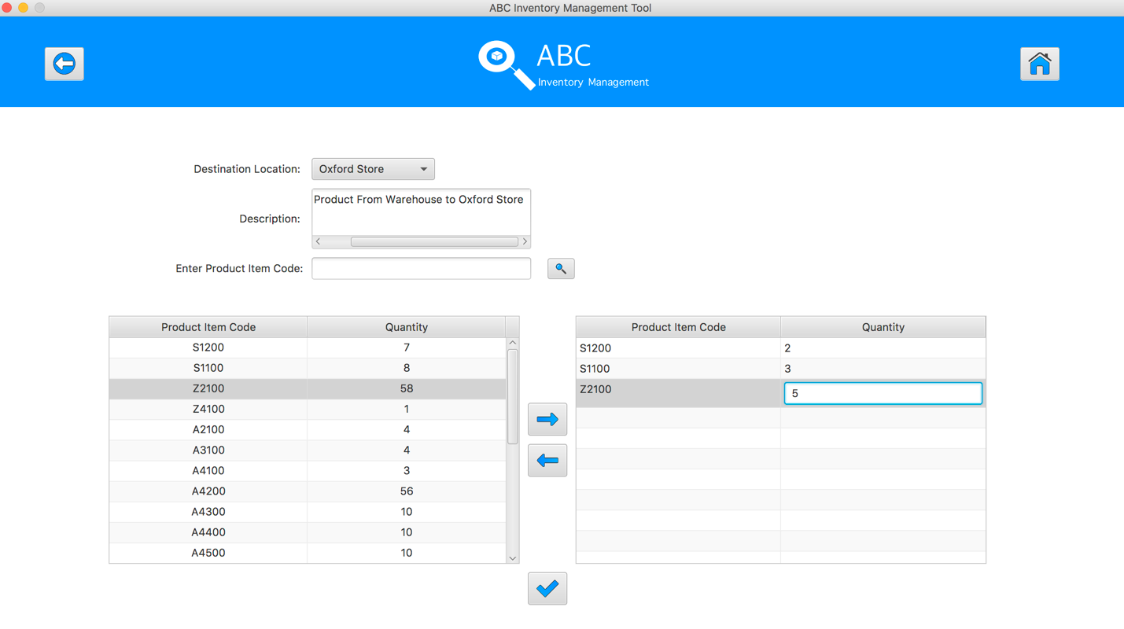
Step 18
Hit enter key to confirm this edited quantity
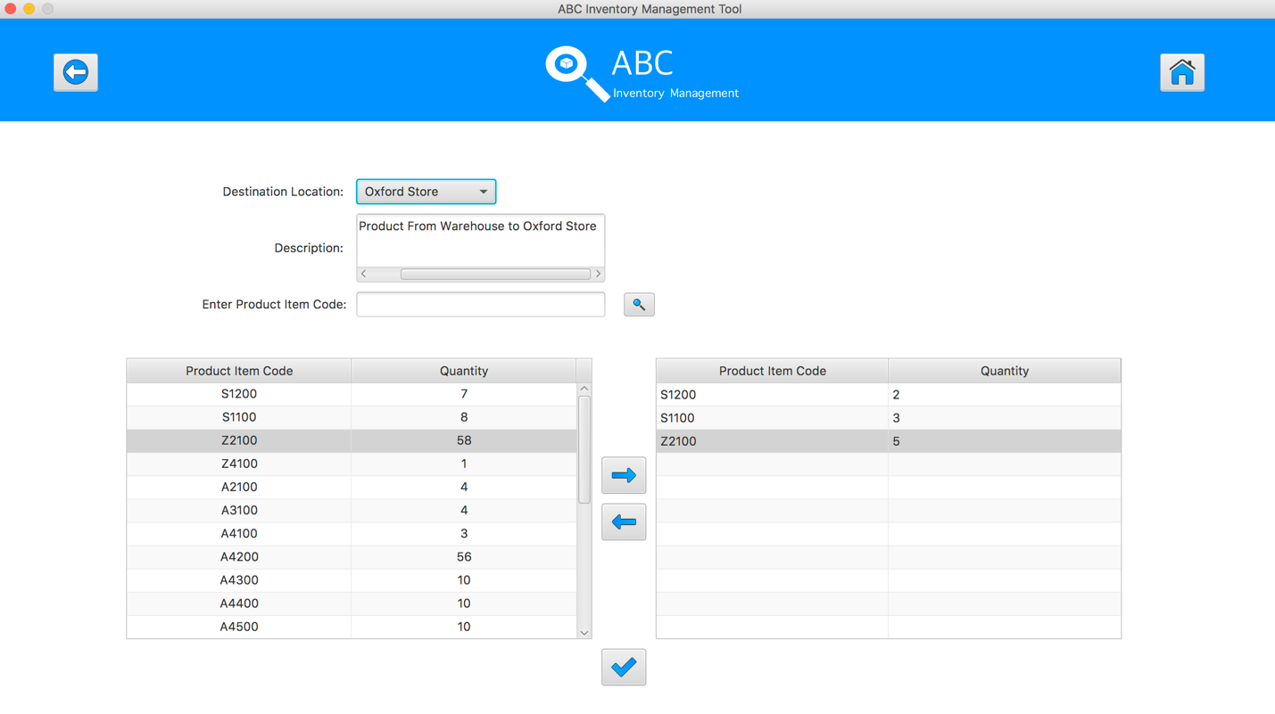
Step 19
After added the desirable items, hit the “Send Product” Button 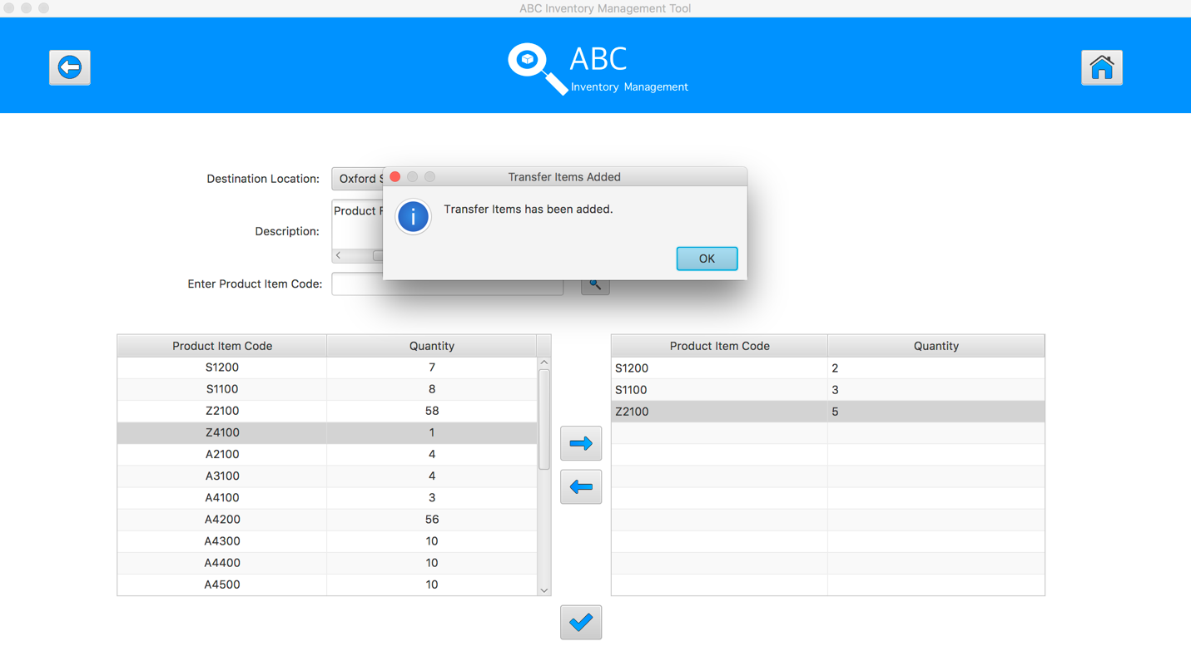
Step 20
Reset the interface for working with new transfer.
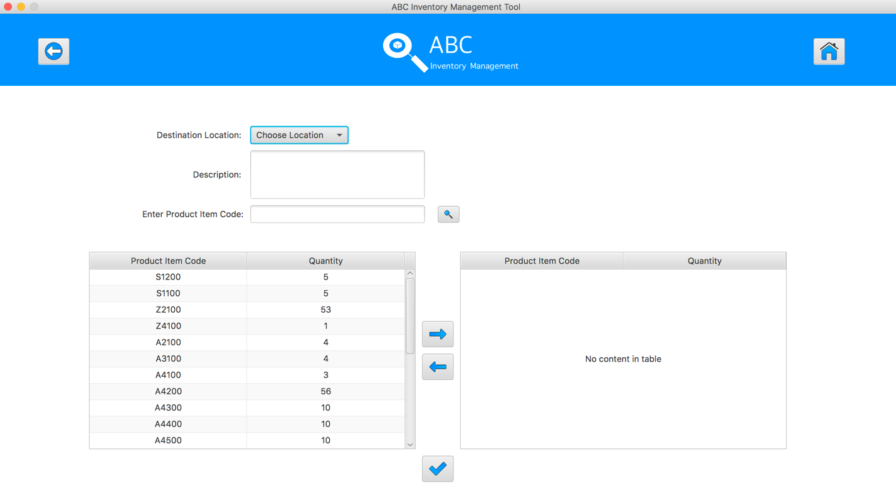
SPT001- Test Send Correct Quantity Of Product To The Destination for Data Set 1: PASS

Data Set 2
Test Data Table
Destination Location | Epping Store
Description | Send Product From Warehouse to Epping Store
Product Item Code | S1200 | Z2100 | A4200
Quantity | 2 | 5 | 6

Result Screenshots
The screenshots of the result on each test step for each data set are given below:

Step 1
Select the destination location
Step 2
Enter the description for this transfer
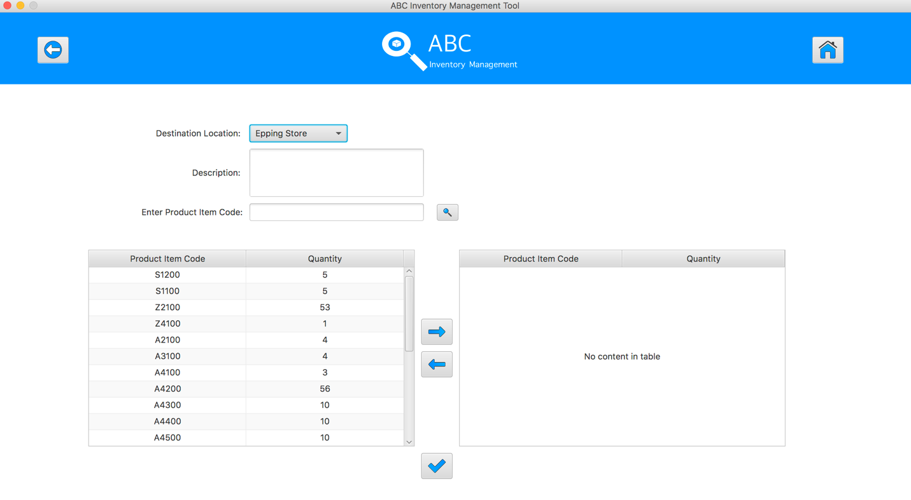
Step 3
Select the product item code in the table on the left
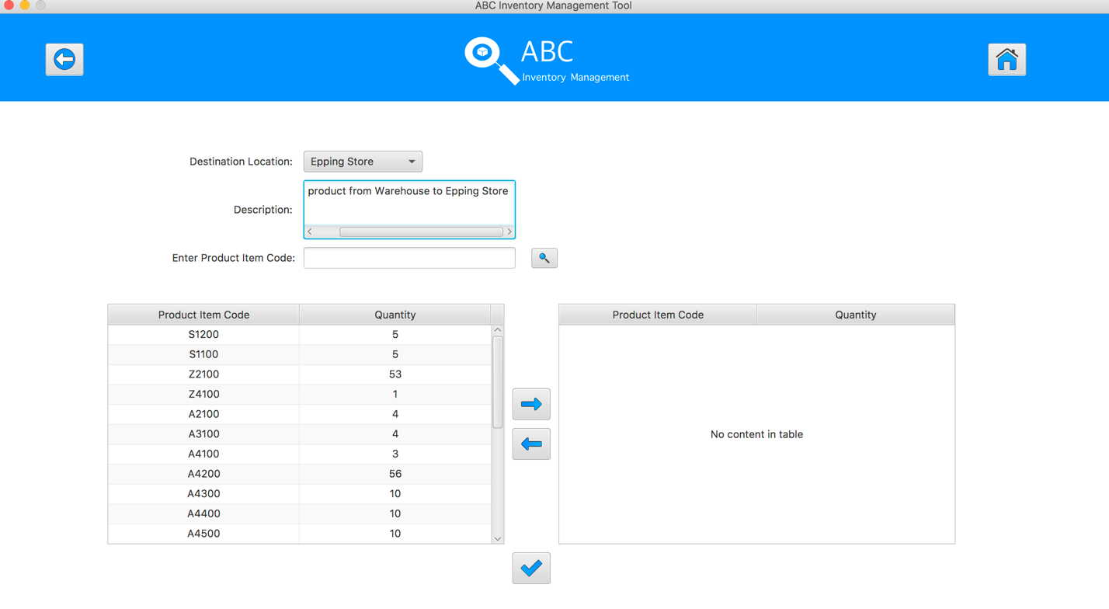
Step 4
Select the product item code in the table on the left
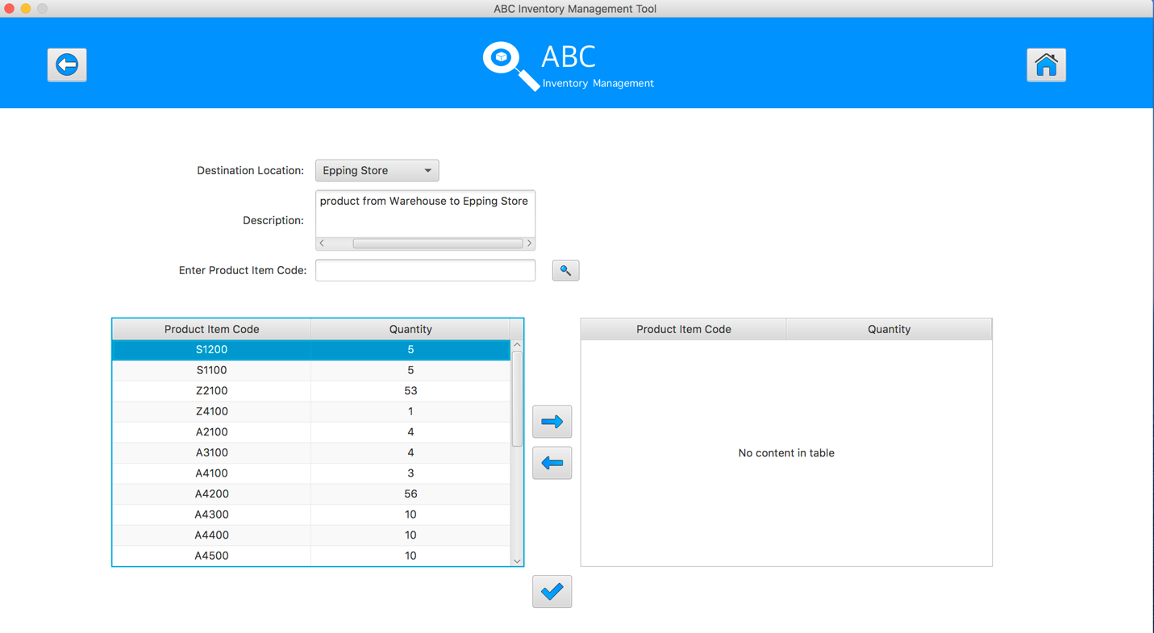
Step 5
Click on the “Add To Cart” Button
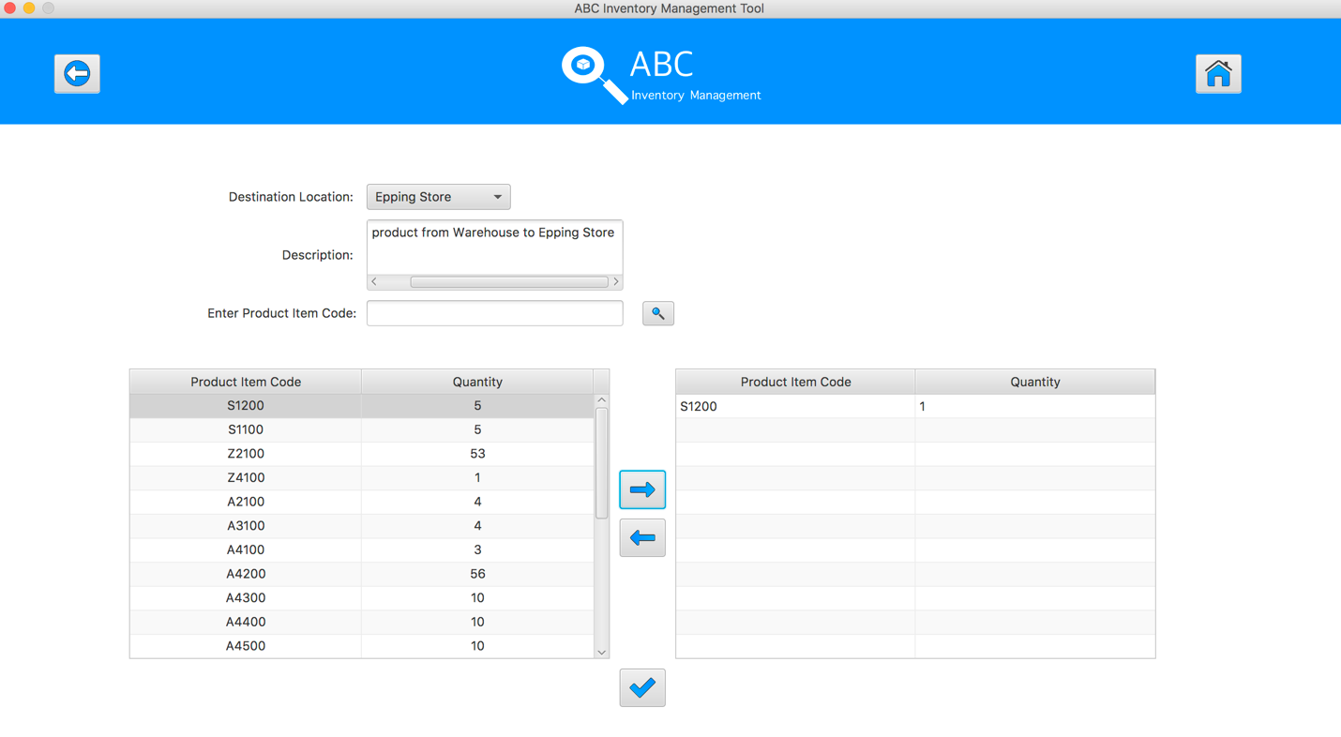
Step 6
Double click to the quantity cell in selected cart table
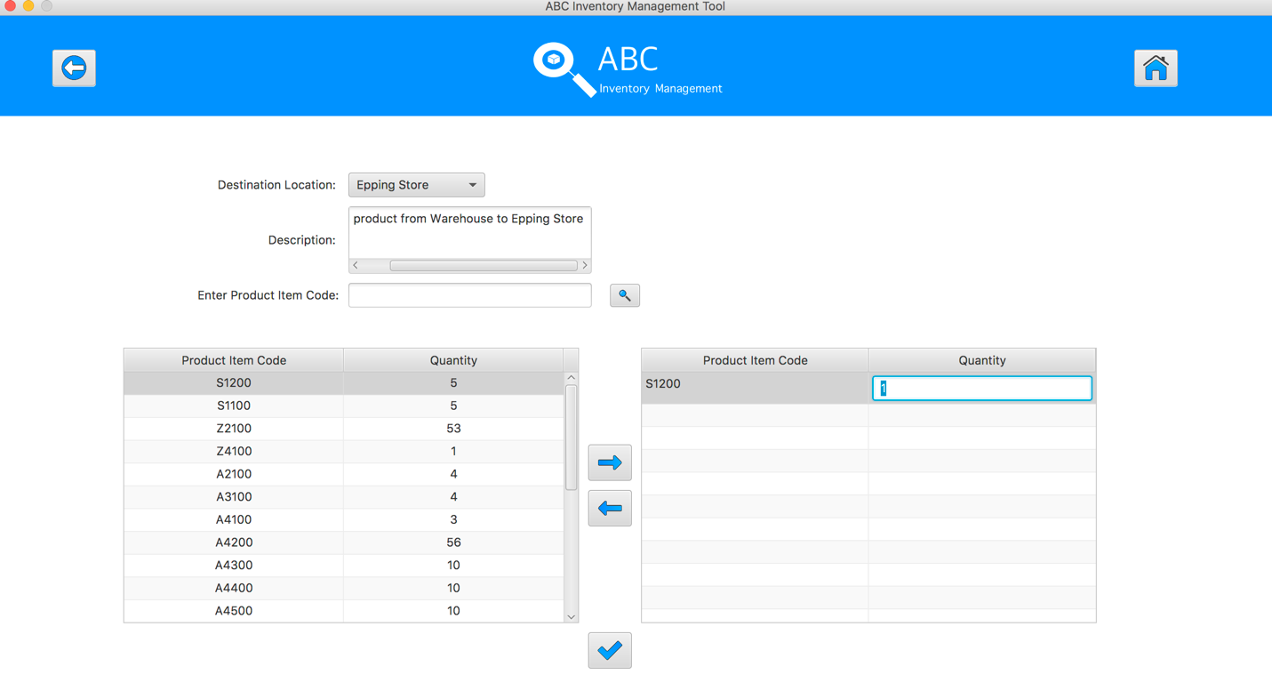
Step 7
Enter the desirable number
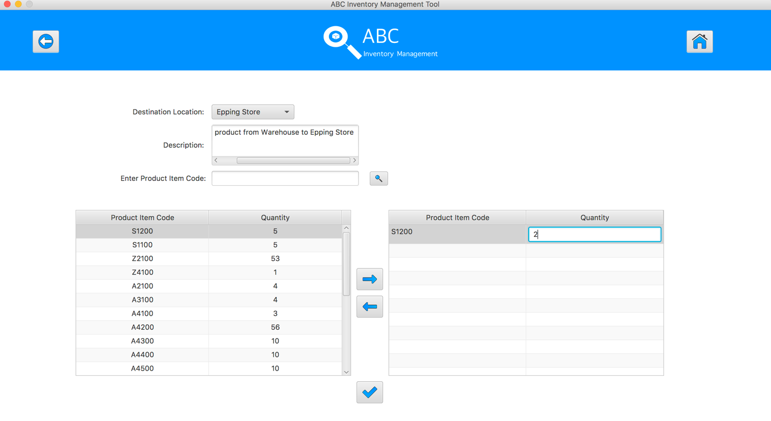
Step 8
Hit enter key to confirm this edited quantity
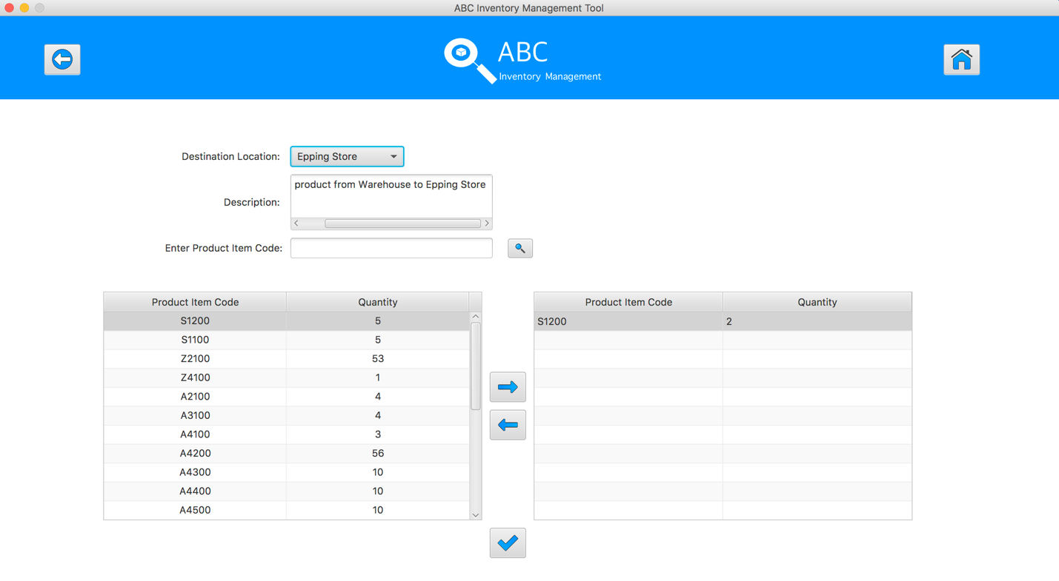
Step 9
Select the product item code in the table on the left
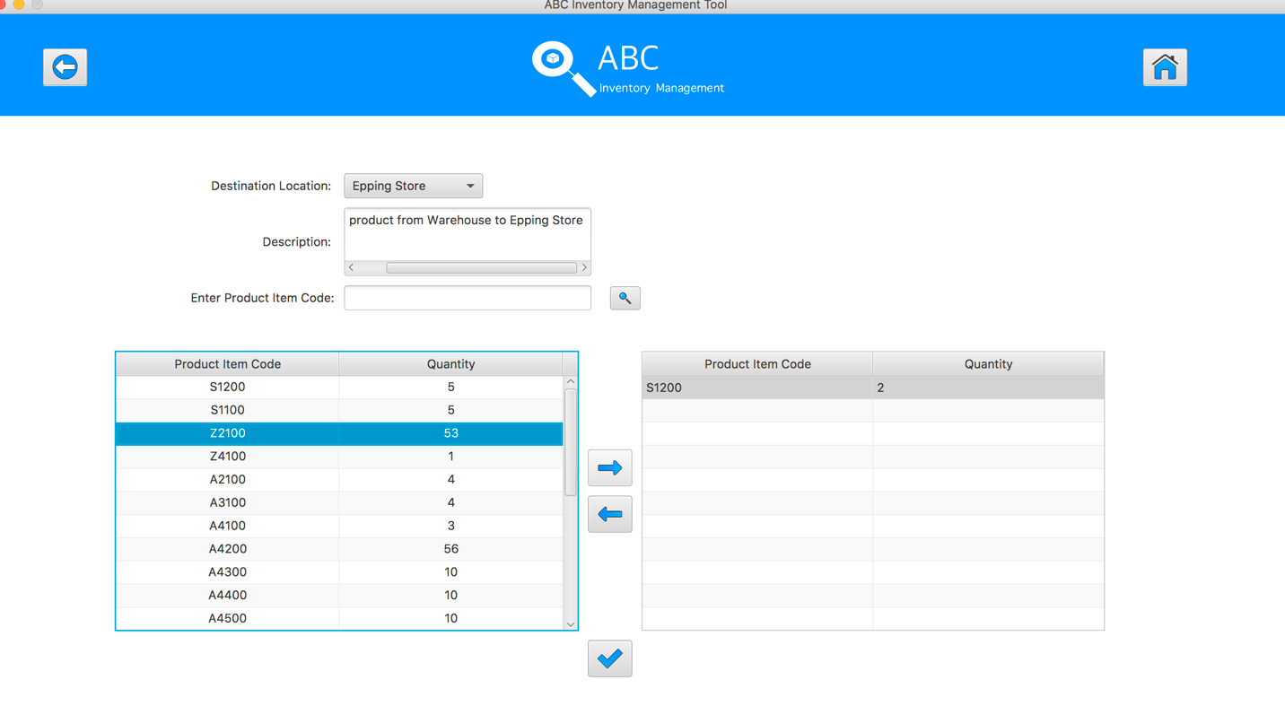
Step 10
Click on the “Add To Cart” Button

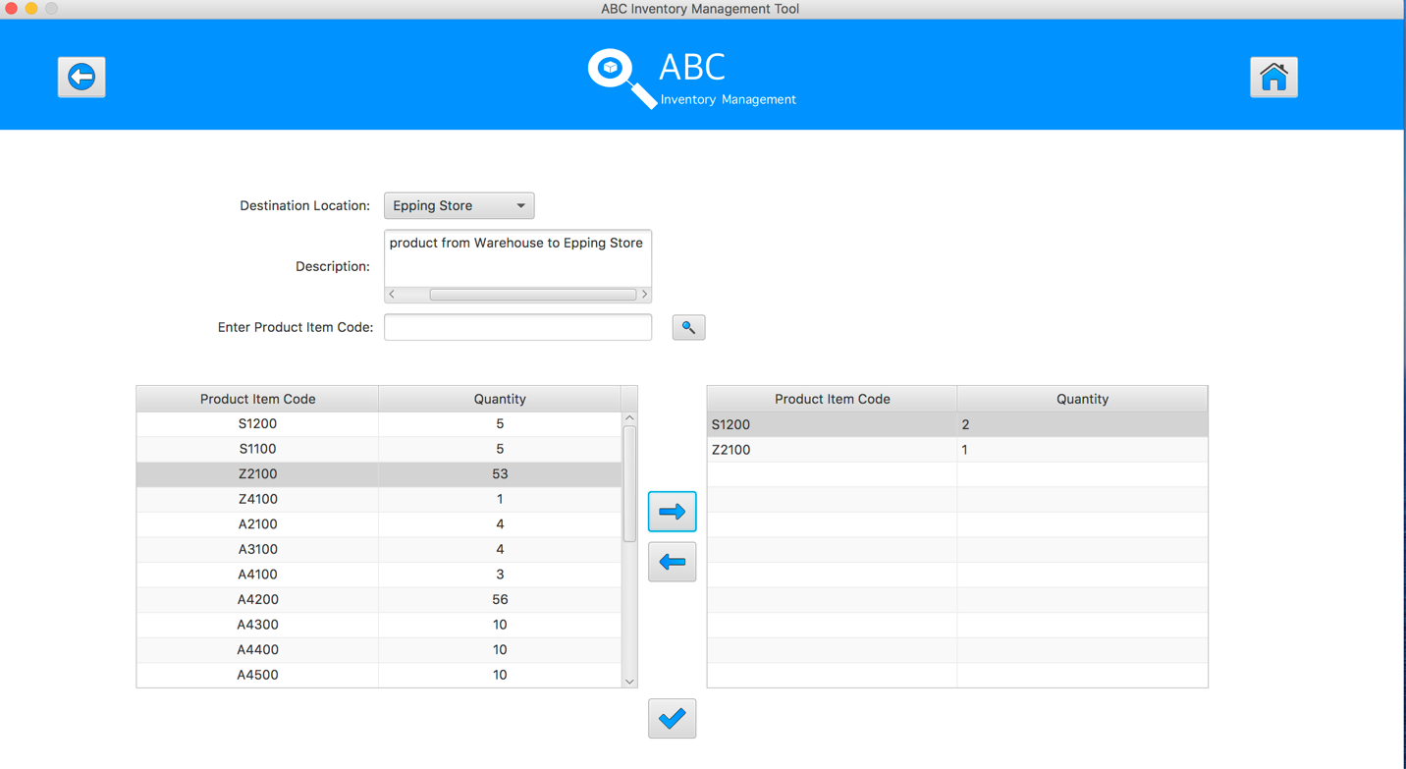
Step 11
Double click to the quantity cell in selected cart table
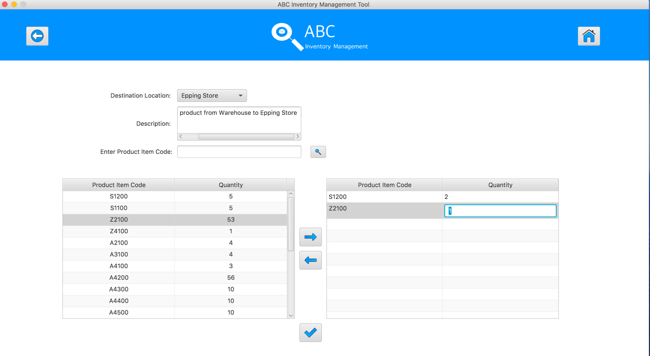
Step 12
Enter the desirable number
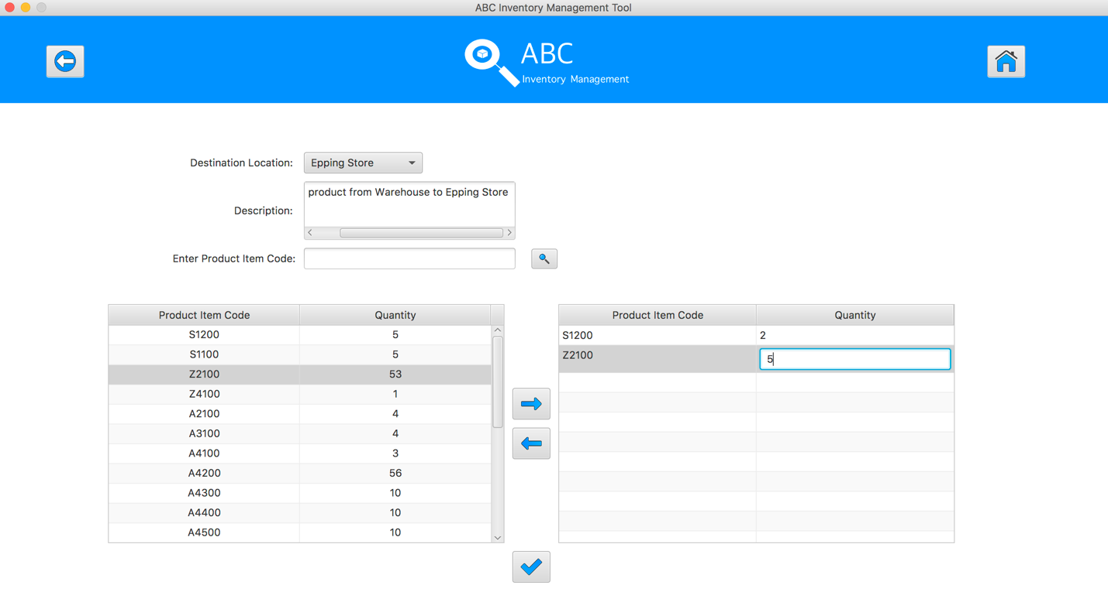
Step 13
Hit enter key to confirm this edited quantity
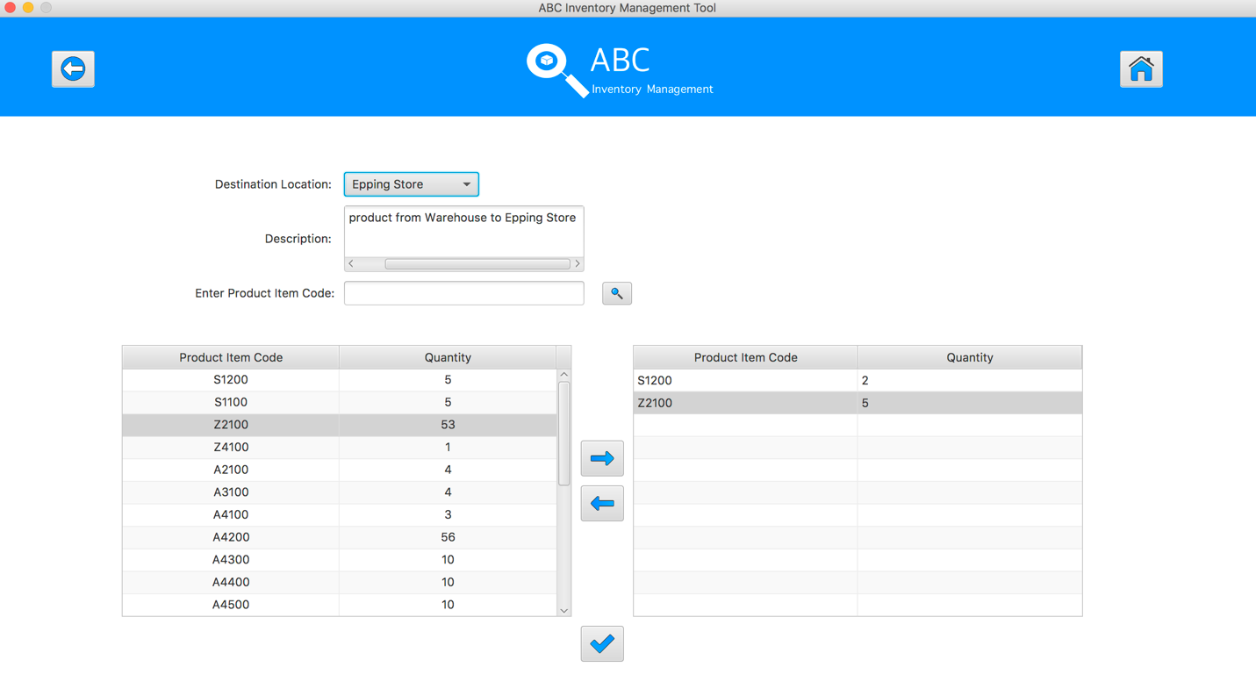
Step 14
Select the product item code in the table on the left

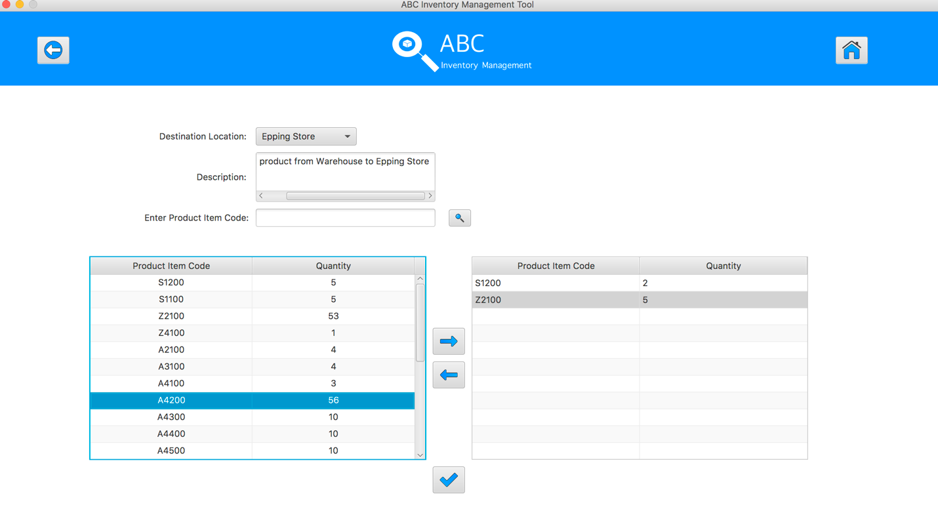
Step 15
Click on the “Add To Cart” Button
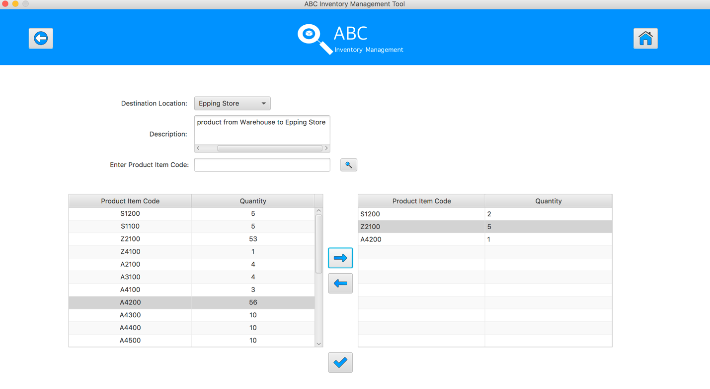
Step 16
Double click to the quantity cell in selected cart table

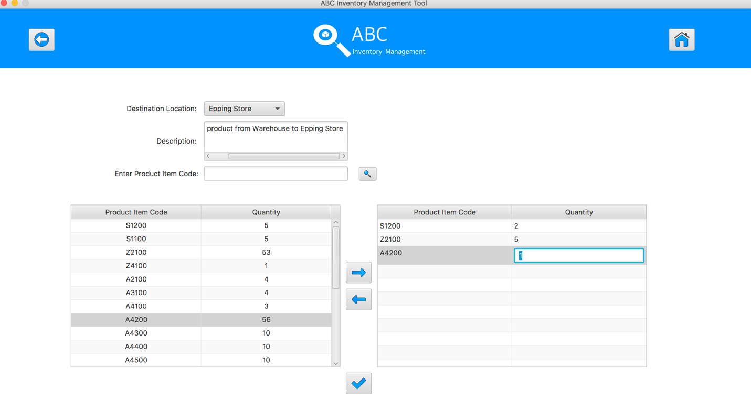
Step 17
Enter the desirable number
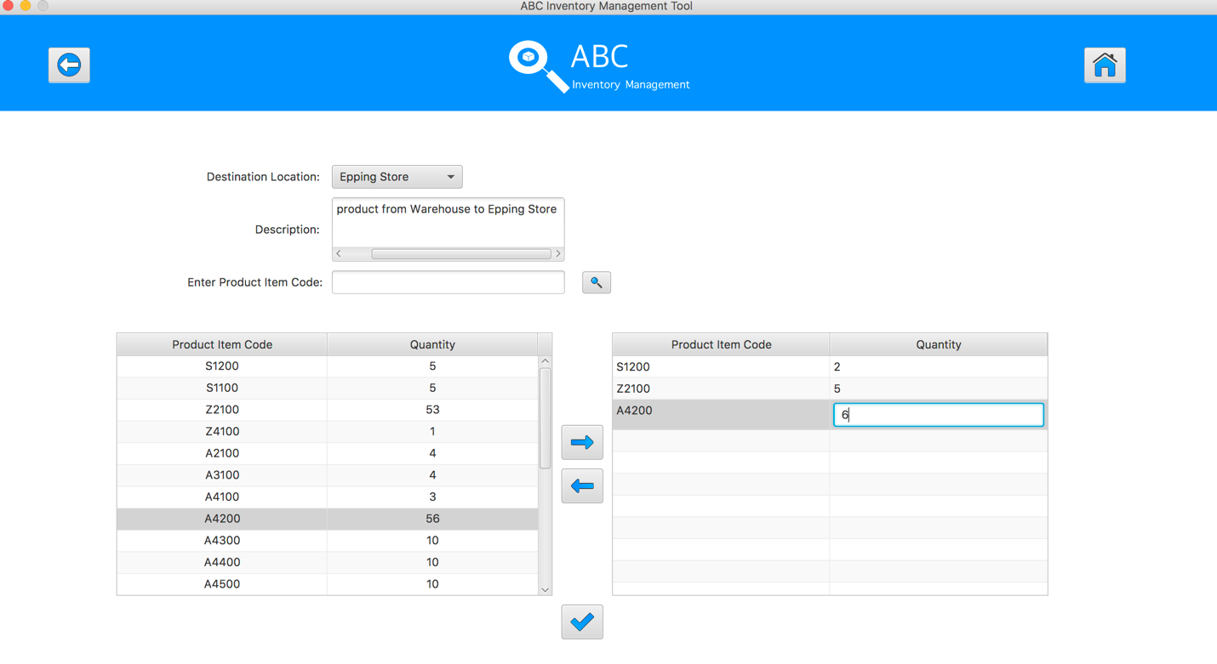
Step 18
Hit enter key to confirm this edited quantity
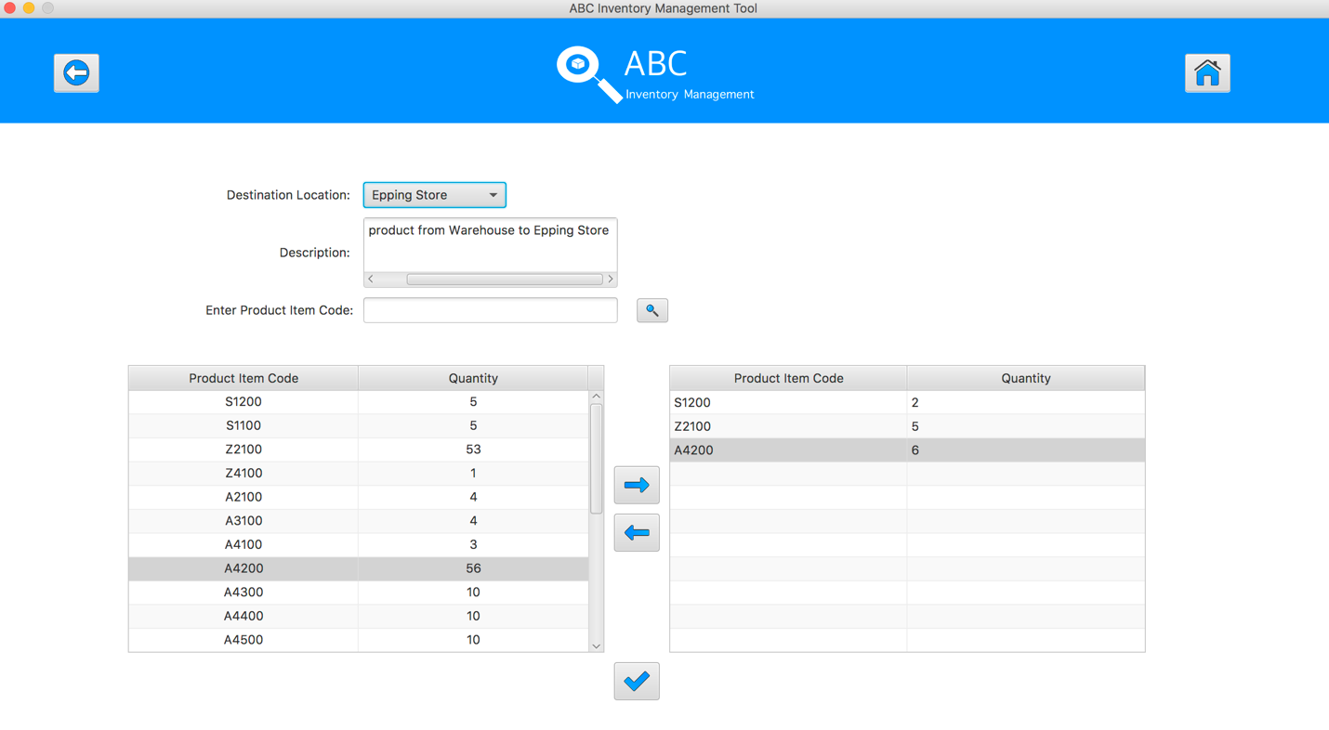
Step 19
After added the desirable items, hit the “Send Product” Button 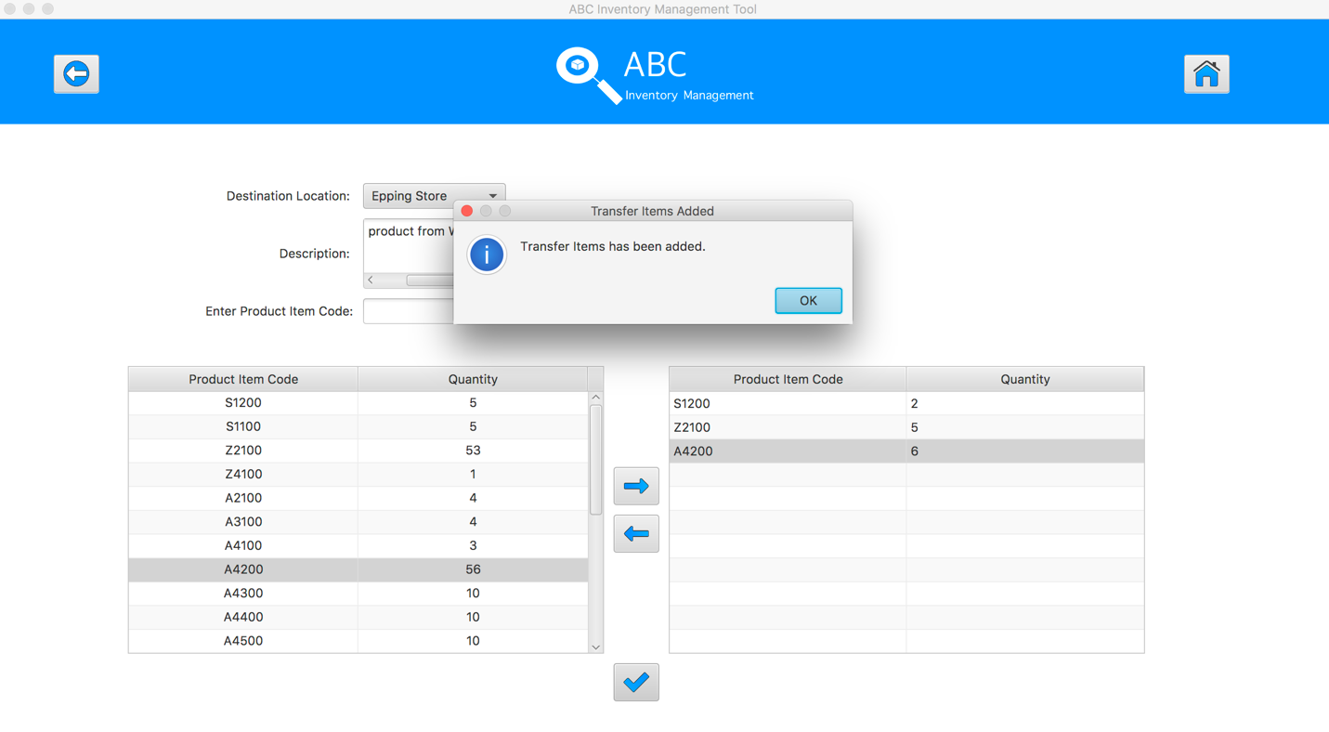
Step 20
Reset the interface for working with new transfer.

SPT001- Test Send Correct Quantity Of Product To The Destination for Data Set 2: PASS

SPT002- Send Incorrect Quantity Of Product To The Destination
Test Name |  | Send Incorrect Quantity Of Product To The Destination (Test Case SPT002)
Use Case Tested |  | Send Product
Test Description |  | This test tests if the system can send product items and its abnormal quantity in current location to destination location.
Pre-Conditions |  | Meta data must exist, product and product details like product item code, location ID and product quantity.
Post-Conditions |  | Appropriate alert message is displayed
Notes |  | This test assumes that the user knows the destination name, product item code.
Result (Pass/Fail/Warning/ Incomplete) |  | Fail:  - User can input the negative number for quantity  - User can input 0 for quantity  - Users do not receive any alert when input letter in quantity  Pass:  - An alert message to notify user cannot input the quantity bigger than the quantity in sending location
 | Test Step |  | Expected Test Results | P | F
1. | Select Send Product Button from home page |  | Display the Send Product page
2. | Select the destination location |  | Destination location combo box changes to the selected location name | P
3. | Enter the description for this transfer |  | Description text area displays user inputs | P
4. | Select the product item code in the table on the left |  | System waits for hitting the “Add to Cart” Button | P
5. | Click on the “Add To Cart” Button |  | The selected item displayed in the right table (cart table) with default quantity is 1 | P
6. | Double click to the quantity cell in selected cart table |  | System change the cell of double clicked cell to be editable | P
7. | Enter the desirable number |  | System waits for hitting enter key from user. | P
8. | Hit enter key to confirm this edited quantity |  | System pops up an appropriate message to notify that user entered a wrong quantity |  | F

Data Set 1
Test Data Table
Destination Location | Oxford Store
Description | Send Product From Warehouse to Oxford Store
Product Item Code | A4200 | X1300 | X1500
Quantity | -3 | -5 | -4
Result | Fail

Result Screenshots
The screenshots of the result on each test step for each data set are given below:

Step 1
Select the destination location
Step 2
Enter the description for this transfer
Step 3
Select the product item code in the table on the left
Step 4
Select the product item code in the table on the left
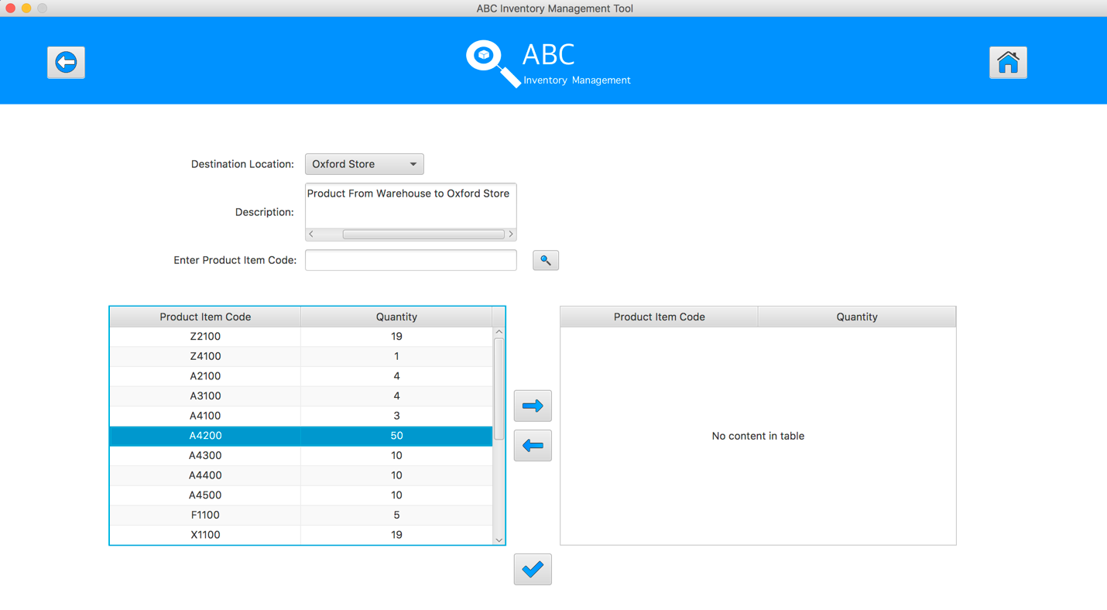
Step 5
Click on the “Add To Cart” Button
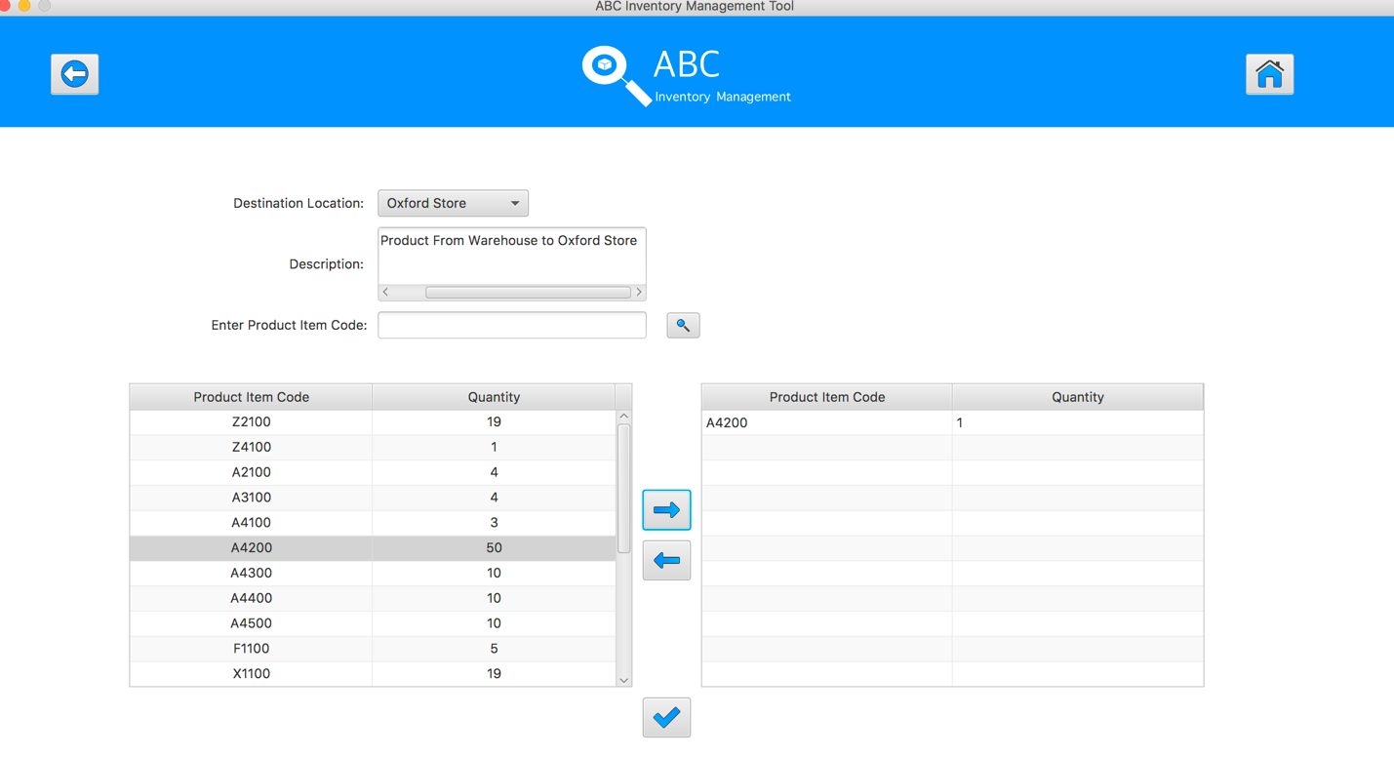
Step 6
Double click to the quantity cell in selected cart table
Step 7
Enter the desirable number
Step 8
Hit enter key to confirm this edited quantity
Step 9
Select the product item code in the table on the left
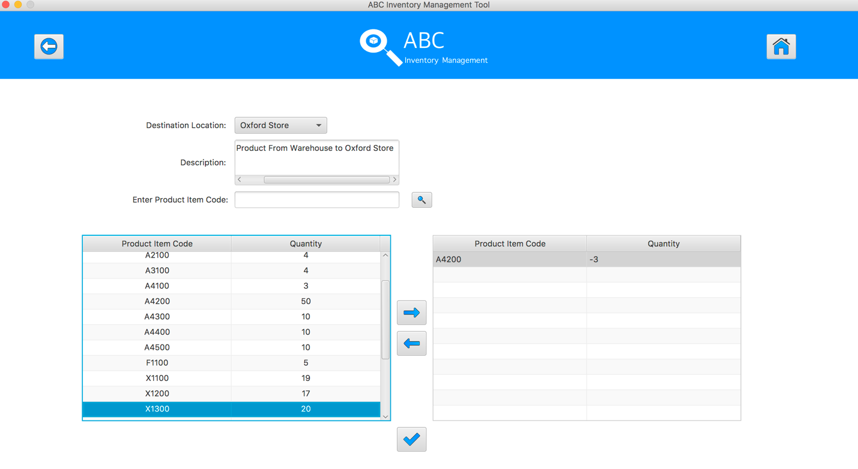
Step 10
Click on the “Add To Cart” Button

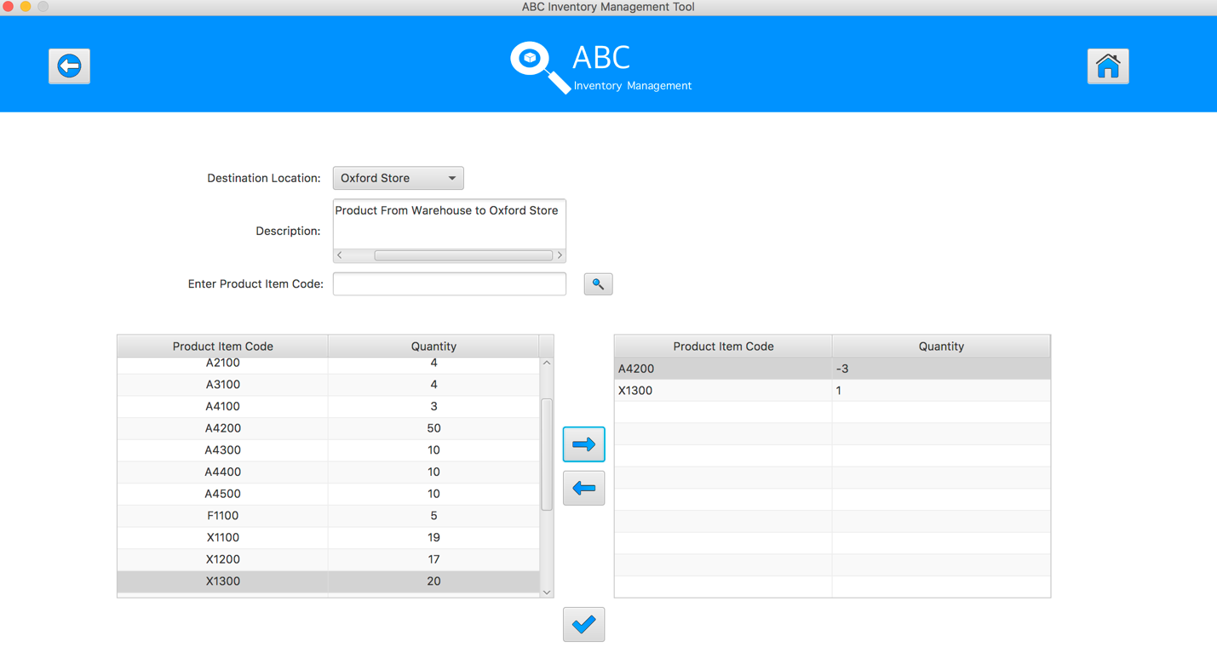
Step 11
Double click to the quantity cell in selected cart table
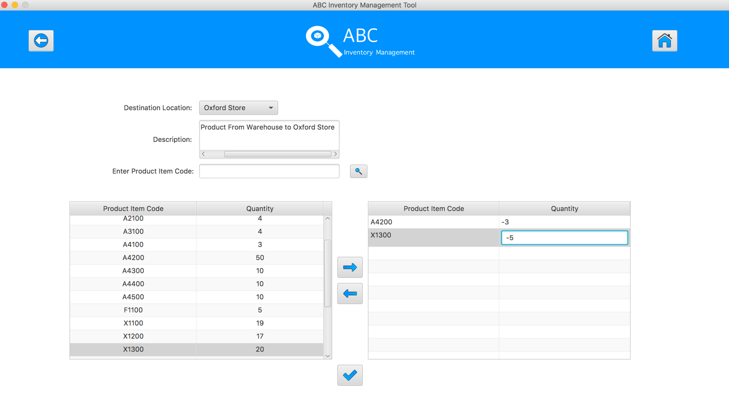
Step 12
Enter the desirable number
Step 13
Hit enter key to confirm this edited quantity
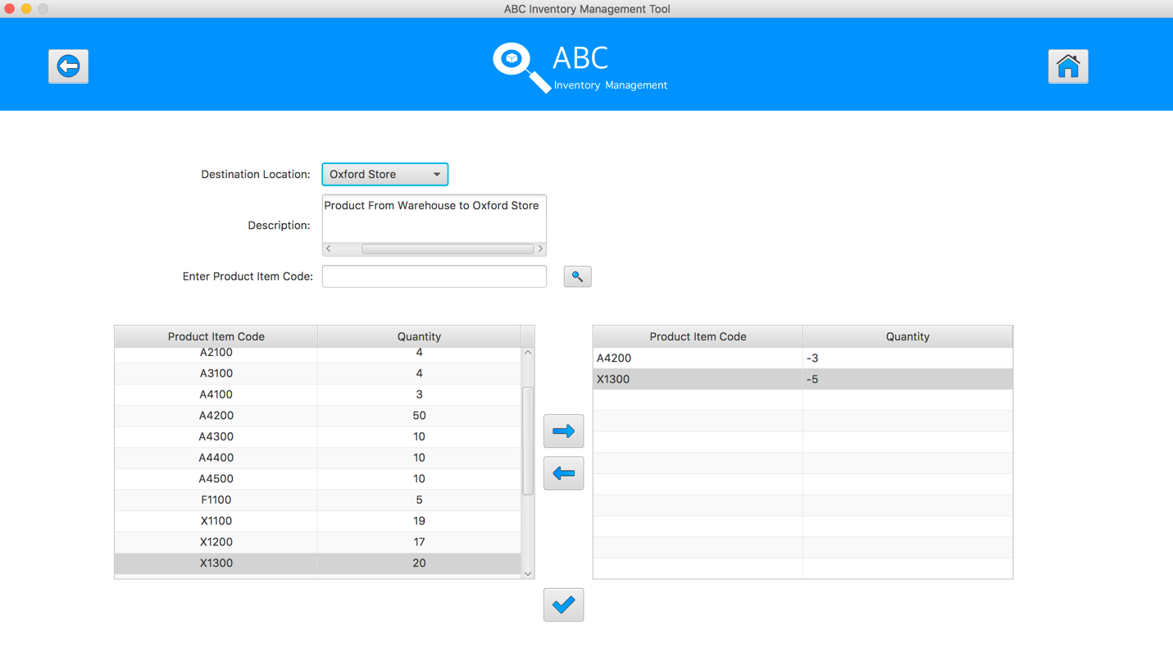
Step 14
Select the product item code in the table on the left

Step 15
Click on the “Add To Cart” Button
Step 16
Double click to the quantity cell in selected cart table

Step 17
Enter the desirable number
Step 18
Hit enter key to confirm this edited quantity
Step 19
After added the desirable items, hit the “Send Product” Button
Step 20
Reset the interface for working with new transfer.
SPT002- Test Send Incorrect Quantity Of Product To The Destination for Data Set 1: FAIL

Data Set 2
Test Data Table
Destination Location | Epping Store
Description | Send Product From Warehouse to Epping Store
Product Item Code | A4200 | X1300 | X1500
Quantity | 0 | 0 | 7
Result | Fail

Result Screenshots
The screenshots of the result on each test step for each data set are given below:

Step 1
Select the destination location
Step 2
Enter the description for this transfer
Step 3
Select the product item code in the table on the left
Step 4
Select the product item code in the table on the left
Step 5
Click on the “Add To Cart” Button
Step 6
Double click to the quantity cell in selected cart table
Step 7
Enter the desirable number
Step 8
Hit enter key to confirm this edited quantity
Step 9
Select the product item code in the table on the left
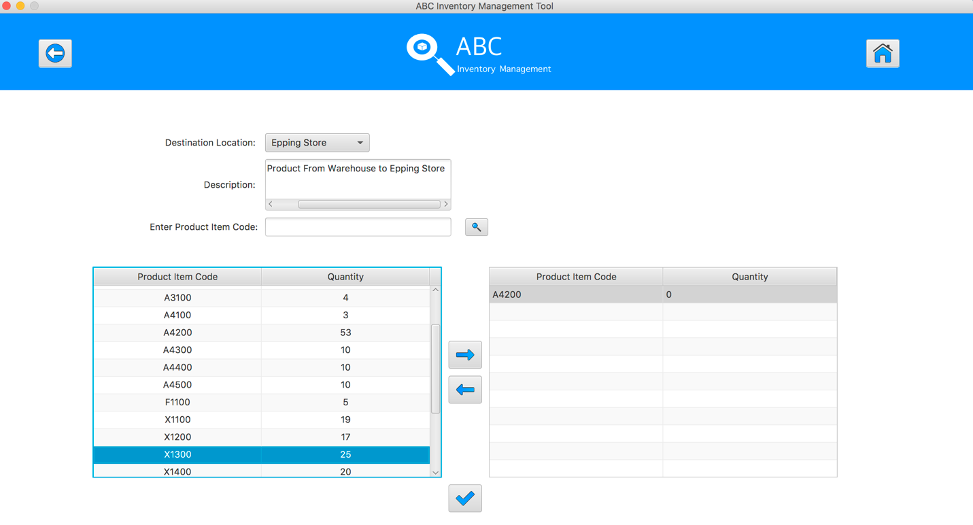
Step 10
Click on the “Add To Cart” Button

Step 11
Double click to the quantity cell in selected cart table
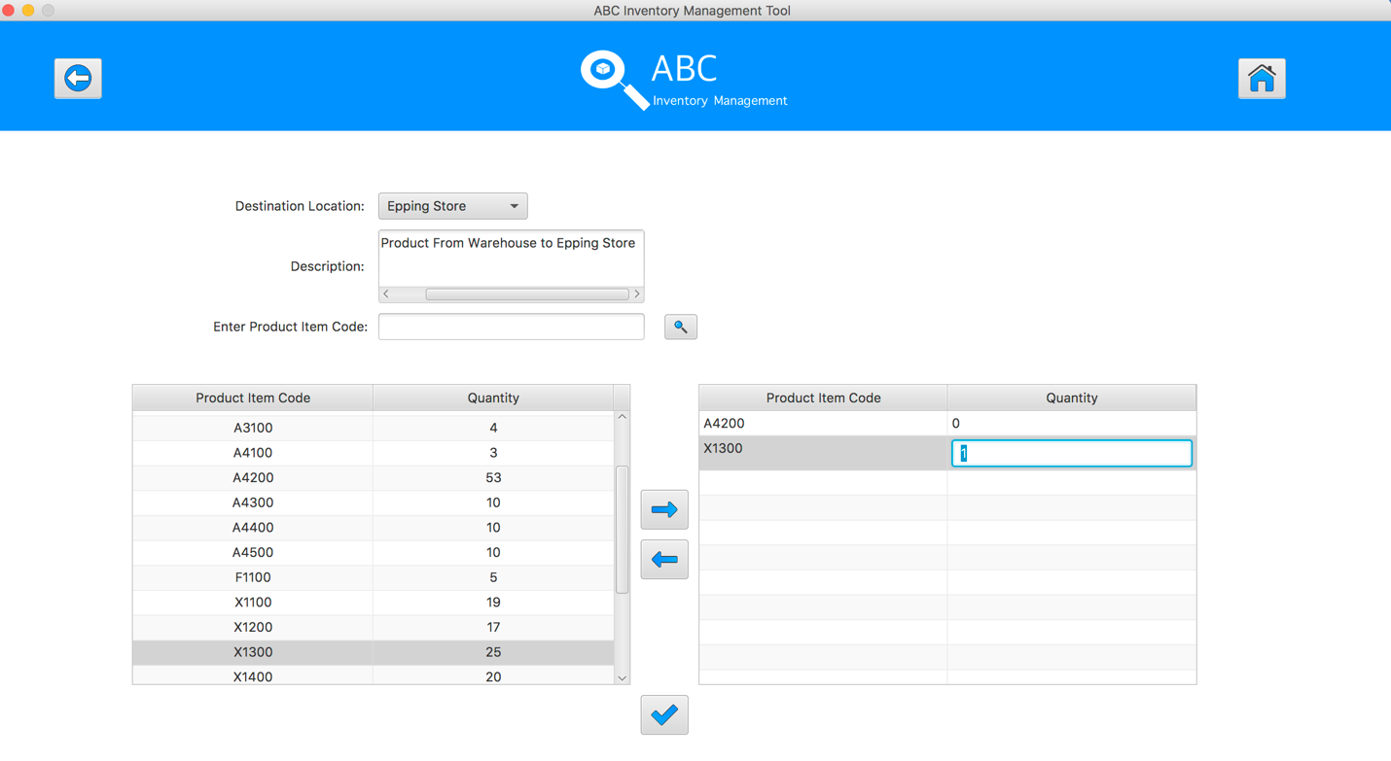
Step 12
Enter the desirable number
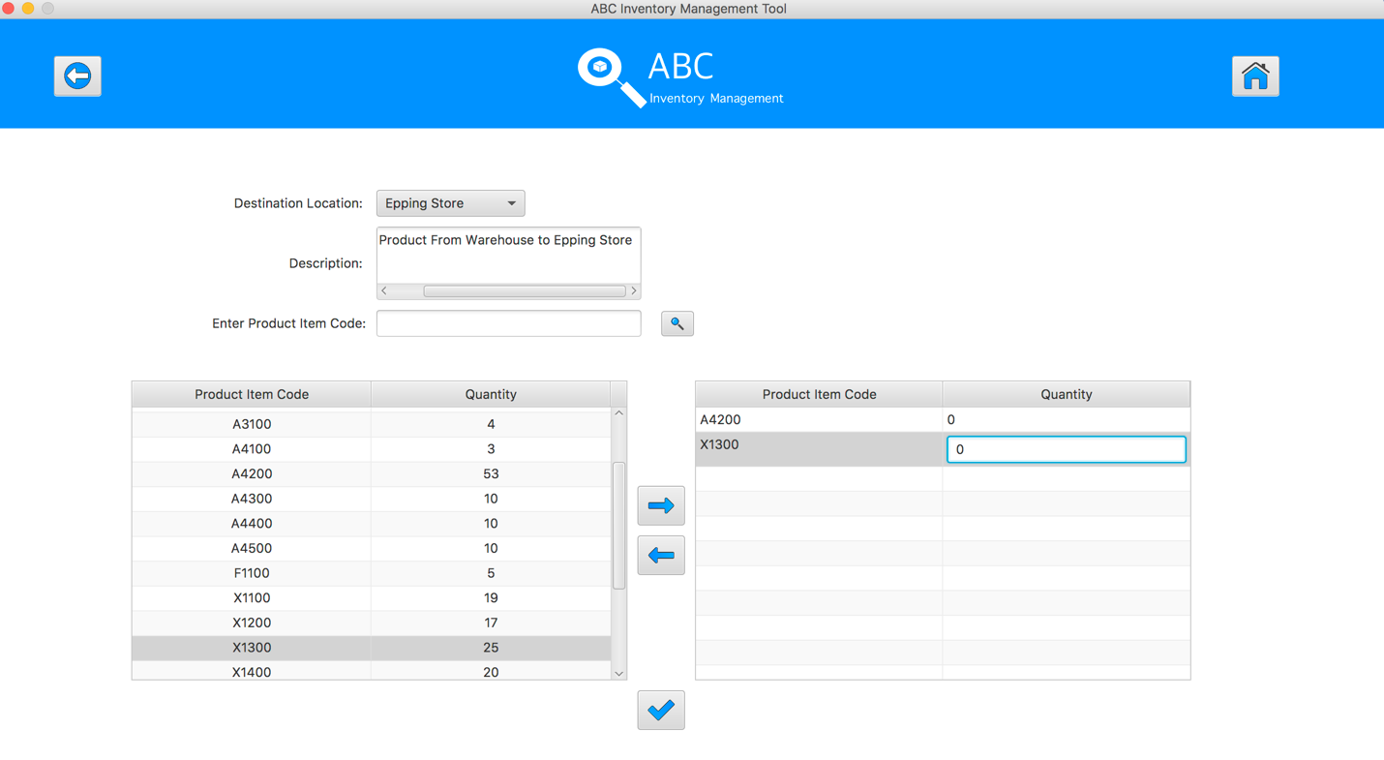
Step 13
Hit enter key to confirm this edited quantity
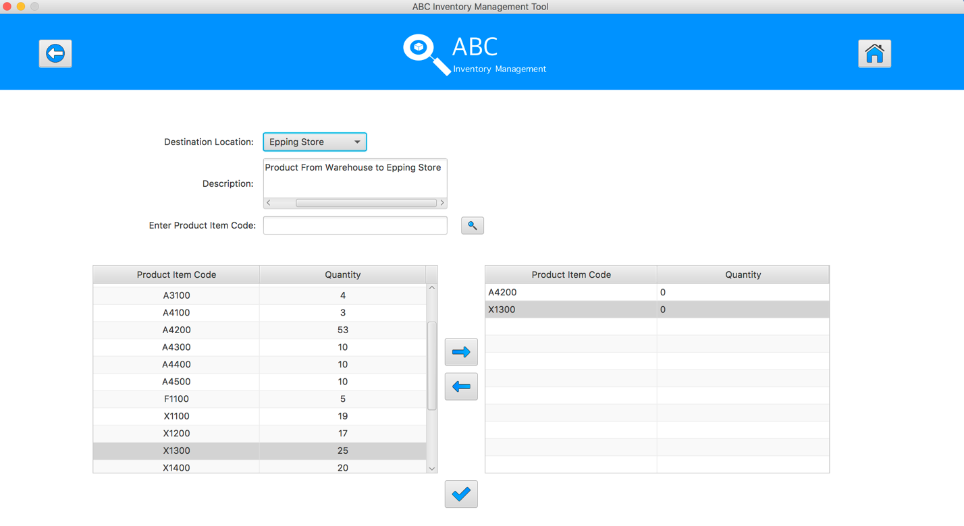
Step 14
Select the product item code in the table on the left

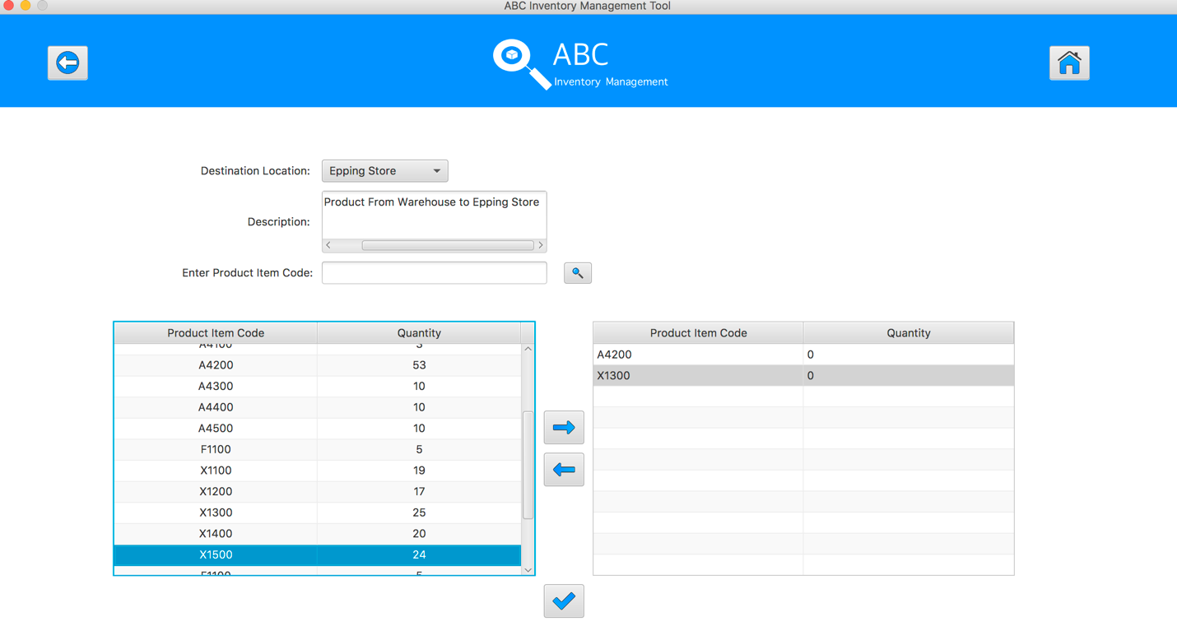
Step 15
Click on the “Add To Cart” Button
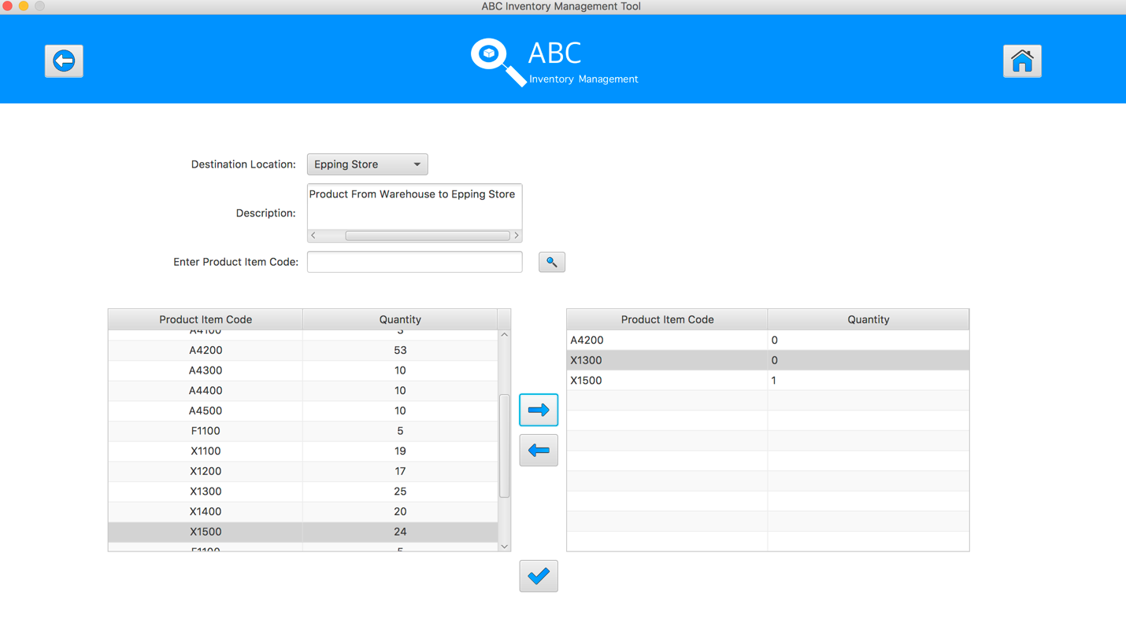
Step 16
Double click to the quantity cell in selected cart table

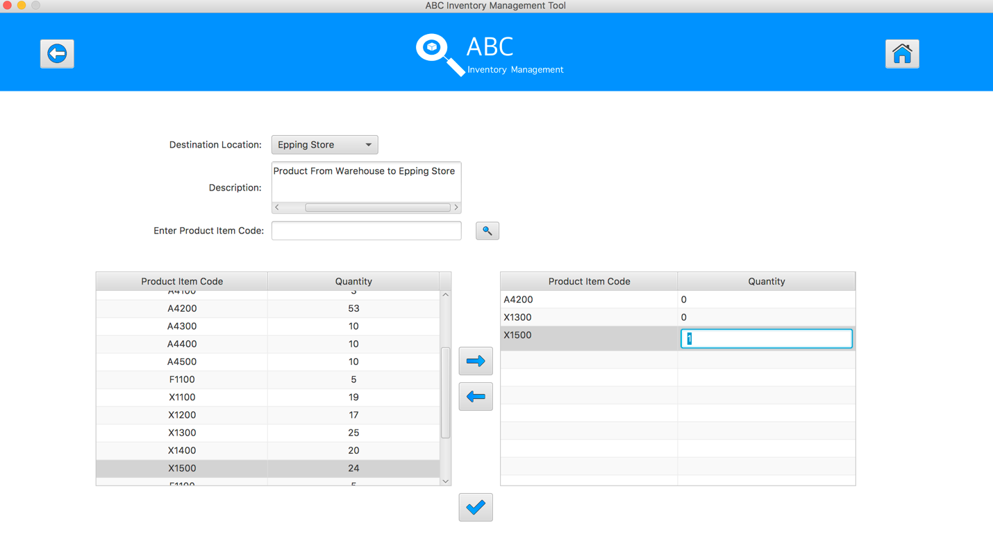
Step 17
Enter the desirable number
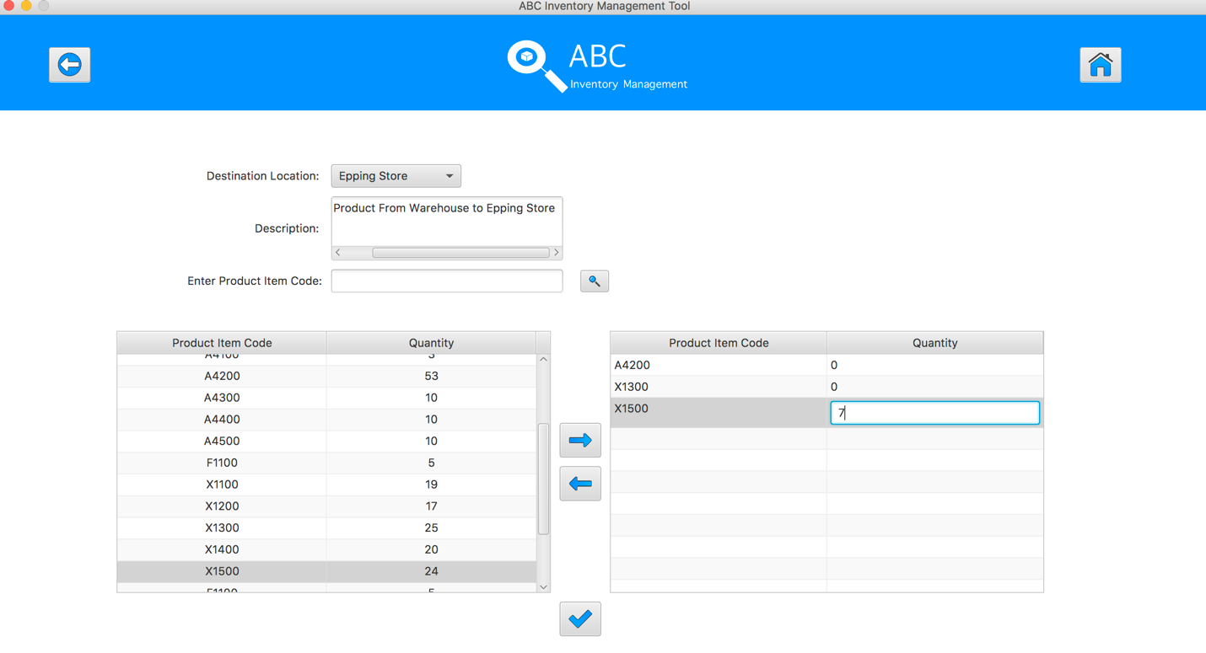
Step 18
Hit enter key to confirm this edited quantity
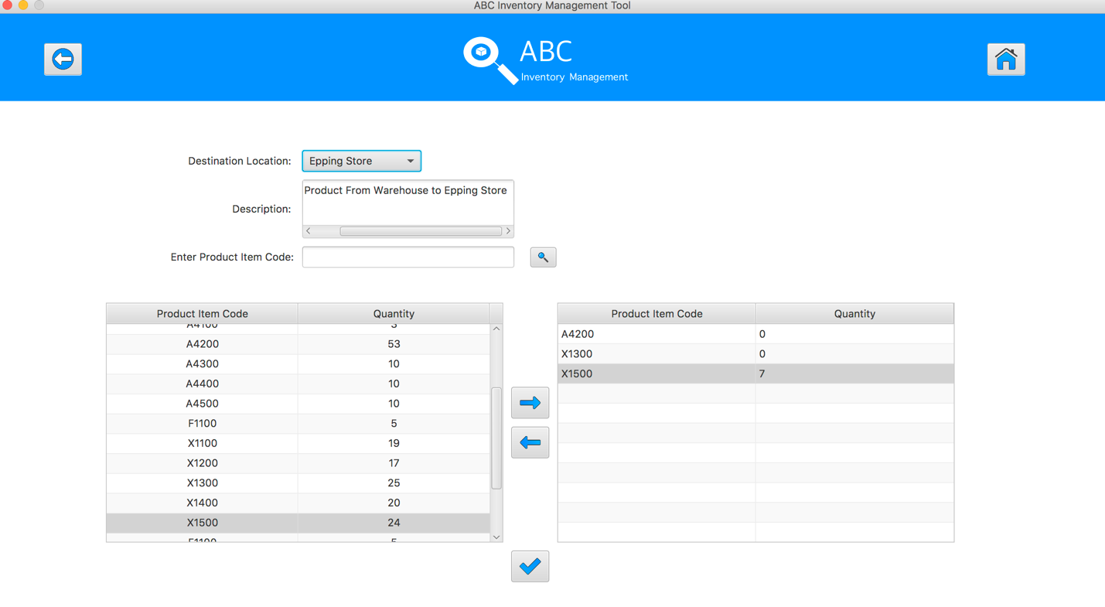
Step 19
After added the desirable items, hit the “Send Product” Button 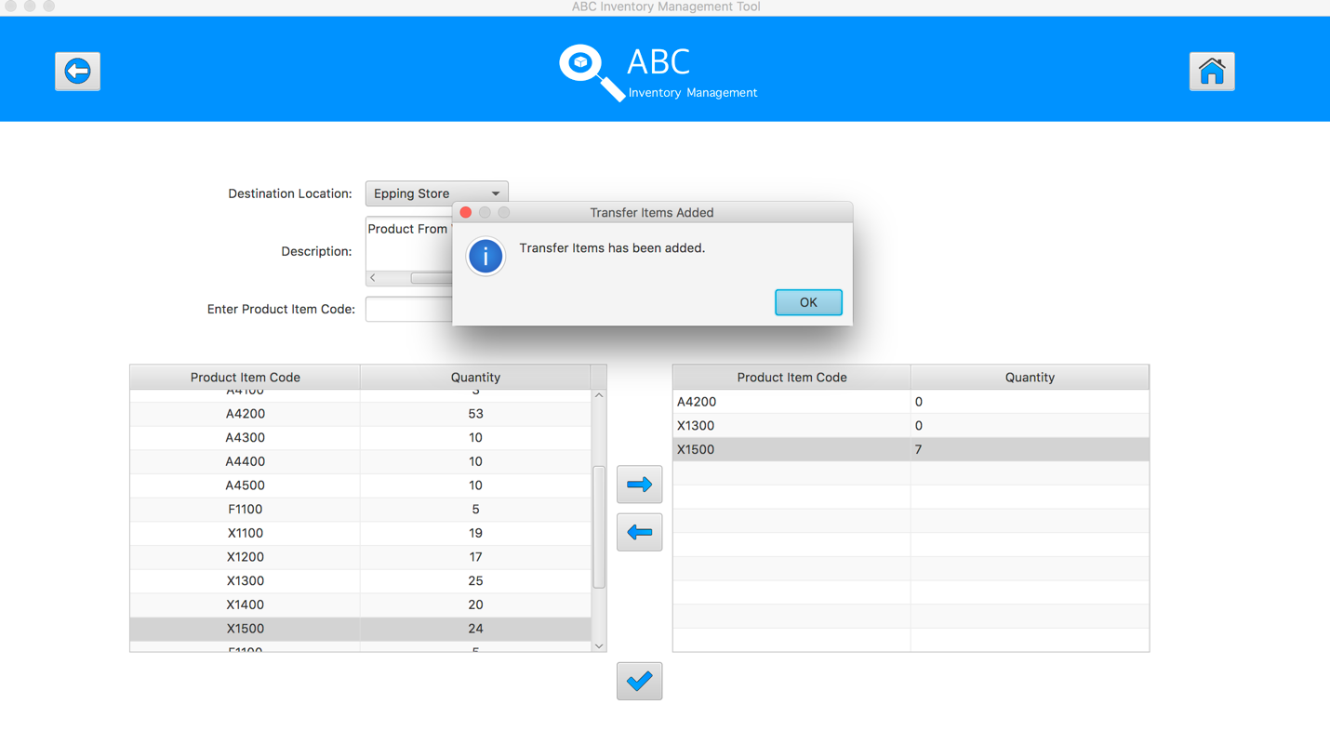
Step 20
Reset the interface for working with new transfer.
SPT002- Test Send Incorrect Quantity Of Product To The Destination for Data Set 2: FAIL

Data Set 3
Test Data Table
Destination Location | Epping Store
Description | Send Product From Warehouse to Epping Store
Product Item Code | A4200 | X1300 | X1500
Quantity | abc | edf | 2
Result | Fail

Result Screenshots
The screenshots of the result on each test step for each data set are given below:

Step 1
Select the destination location
Step 2
Enter the description for this transfer
Step 3
Select the product item code in the table on the left
Step 4
Select the product item code in the table on the left
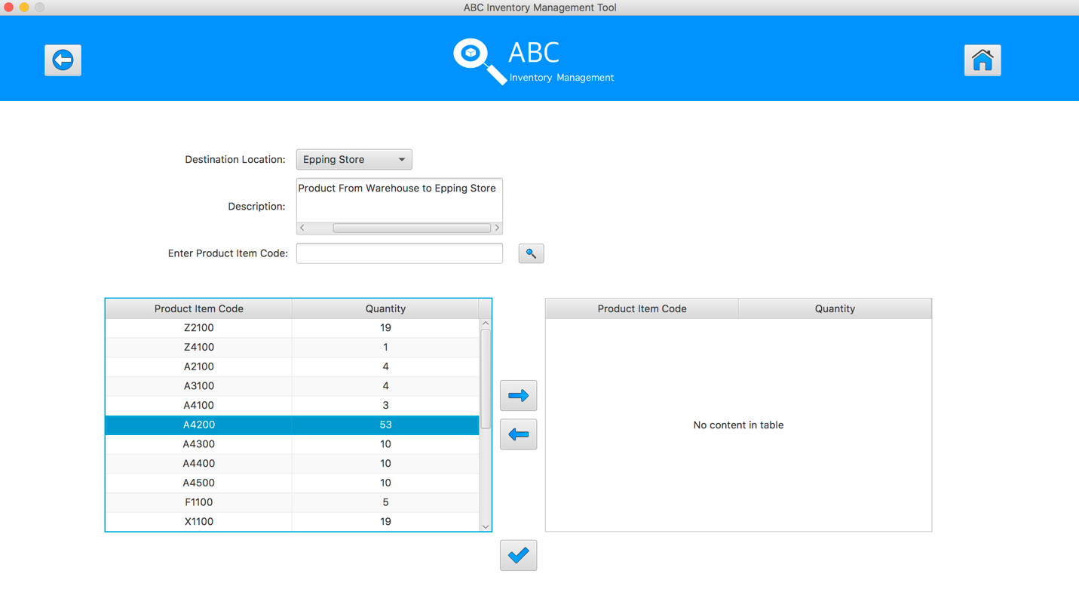
Step 5
Click on the “Add To Cart” Button
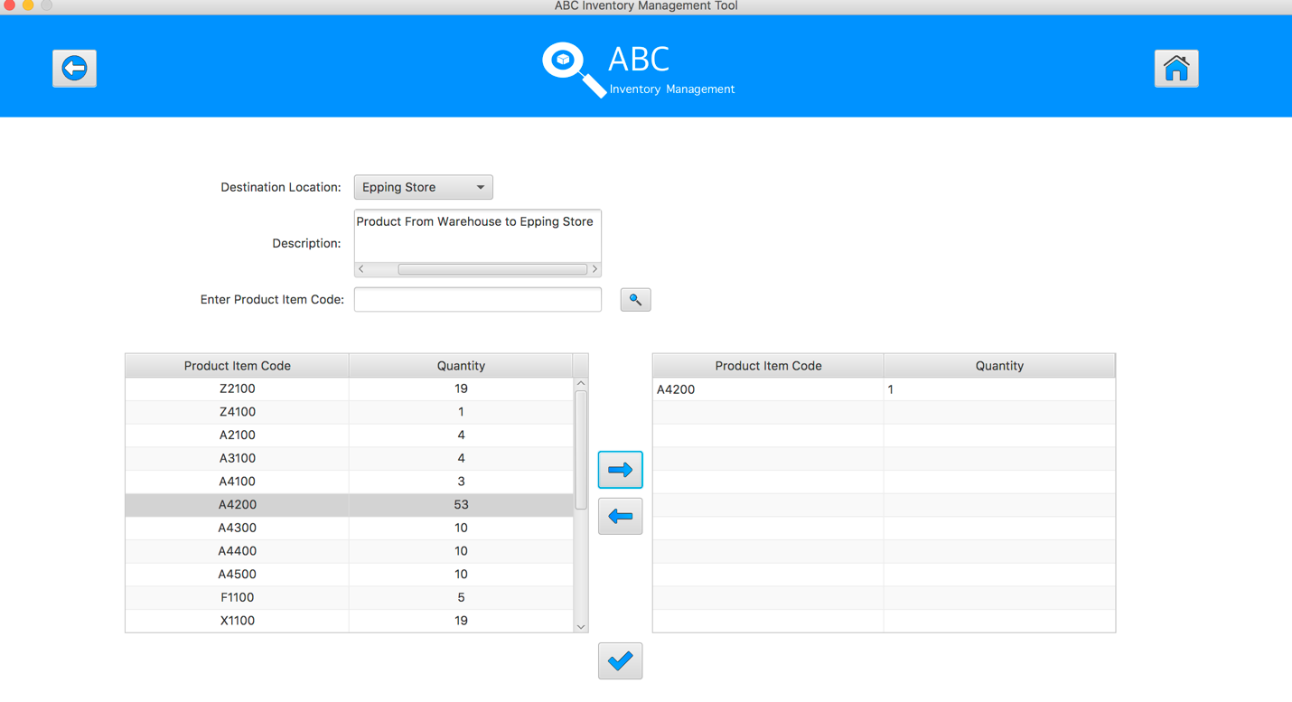
Step 6
Double click to the quantity cell in selected cart table
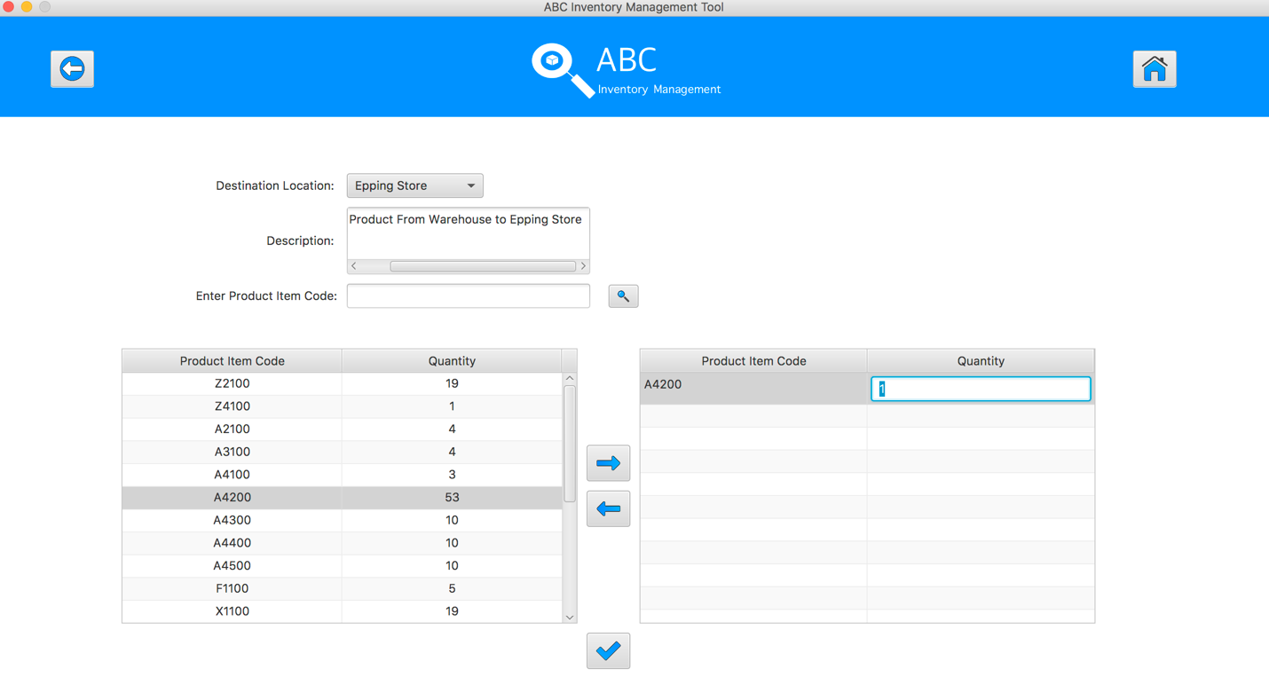
Step 7
Enter the desirable number
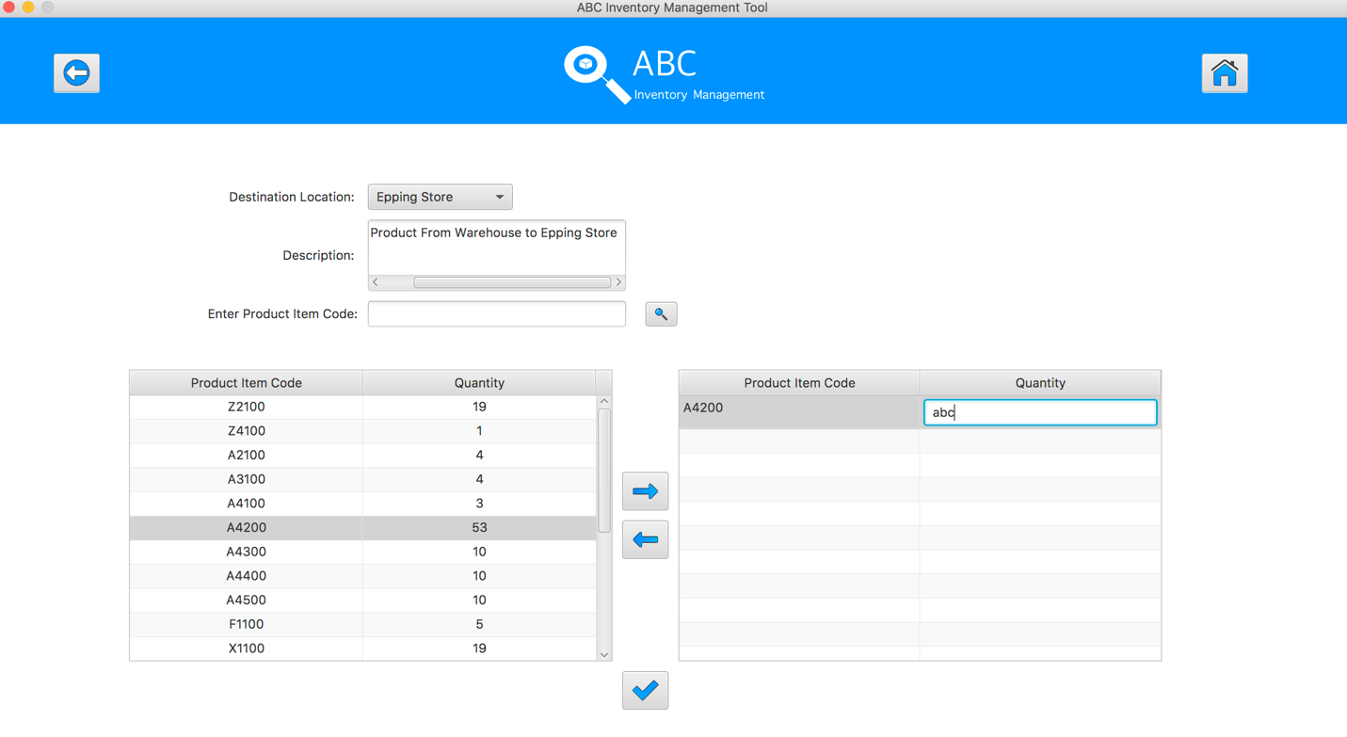
Step 8
Hit enter key to confirm this edited quantity
Step 9
Select the product item code in the table on the left
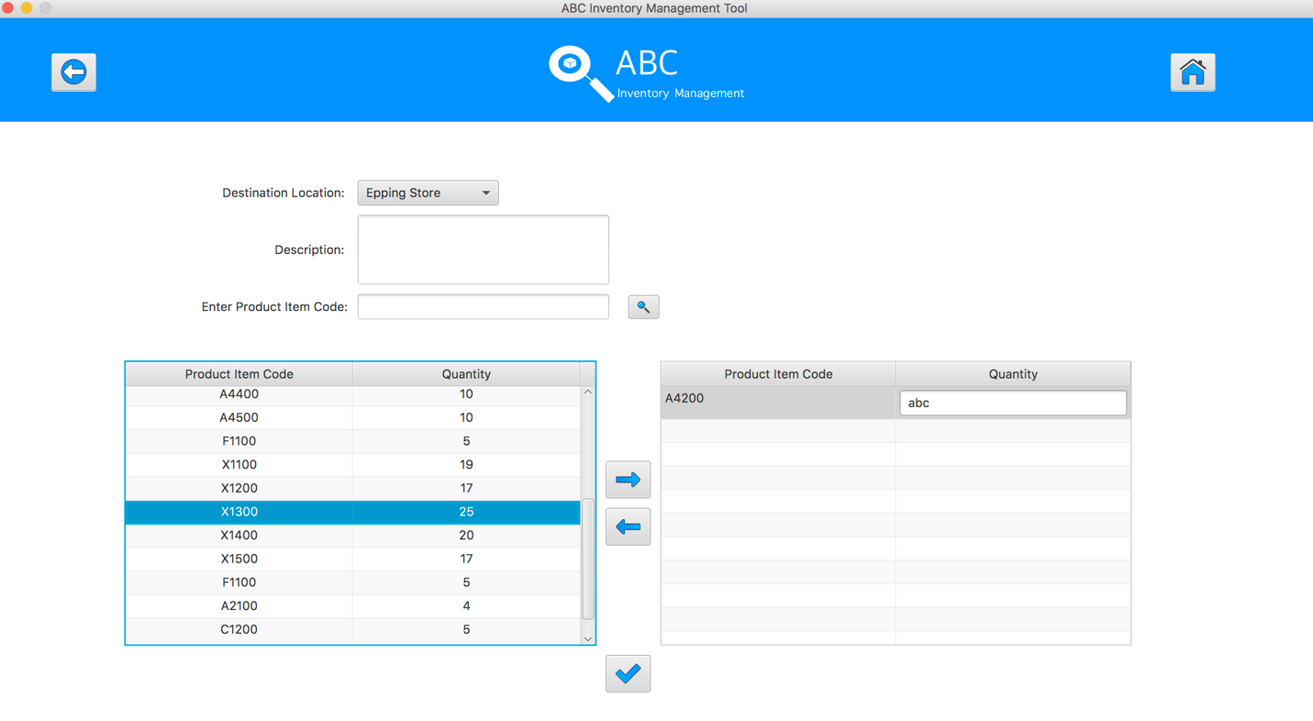
Step 10
Click on the “Add To Cart” Button

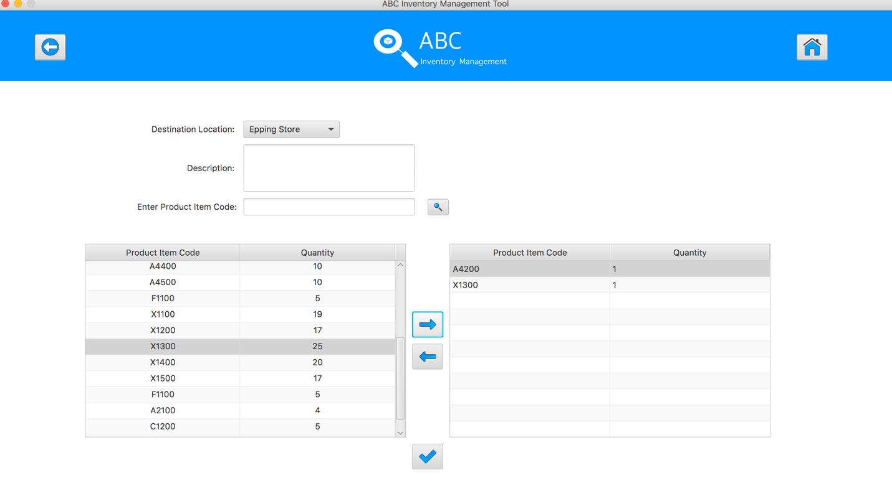
Step 11
Double click to the quantity cell in selected cart table
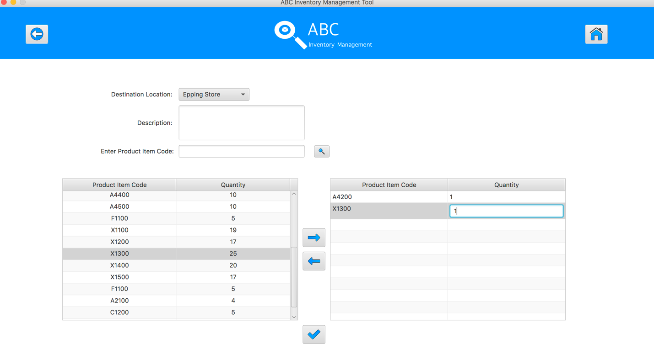
Step 12
Enter the desirable number
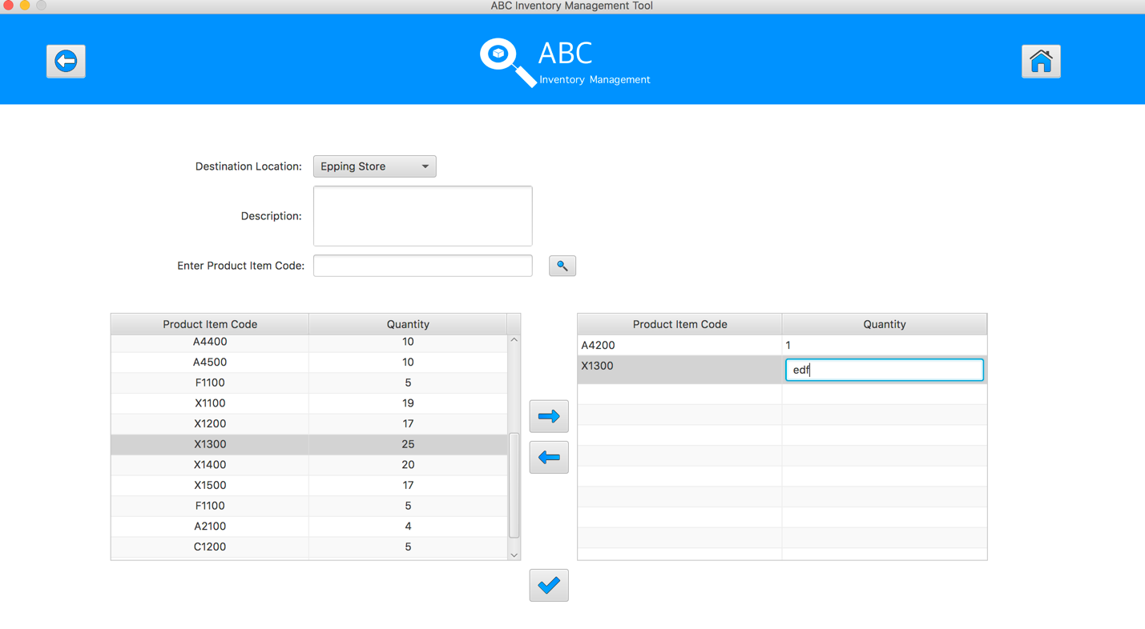
Step 13
Hit enter key to confirm this edited quantity
Step 14
Select the product item code in the table on the left

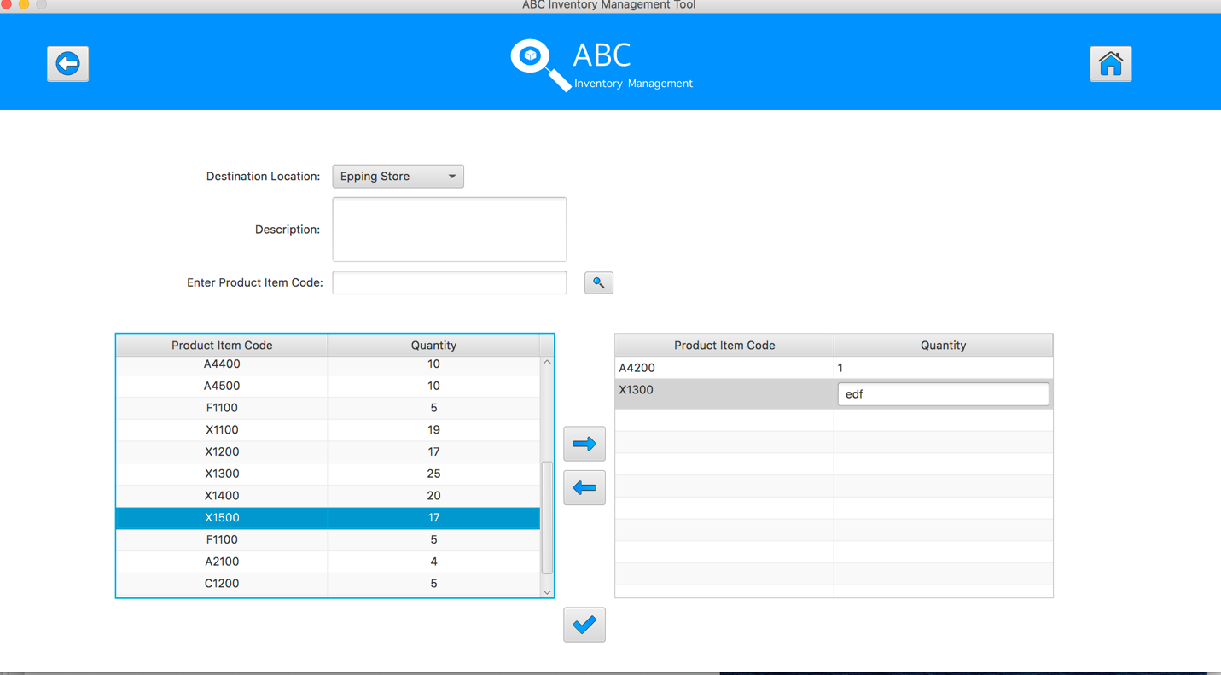
Step 15
Click on the “Add To Cart” Button
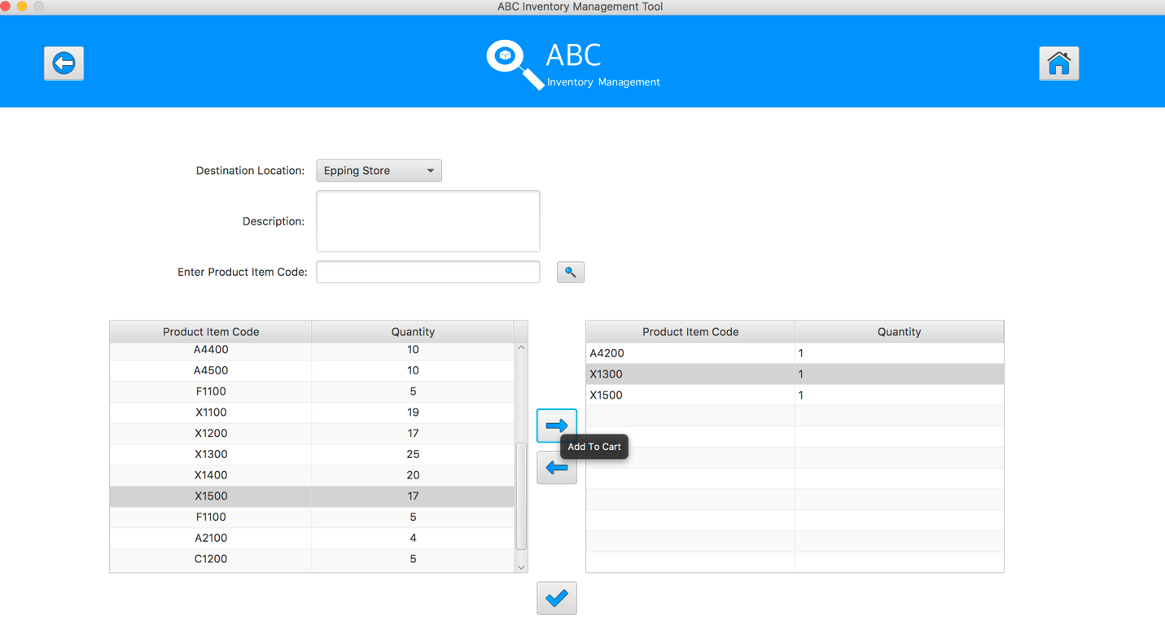
Step 16
Double click to the quantity cell in selected cart table

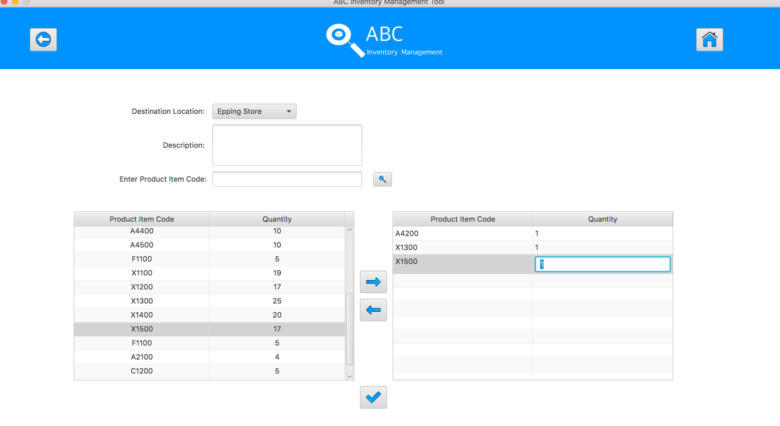
Step 17
Enter the desirable number
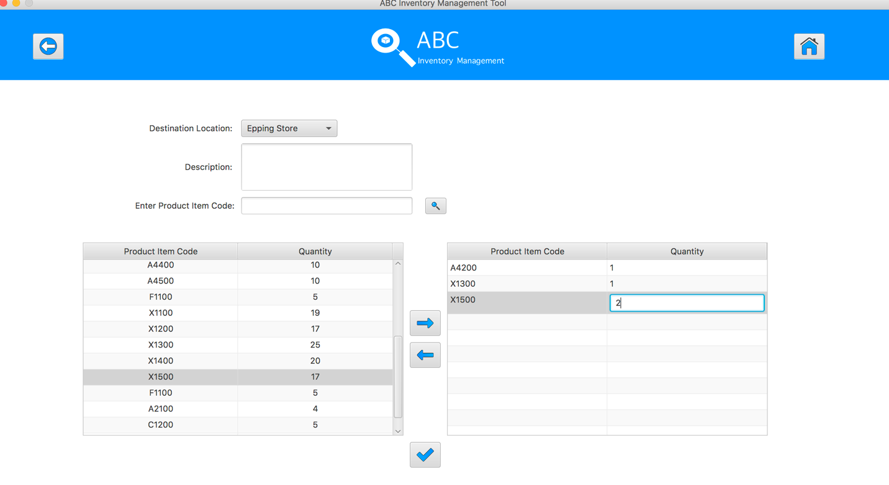
Step 18
Hit enter key to confirm this edited quantity
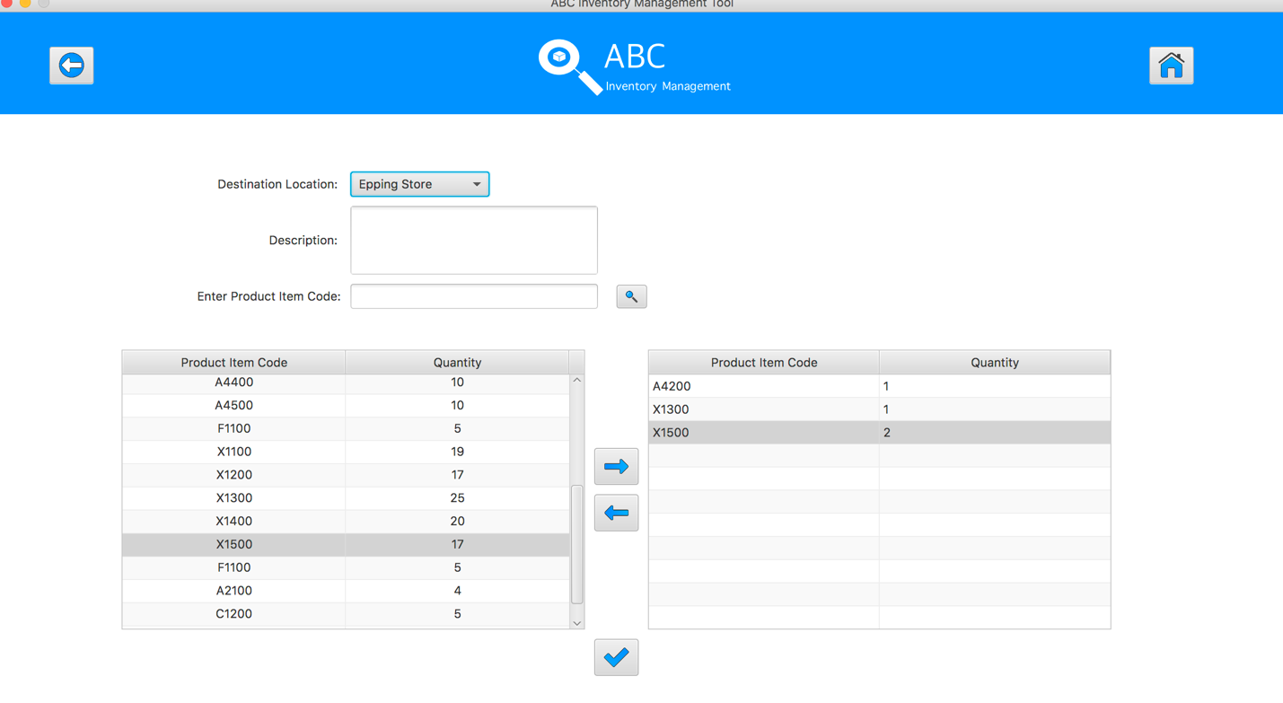
Step 19
After added the desirable items, hit the “Send Product” Button 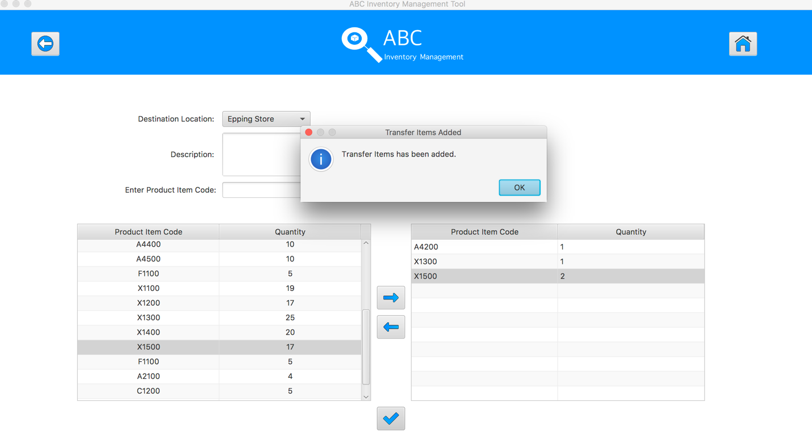
Step 20
Reset the interface for working with new transfer.
SPT002- Test Send Incorrect Quantity Of Product To The Destination for Data Set 3: FAIL

Data Set 4
Test Data Table
Destination Location | Epping Store
Description | Send Product From Warehouse to Epping Store
Product Item Code | A4100 | X1300
Quantity | 10 | 2
Result | Pass

Result Screenshots
The screenshots of the result on each test step for each data set are given below:

Step 1
Select the destination location
Step 2
Enter the description for this transfer
Step 3
Select the product item code in the table on the left
Step 4
Select the product item code in the table on the left
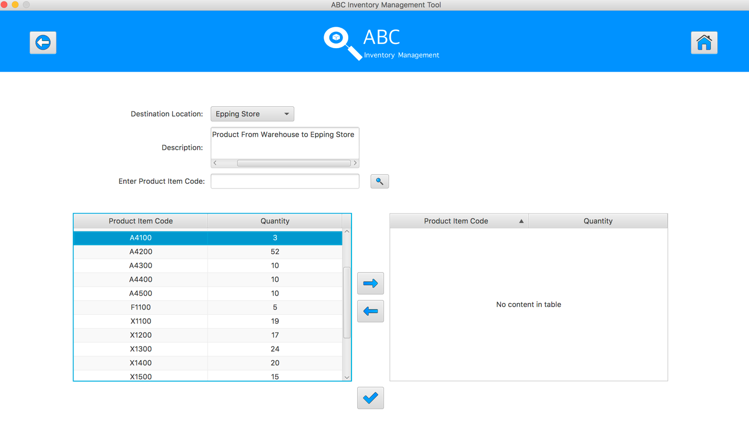
Step 5
Click on the “Add To Cart” Button
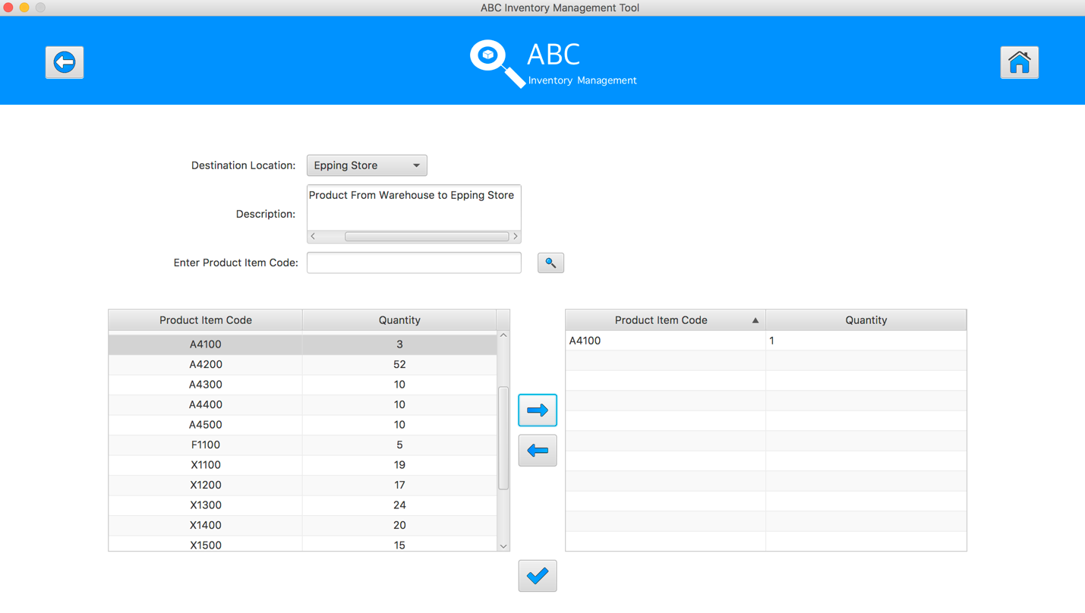
Step 6
Double click to the quantity cell in selected cart table
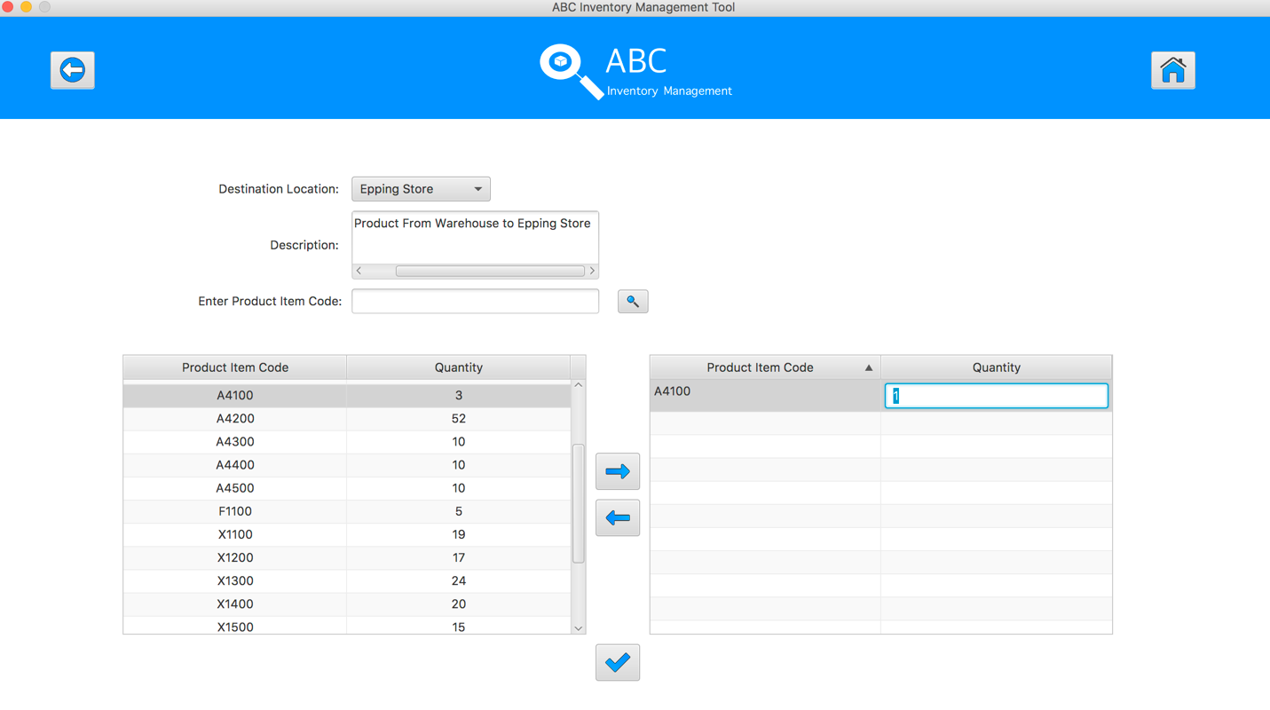
Step 7
Enter the desirable number
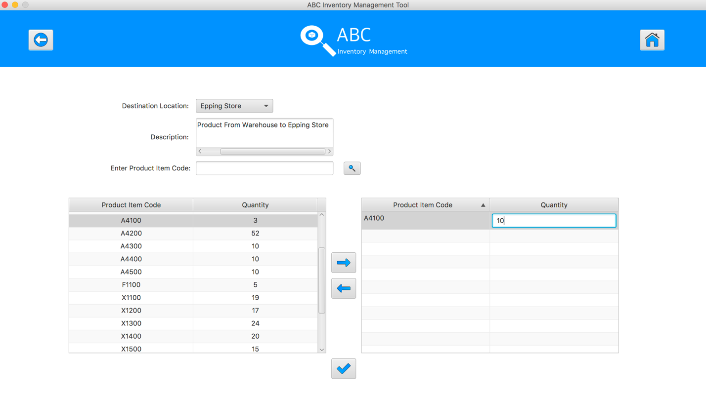
Step 8
Hit enter key to confirm this edited quantity
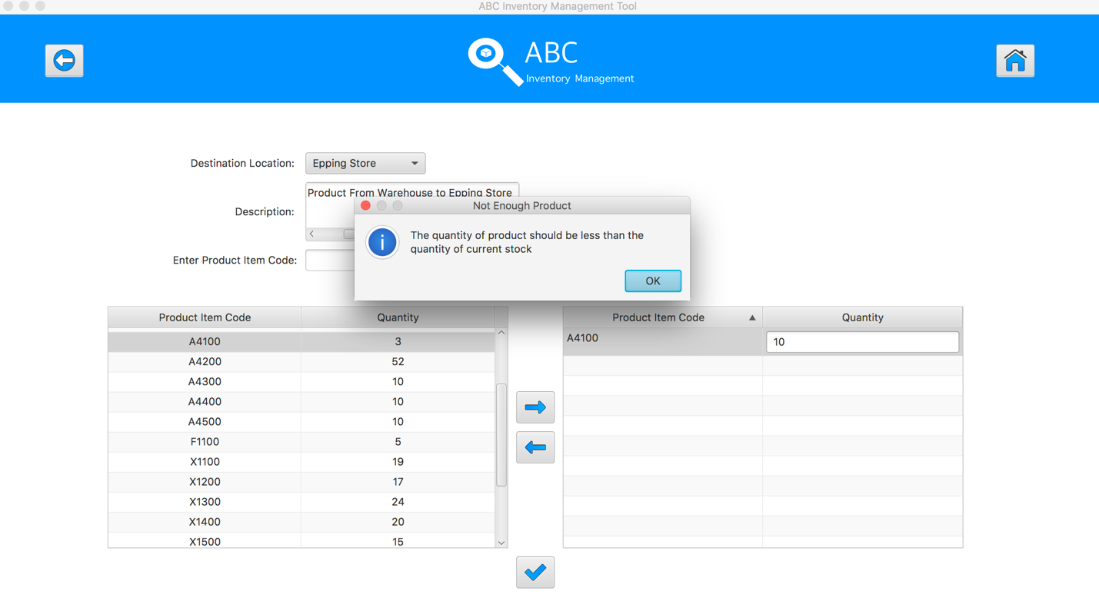
Step 9
Edit the quantity to be smaller than the current quantity in sending store
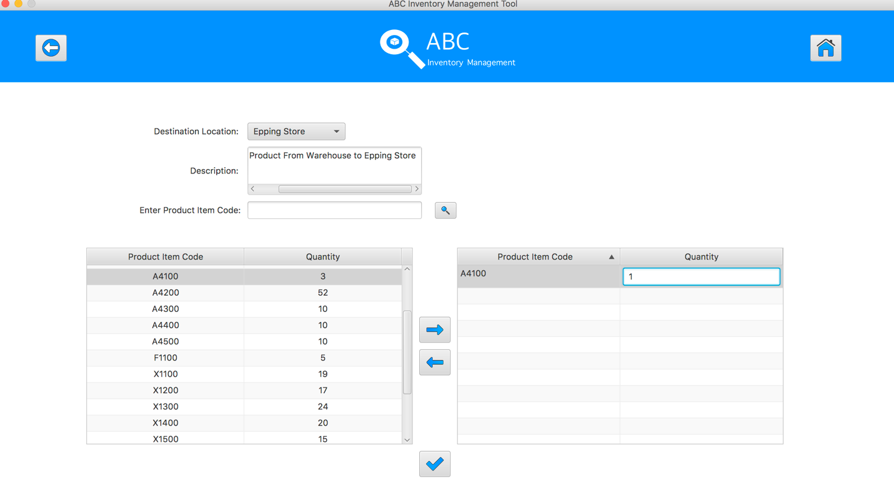
Step 10
Hit Enter to confirm the edited quantity

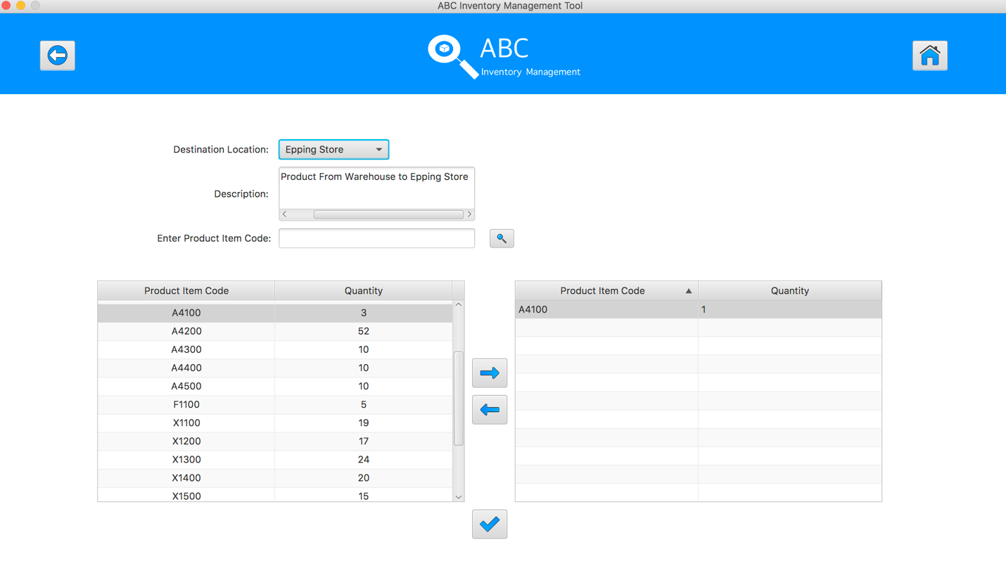
Step 11
Select the product item code in the table on the left

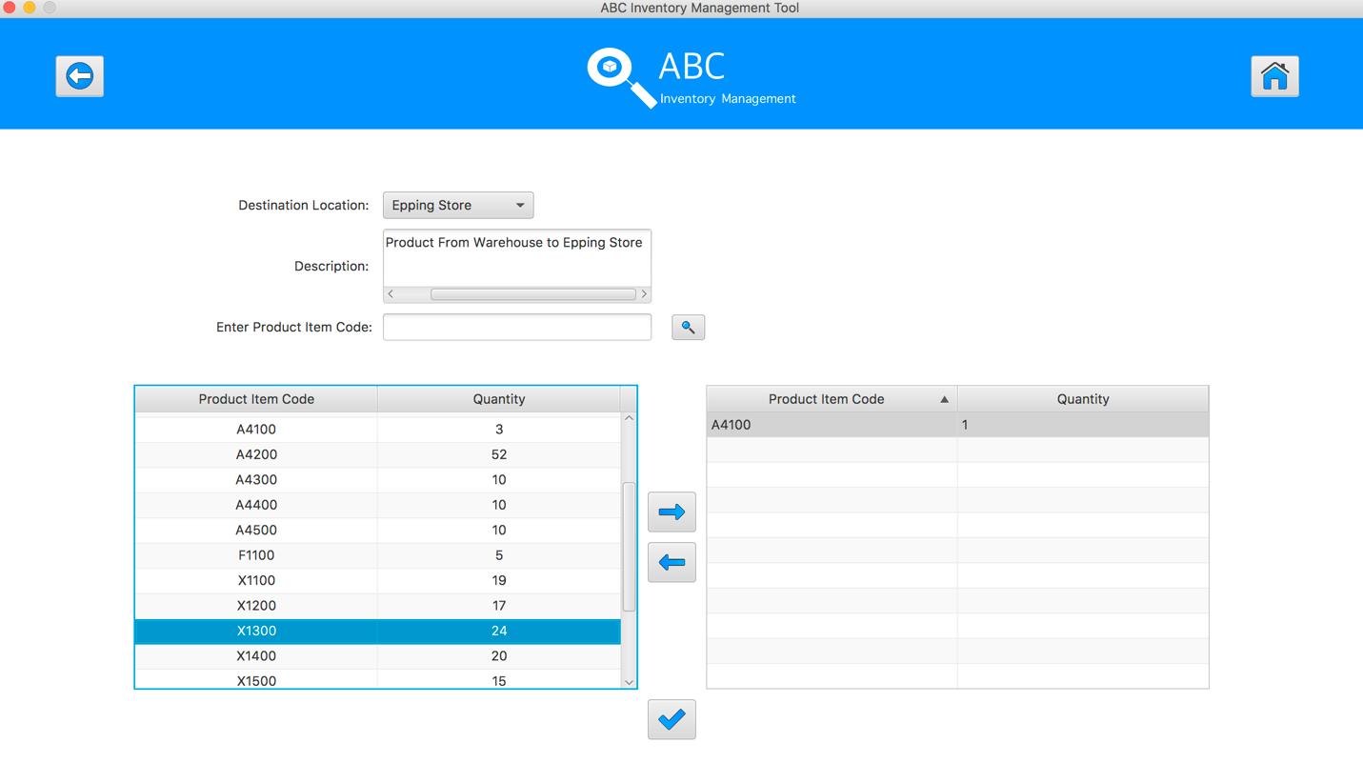
Step 12
Click on the “Add To Cart” Button
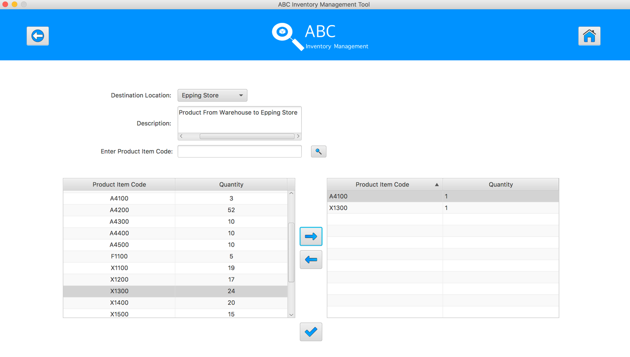
Step 13
Double click to the quantity cell in selected cart table

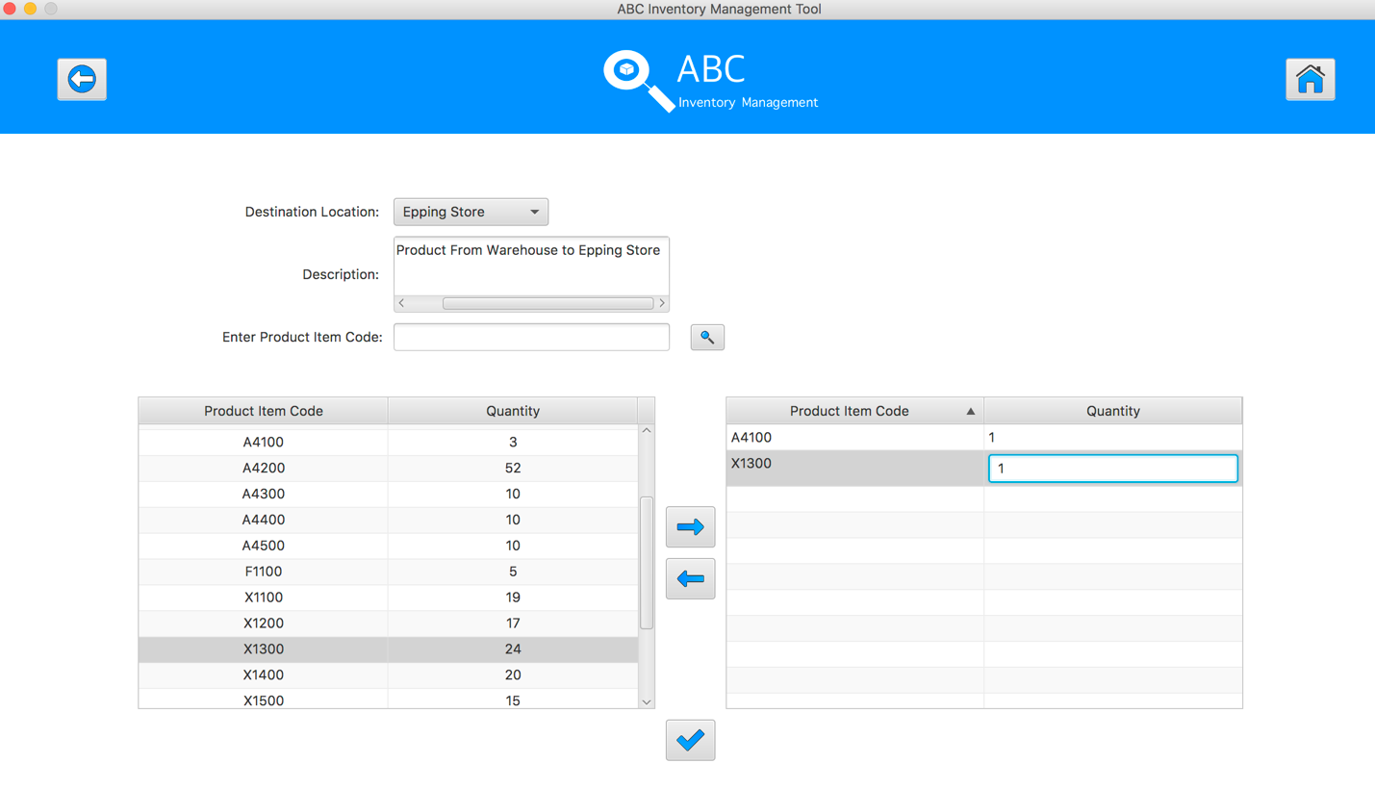
Step 14
Enter the desirable number
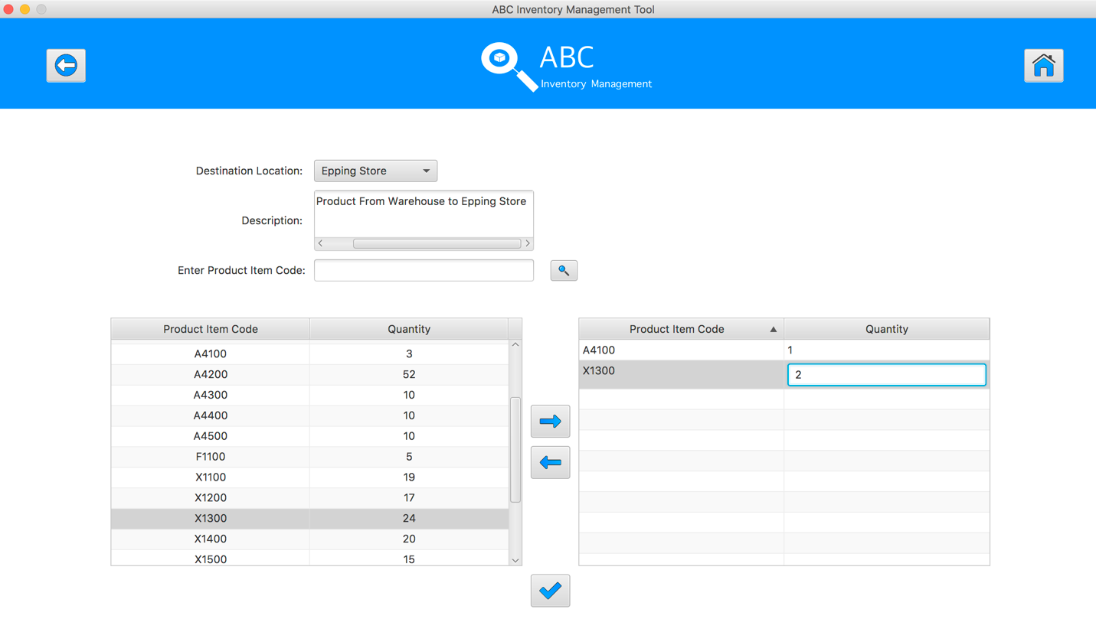
Step 15
Hit enter key to confirm this edited quantity
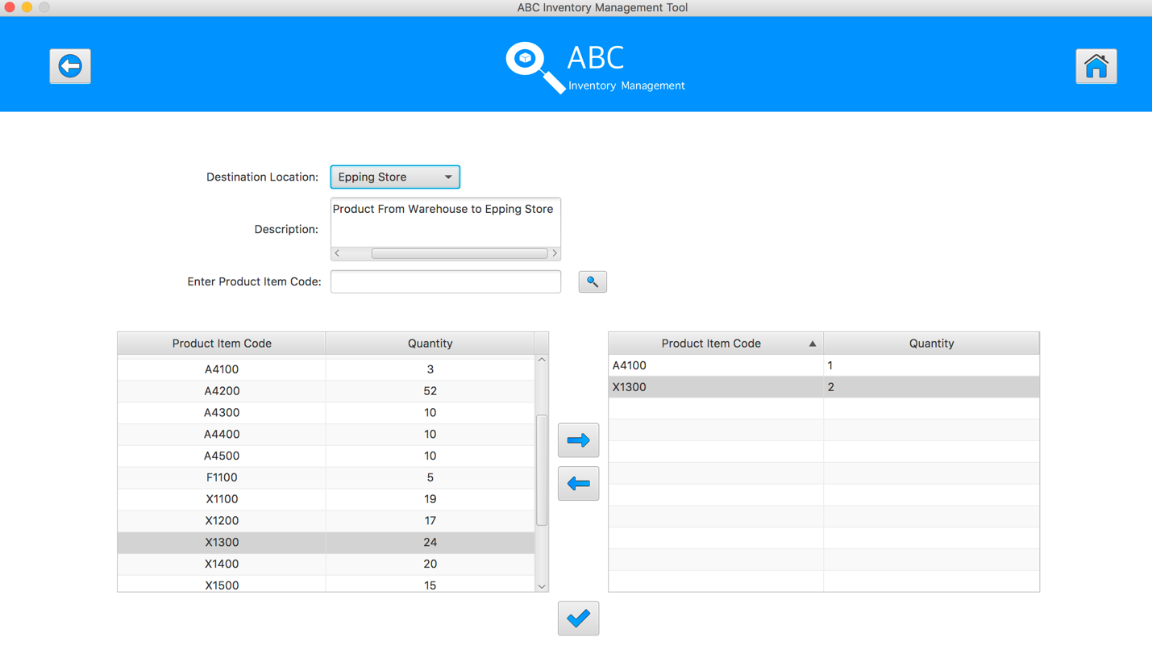
Step 16
After added the desirable items, hit the “Send Product” Button 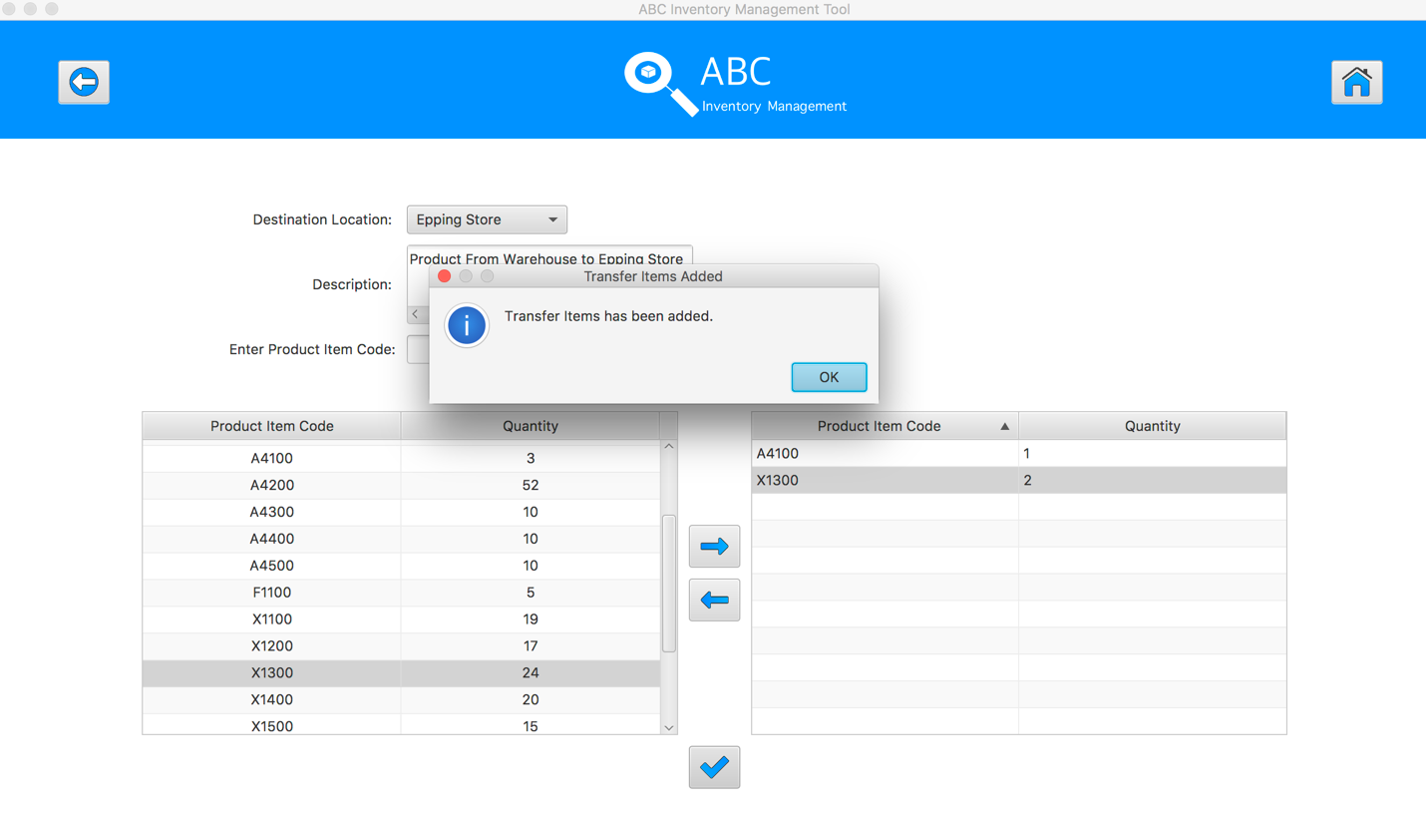
Step 17
Reset the interface for working with new transfer.
SPT002- Test Send Incorrect Quantity Of Product To The Destination for Data Set 1: PASS

SPT003 - Send Correct Quantity Of Product By Searching Known Product Item Code To The Destination
Test Name |  | Send Correct Quantity Of Product By Searching Known Product Item Code To The Destination (Test Case SPT003)
Use Case Tested |  | Send Product
Test Description |  | This test tests if the system can search product item code and send these product items in current location to destination location.
Pre-Conditions |  | Meta data must exist, product and product details like product item code, location ID and product quantity.
Post-Conditions |  | Sending Products should be sent to the destination, the status of transfer change to “Sending” to wait for the receiver accept it, the quantity of sending product from sending location should be reduced.
Notes |  | This test assumes that the user knows the destination name, product item code.
Result (Pass/Fail/Warning/ Incomplete) |  | Pass
 | Test Step |  | Expected Test Results | P | F
1. | Select Send Product Button from home page |  | Display the Send Product page | P
2. | Select the destination location |  | Destination location combo box changes to the selected location name | P
3. | Enter the description for this transfer |  | Description text area displays user inputs | P
4. | Enter the product item code in search field and hit search button |  | System display the searched product in sending location | P
4. | Select the product item code in the table on the left |  | System waits for hitting the “Add to Cart” Button | P
5. | Click on the “Add To Cart” Button |  | The selected item displayed in the right table (cart table) with default quantity is 1 | P
6. | Double click to the quantity cell in selected cart table |  | System change the cell of double clicked cell to be editable | P
7. | Enter the desirable number |  | System waits for hitting enter key from user. | P
8. | Hit enter key to confirm this edited quantity |  | System waits for adding other product items and hitting the “Send Product” Button | P
9. | After added the desirable items, hit the “Send Product” Button |  | An message pops up to notify that the products in the cart table are sent to the destination.  Reset the interface for working with new transfer. | P

Data Set 1
Test Data Table
Destination Location | Oxford Store
Description | Send Product From Warehouse to Oxford Store
Product Item Code | A4300 | X1100 | A4200
Quantity | 2 | 3 | 5

Result Screenshots
The screenshots of the result on each test step for each data set are given below:

Step 1
Select the destination location
Step 2
Enter the description for this transfer
Step 3
Select the product item code in the table on the left
Step 4
Enter the product item code in search field and hit search button
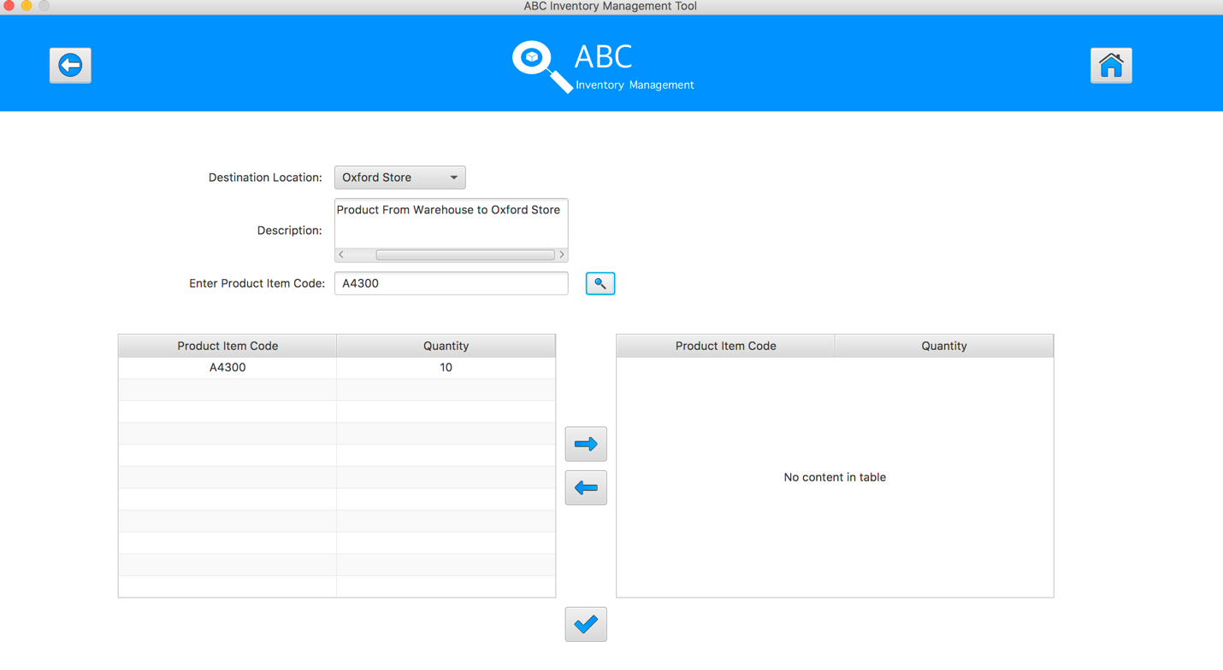
Step 5
Select the product item code in the table on the left
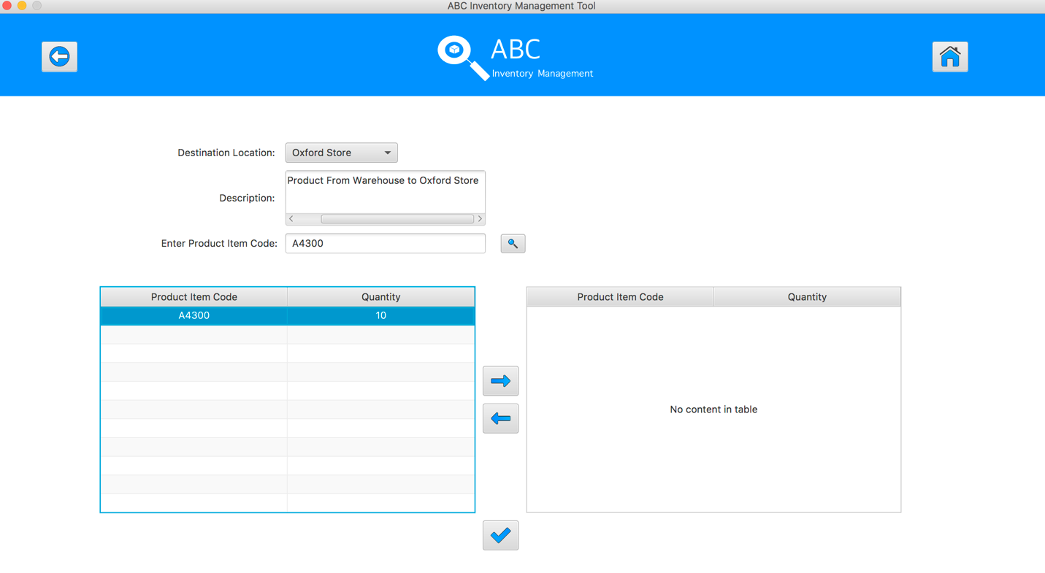
Step 6
Click on the “Add To Cart” Button
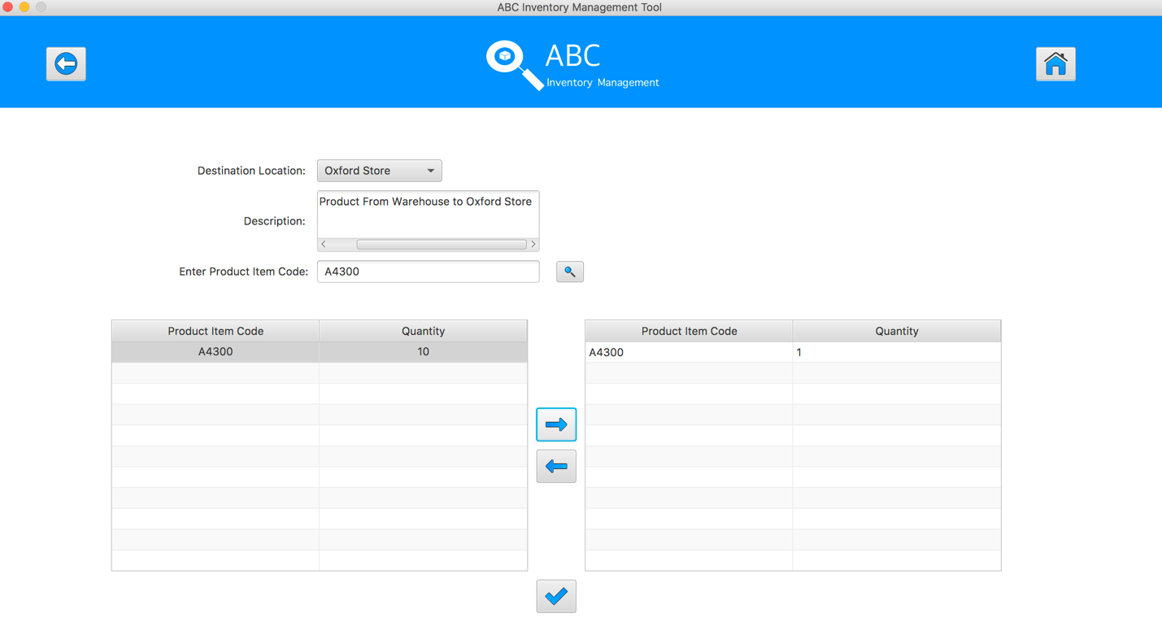
Step 7
Double click to the quantity cell in selected cart table
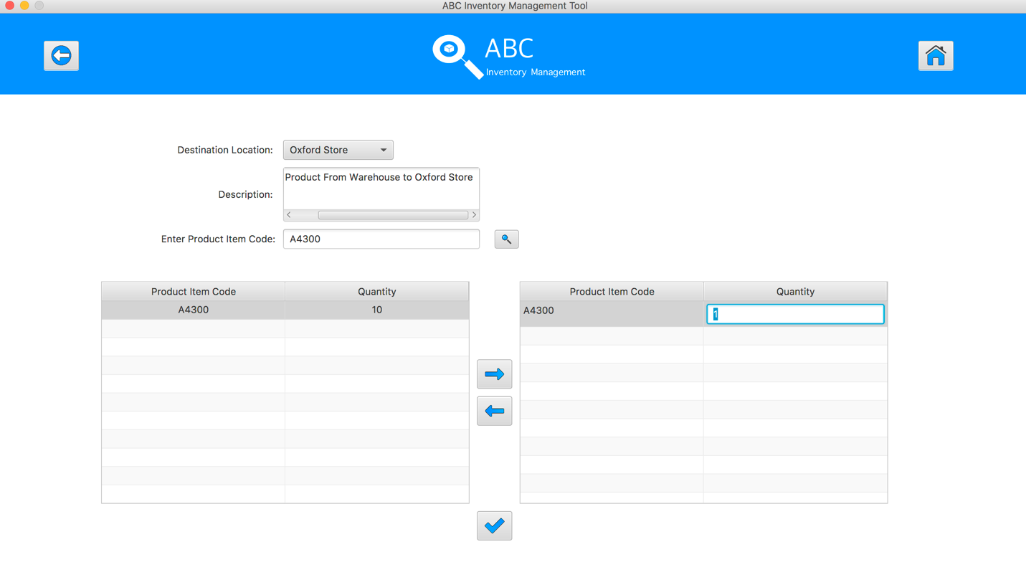
Step 8
Enter the desirable number
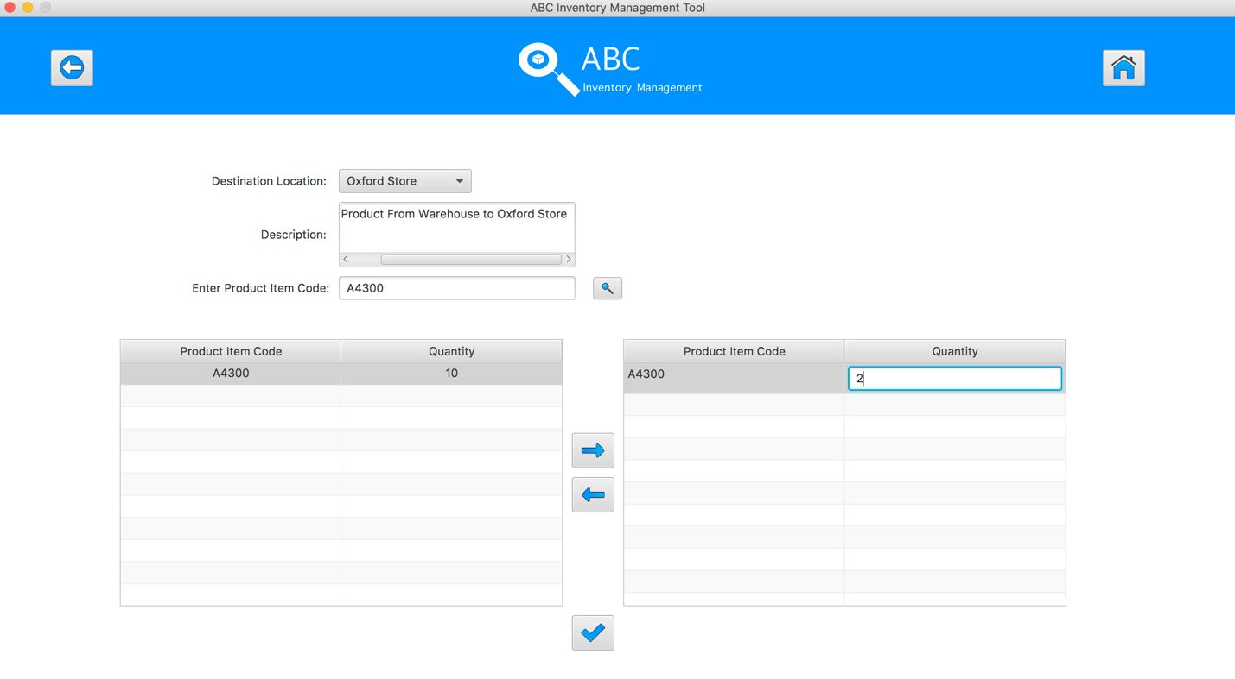
Step 9
Hit enter key to confirm this edited quantity
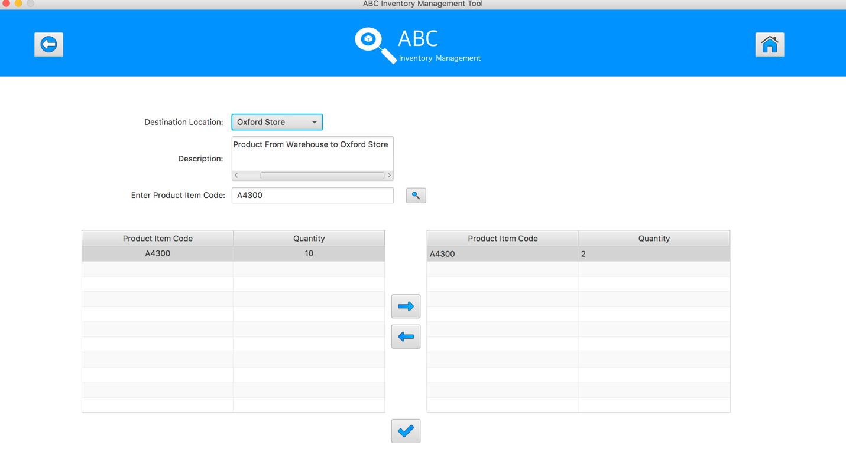
Step 10
Enter the product item code in search field and hit search button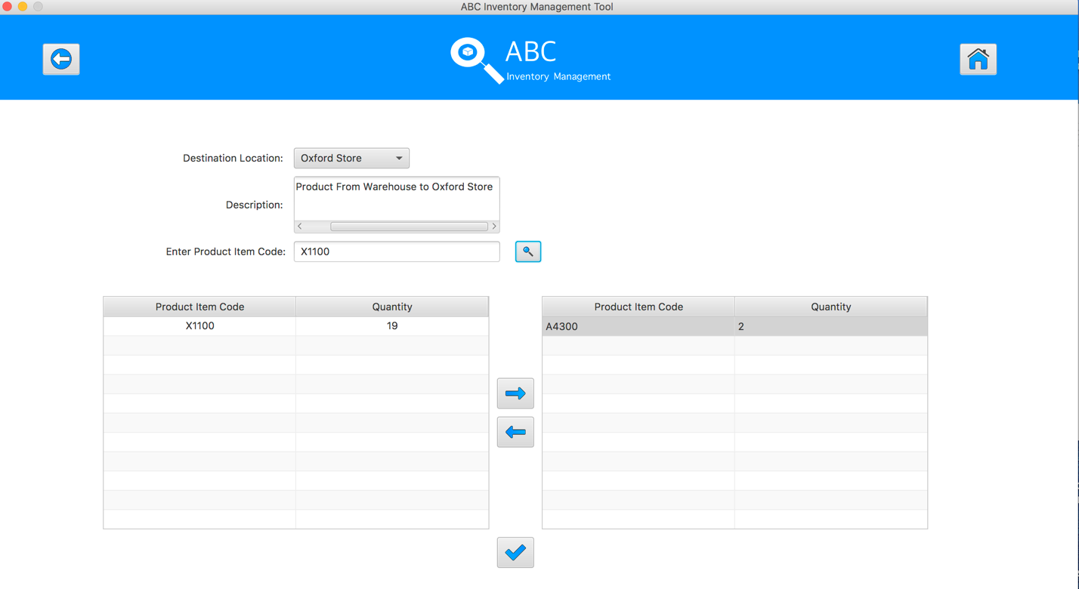

Step 11
Select the product item code in the table on the left

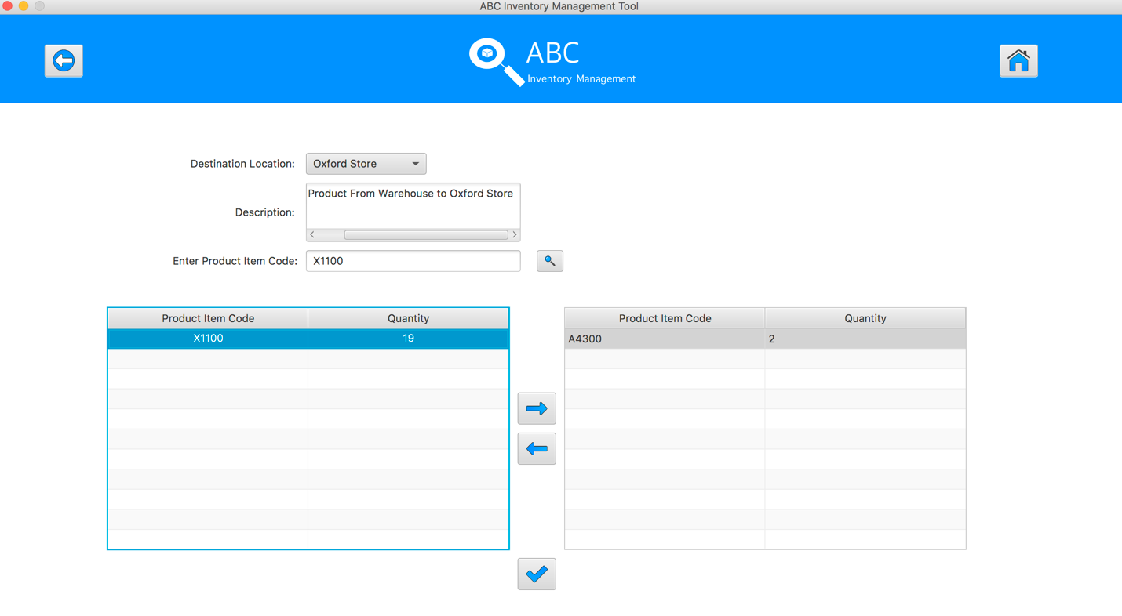
Step 12
Click on the “Add To Cart” Button

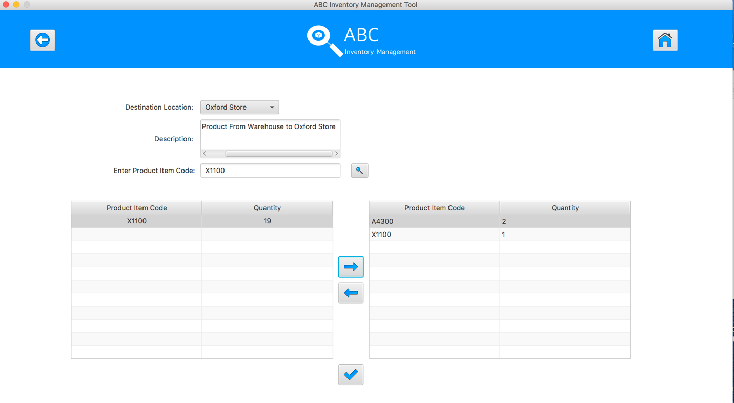
Step 13
Double click to the quantity cell in selected cart table
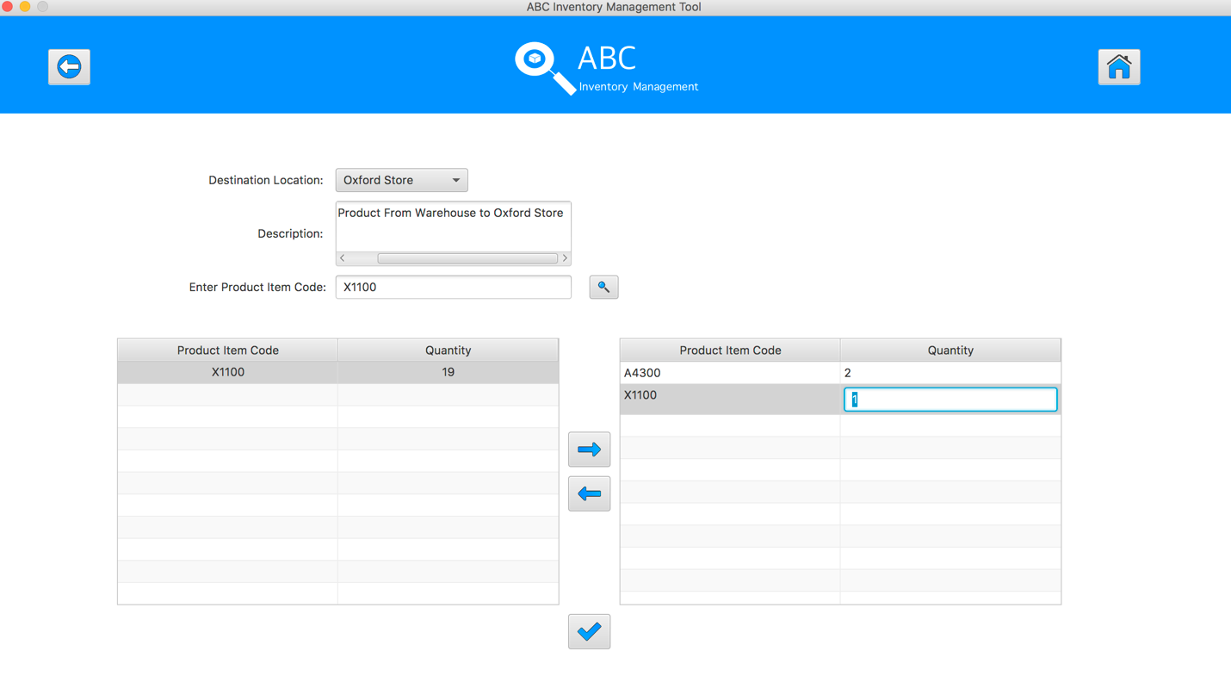
Step 14
Enter the desirable number
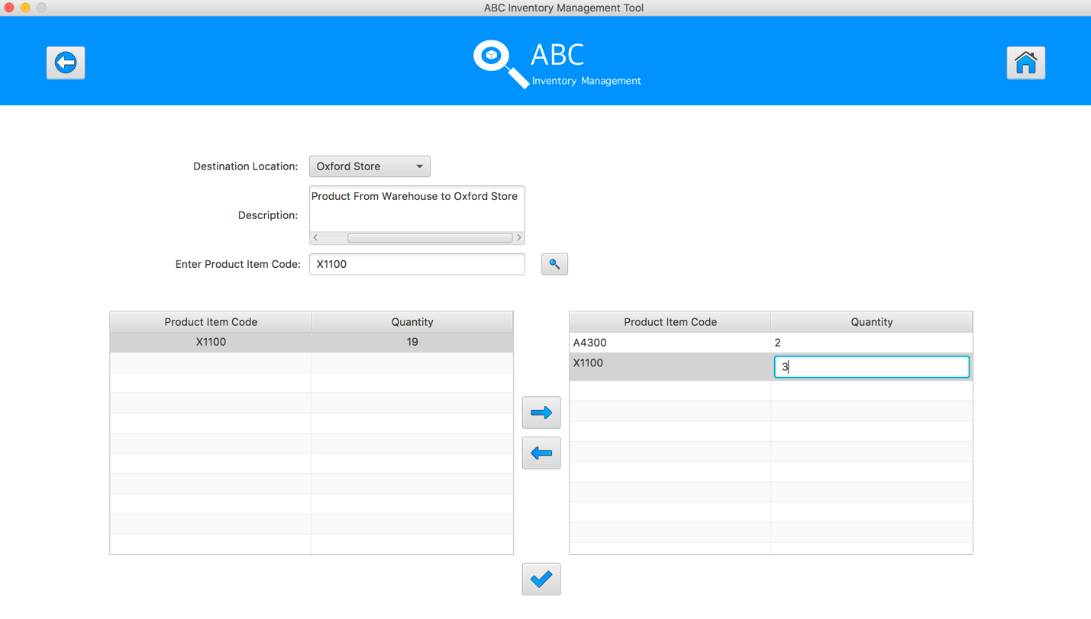
Step 15
Hit enter key to confirm this edited quantity
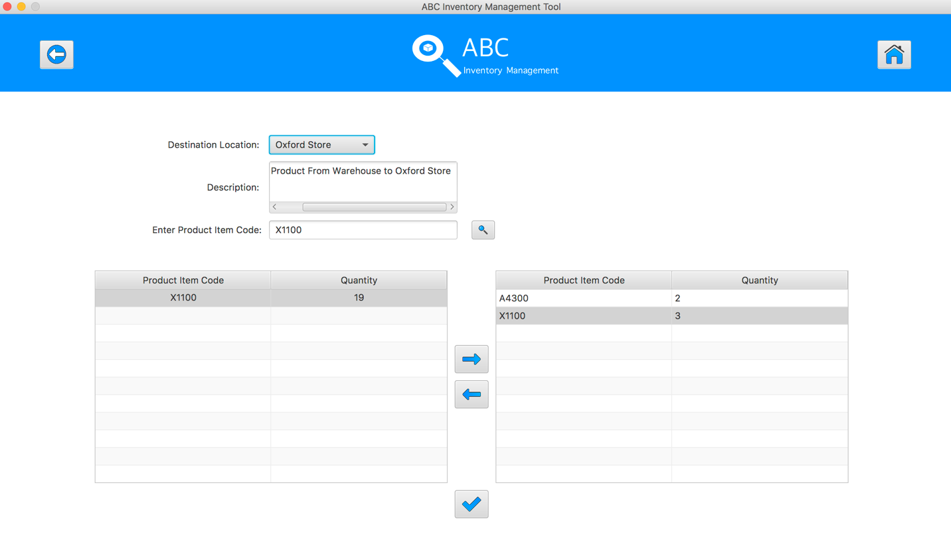
Step 16
Enter the product item code in search field and hit search button
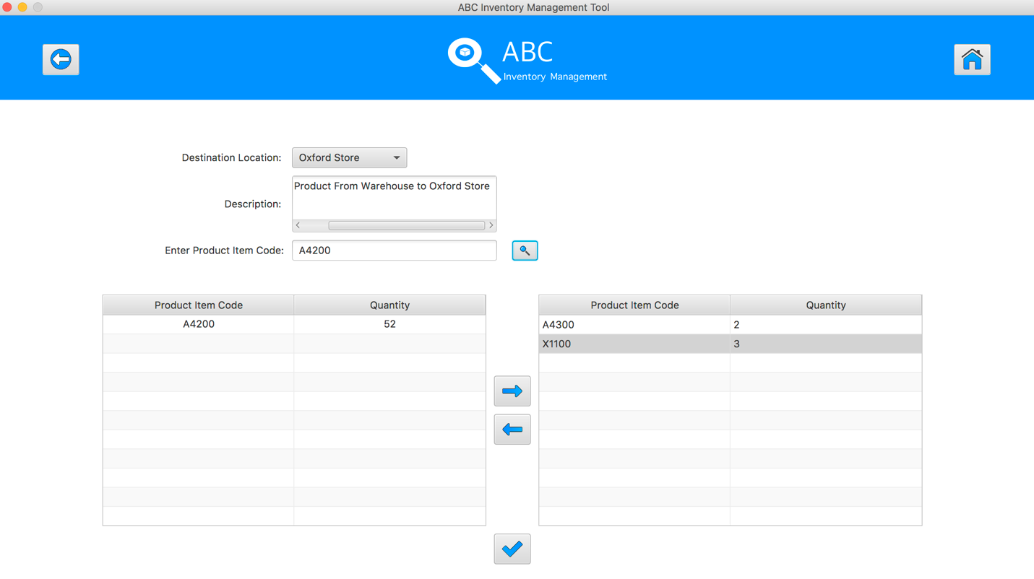
Step 17
Select the product item code in the table on the left

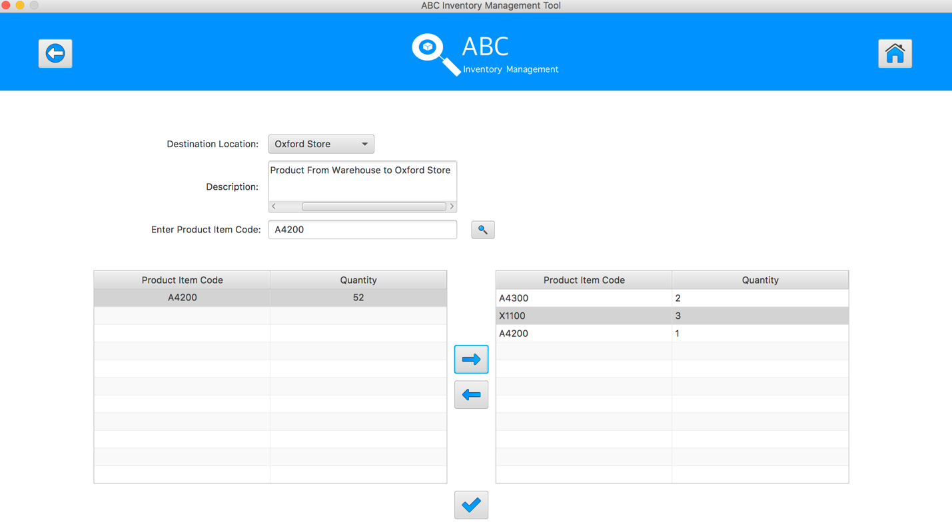
Step 18
Click on the “Add To Cart” Button
Step 19
Double click to the quantity cell in selected cart table

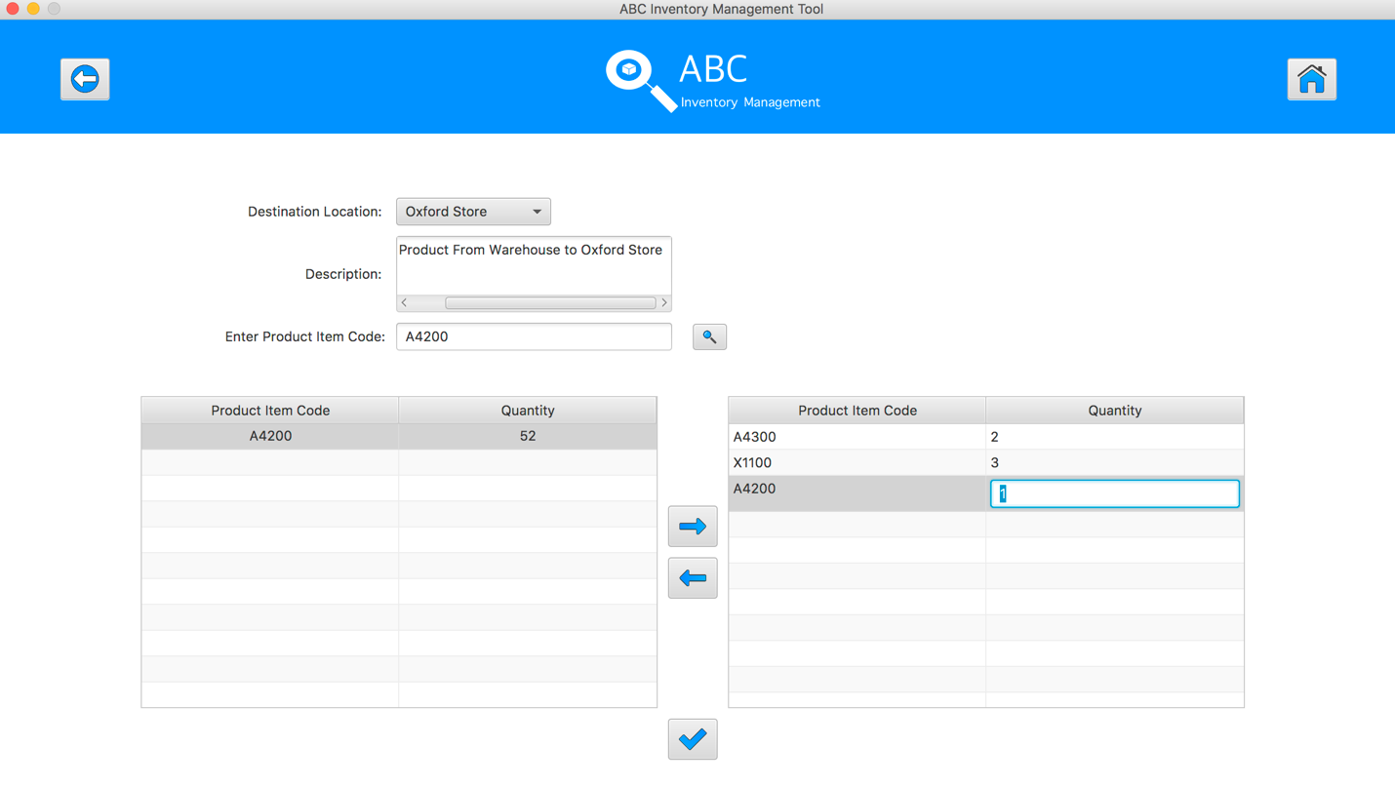
Step 20
Enter the desirable number
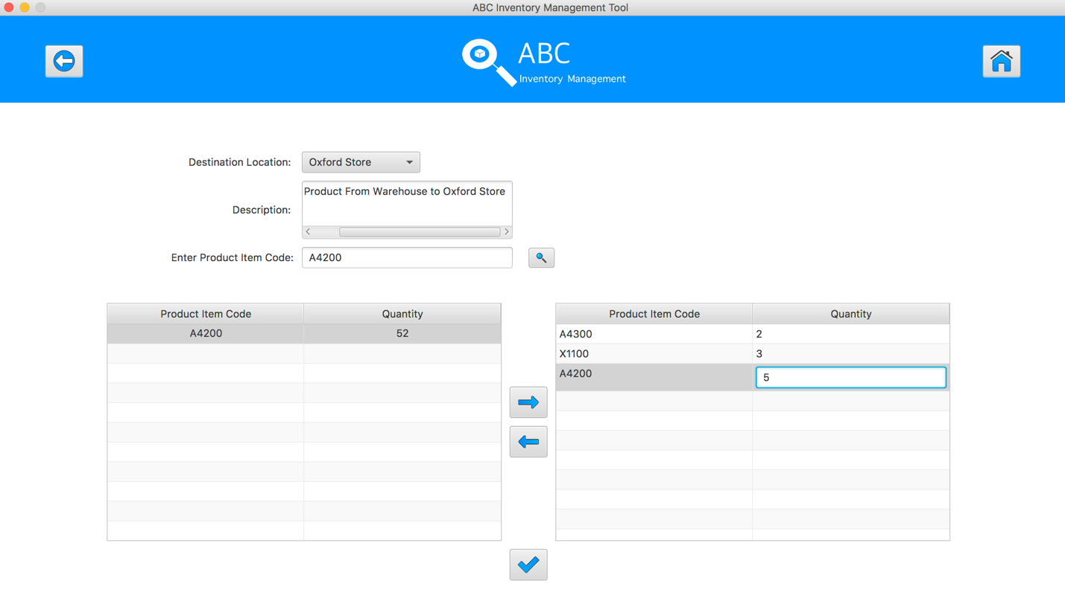
Step 21
Hit enter key to confirm this edited quantity
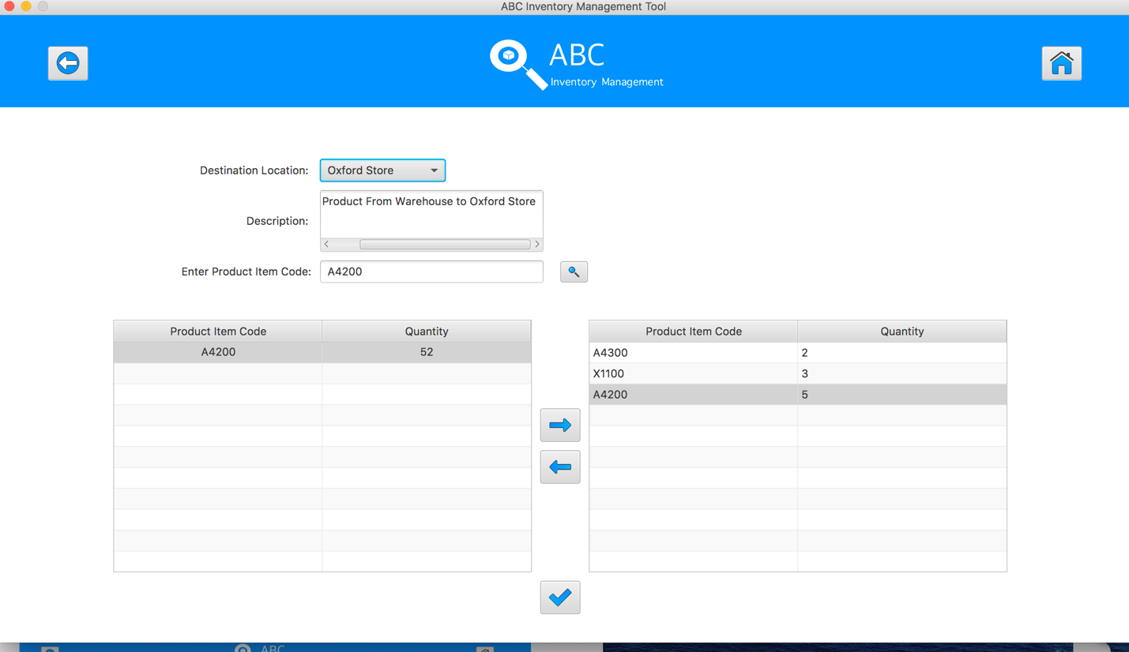
Step 22
After added the desirable items, hit the “Send Product” Button 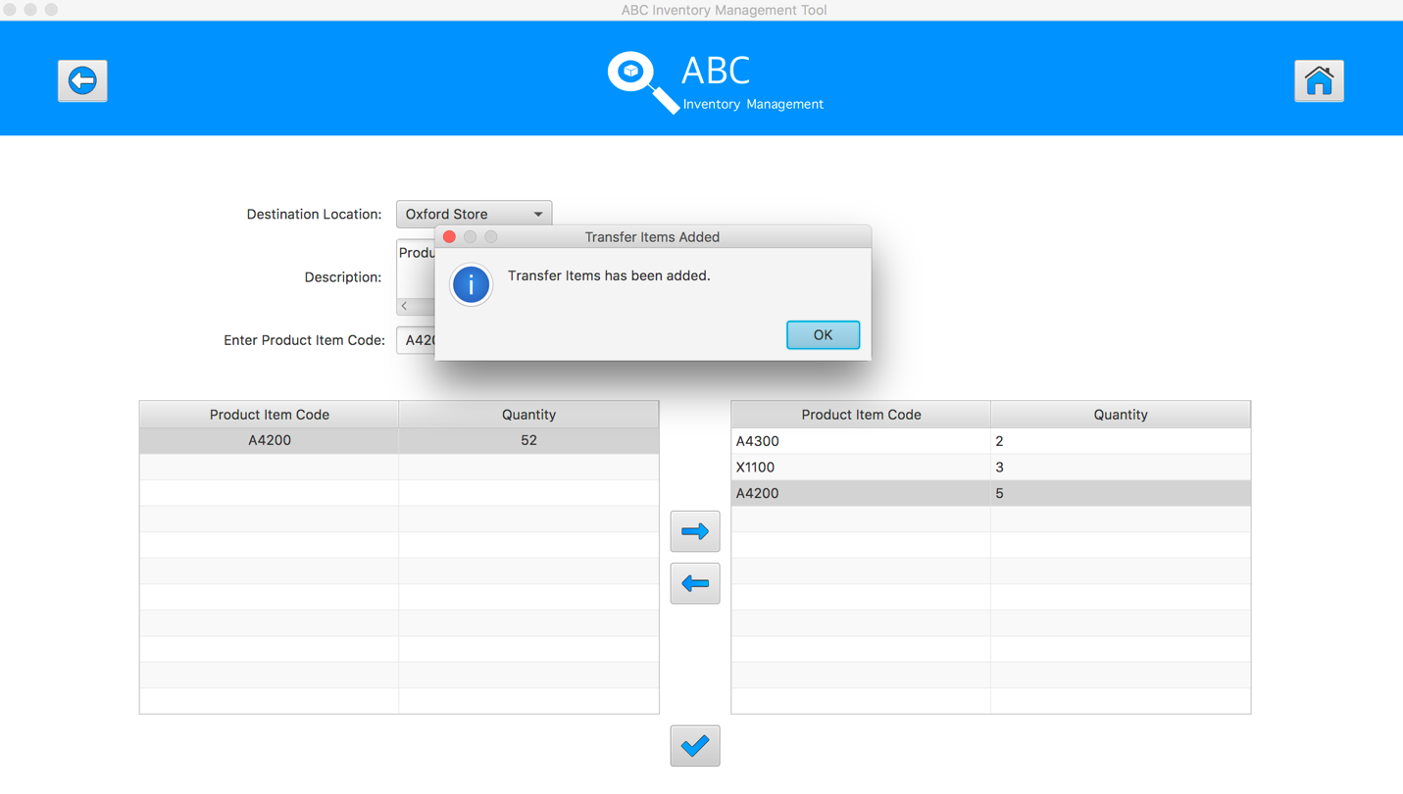
Step 23
Reset the interface for working with new transfer.
SPT003 - Send Correct Quantity Of Product By Searching Known Product Item Code To The Destination for Data Set 1: PASS

Data Set 2
Test Data Table
Destination Location | Epping Store
Description | Send Product From Warehouse to Epping Store
Product Item Code | A4500 | X1200 | E1200
Quantity | 3 | 2 | 2

Result Screenshots
The screenshots of the result on each test step for each data set are given below:

Step 1
Select the destination location
Step 2
Enter the description for this transfer
Step 3
Select the product item code in the table on the left
Step 4
Enter the product item code in search field and hit search button
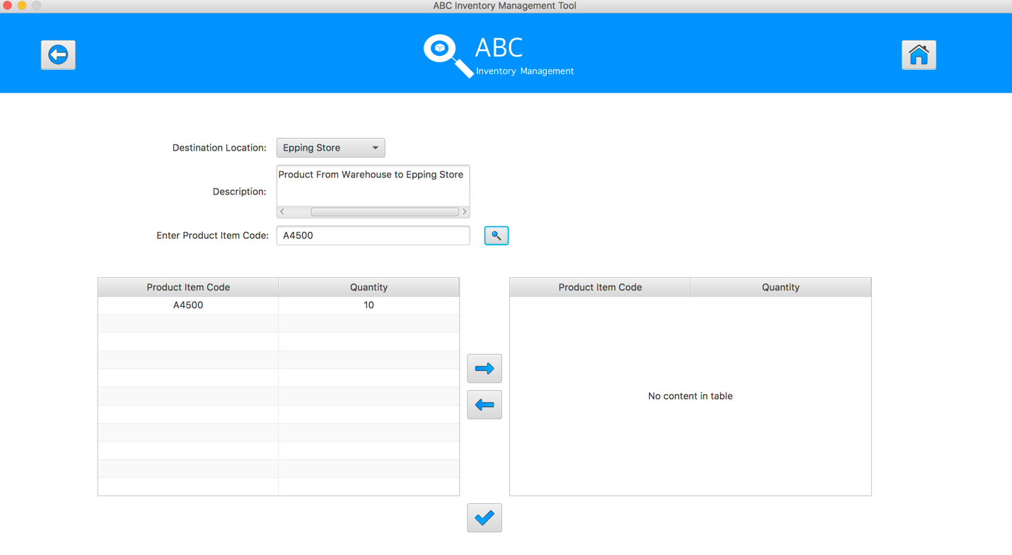
Step 5
Select the product item code in the table on the left
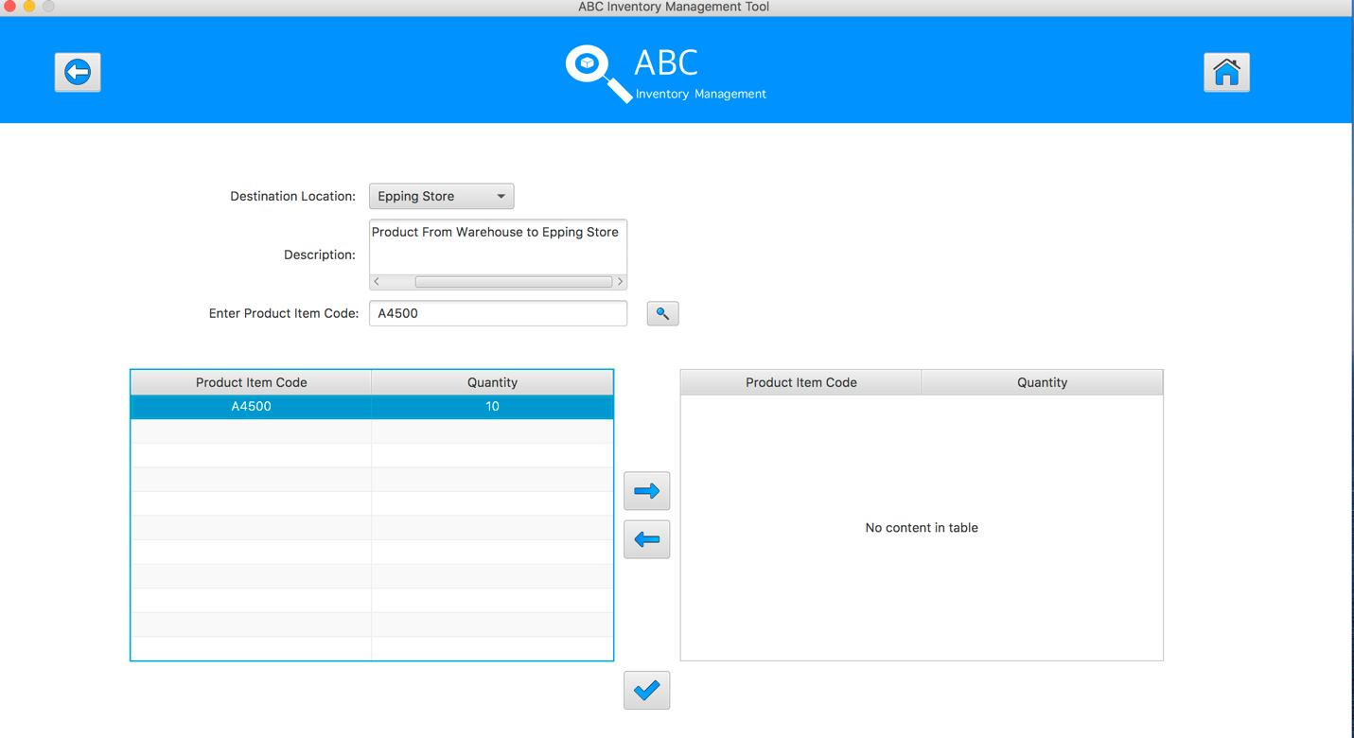
Step 6
Click on the “Add To Cart” Button
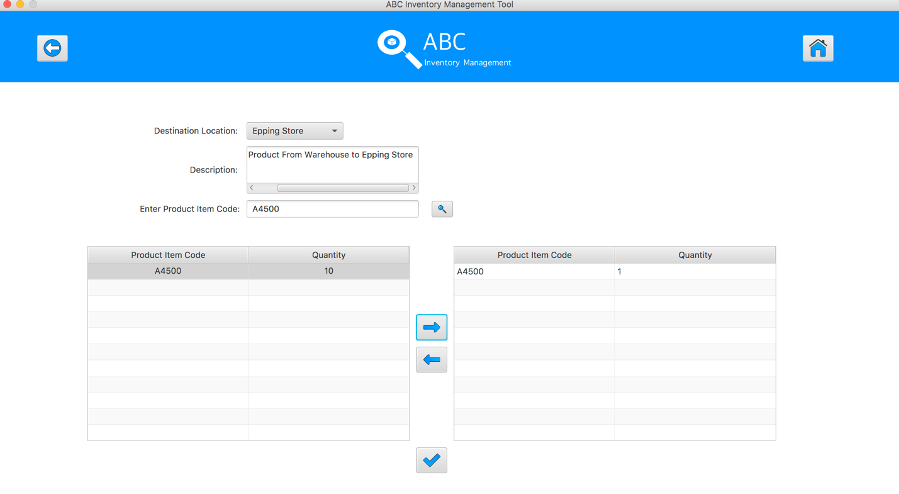
Step 7
Double click to the quantity cell in selected cart table
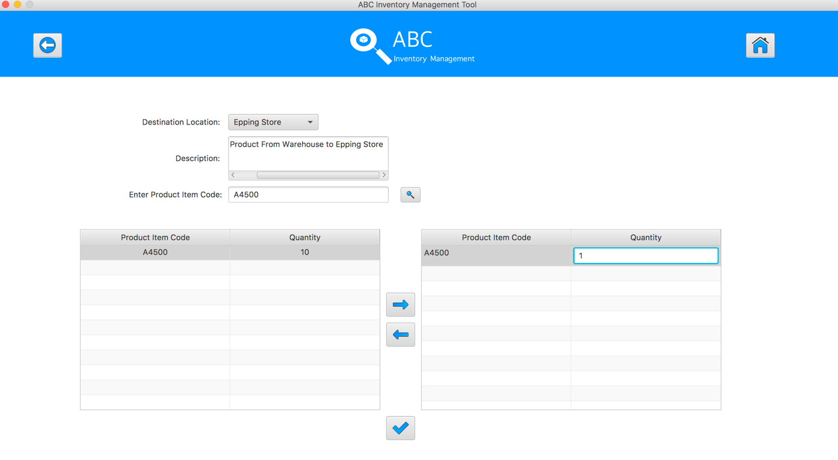
Step 8
Enter the desirable number
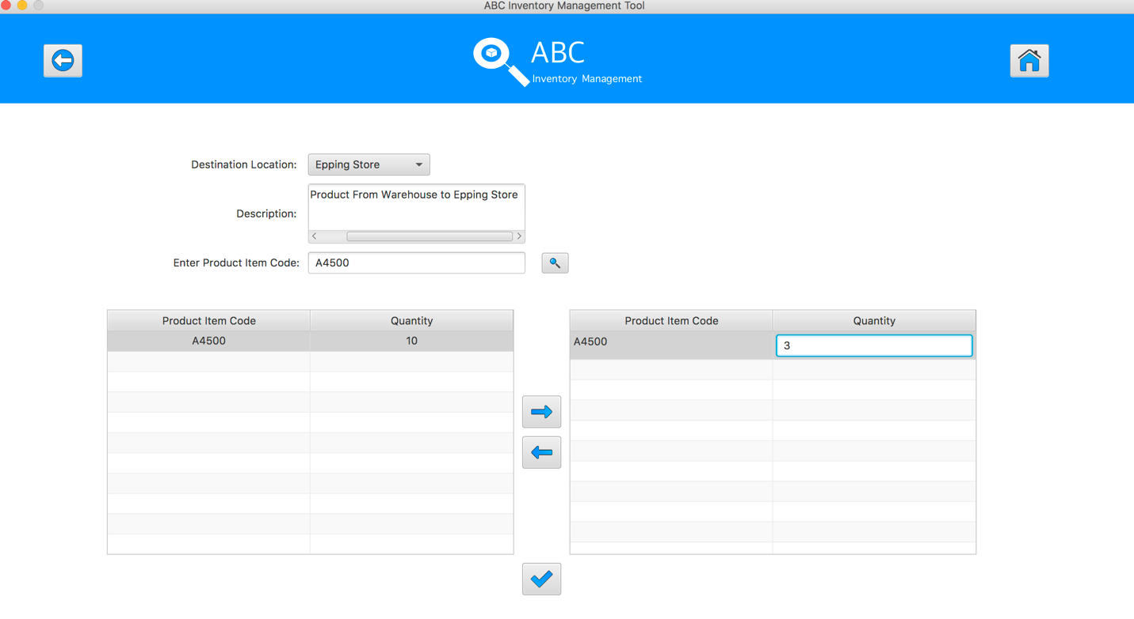
Step 9
Hit enter key to confirm this edited quantity
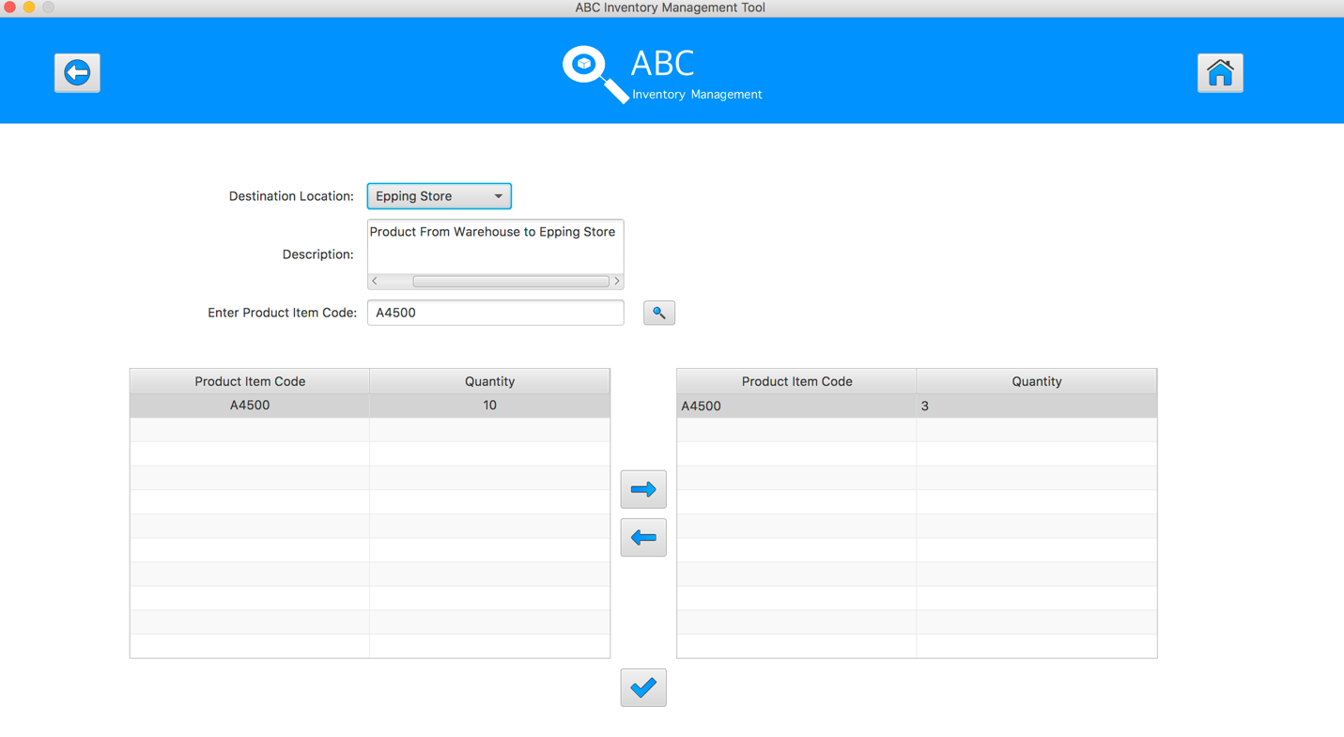
Step 10
Enter the product item code in search field and hit search button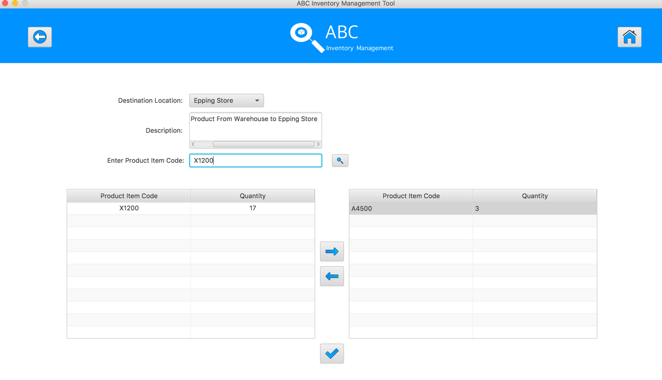

Step 11
Select the product item code in the table on the left

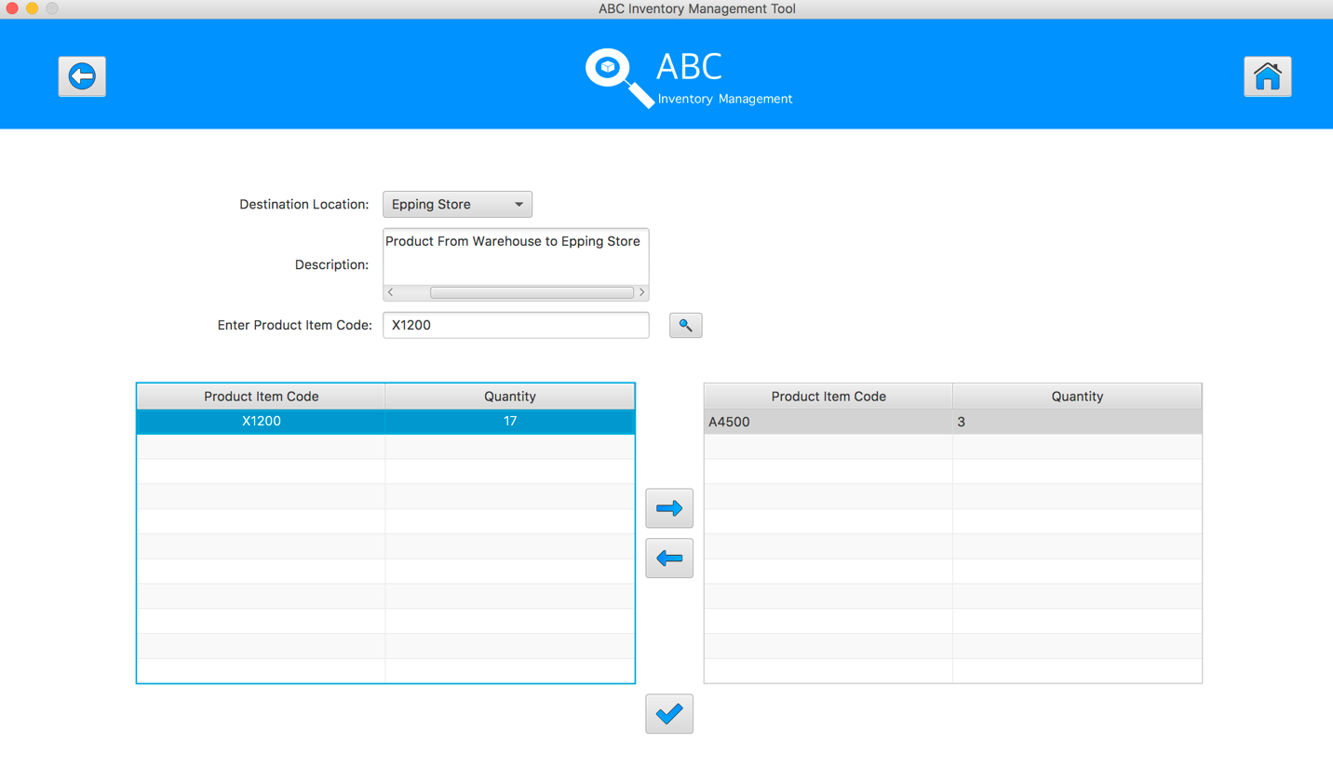
Step 12
Click on the “Add To Cart” Button

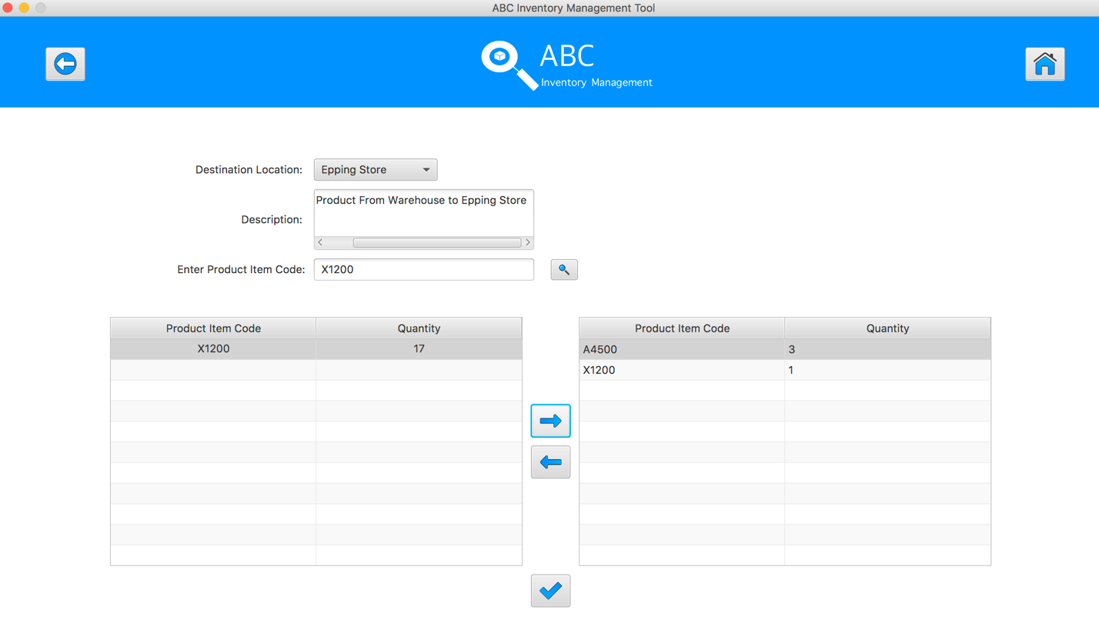
Step 13
Double click to the quantity cell in selected cart table
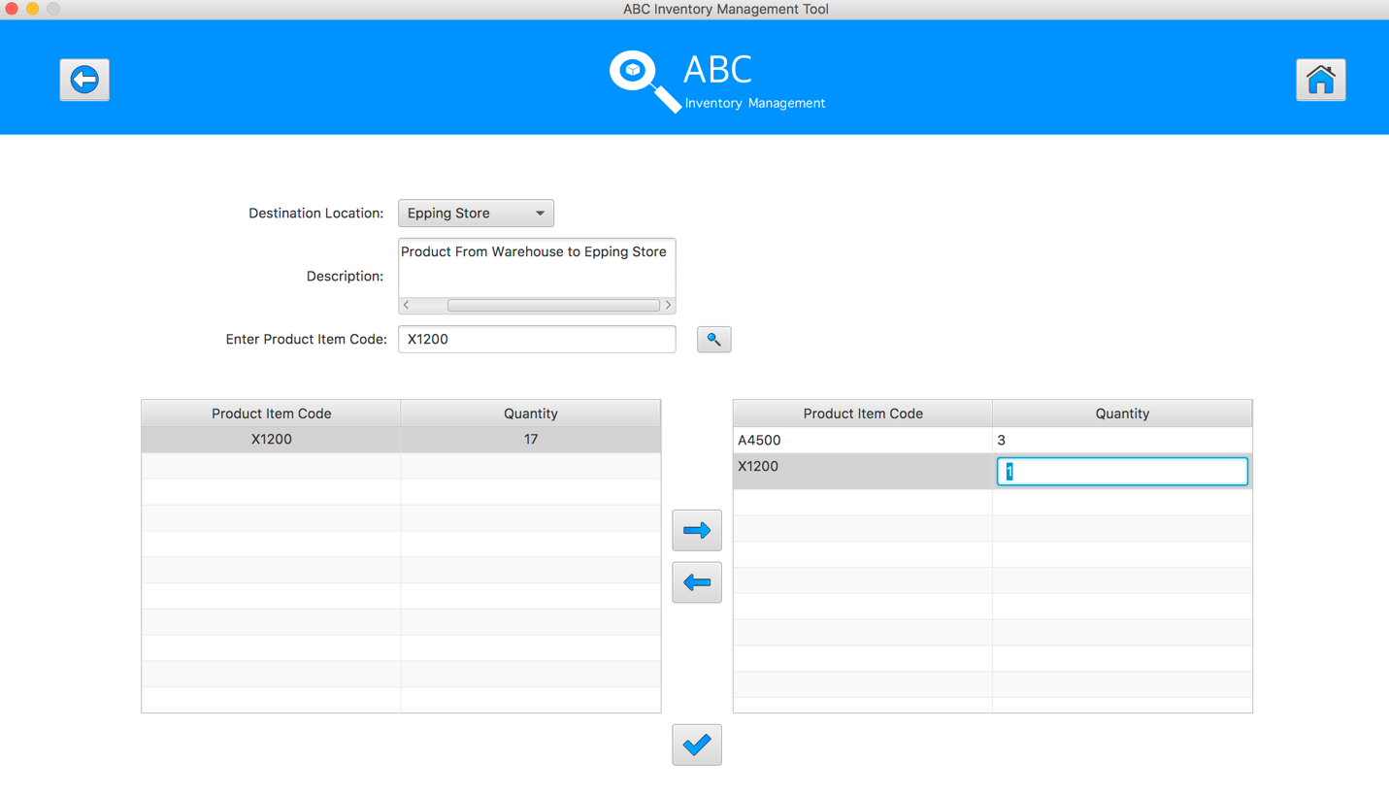
Step 14
Enter the desirable number
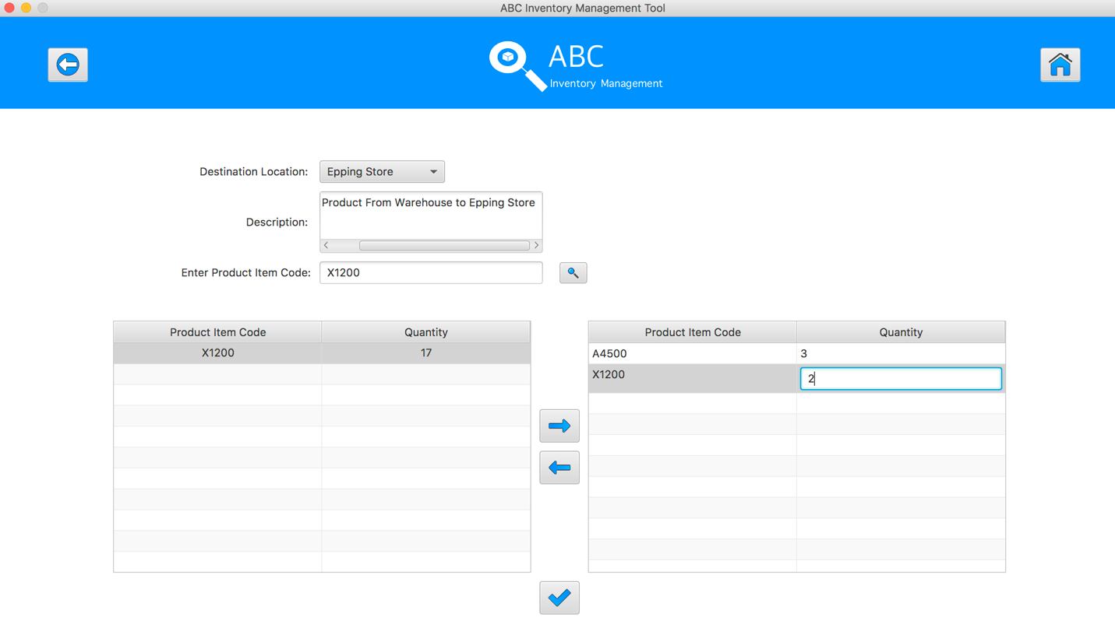
Step 15
Hit enter key to confirm this edited quantity
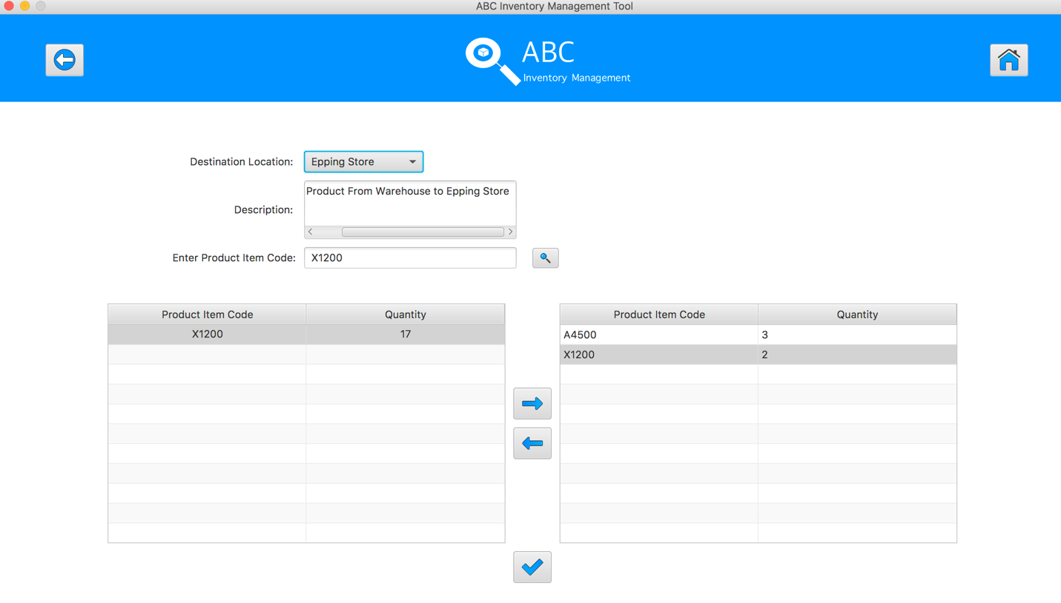
Step 16
Enter the product item code in search field and hit search button
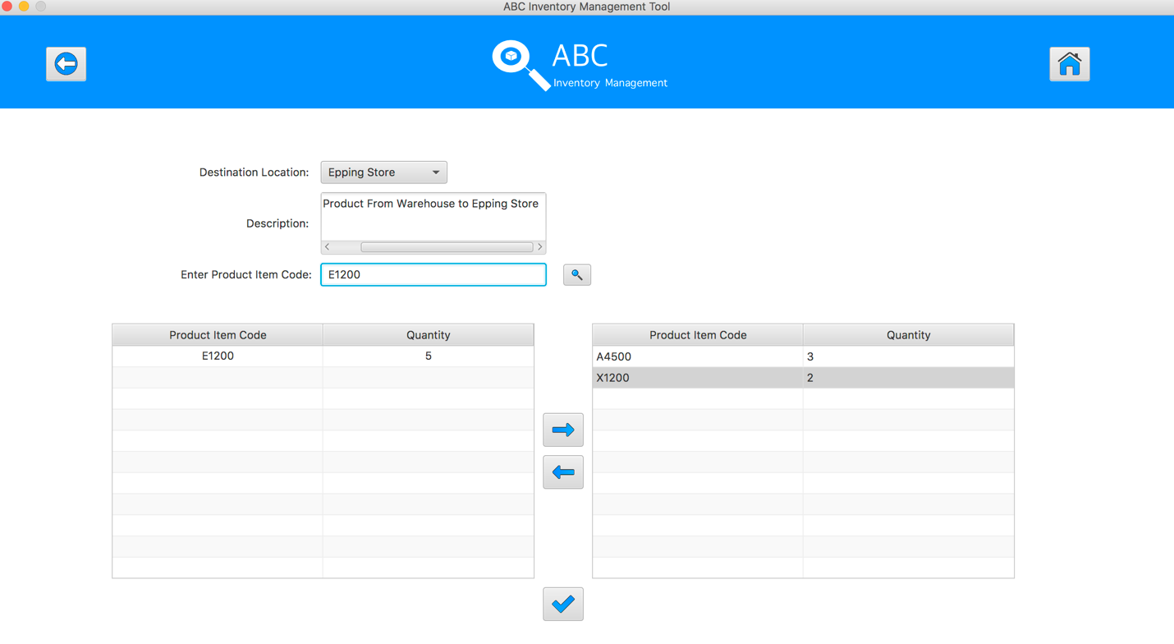
Step 17
Select the product item code in the table on the left

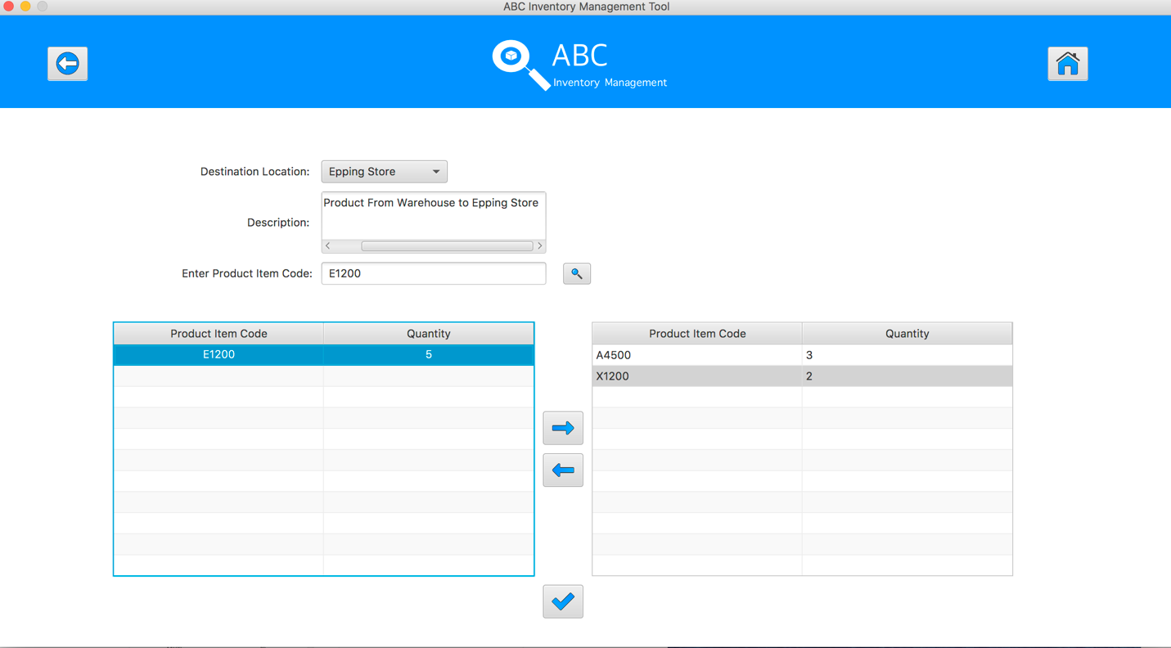
Step 18
Click on the “Add To Cart” Button
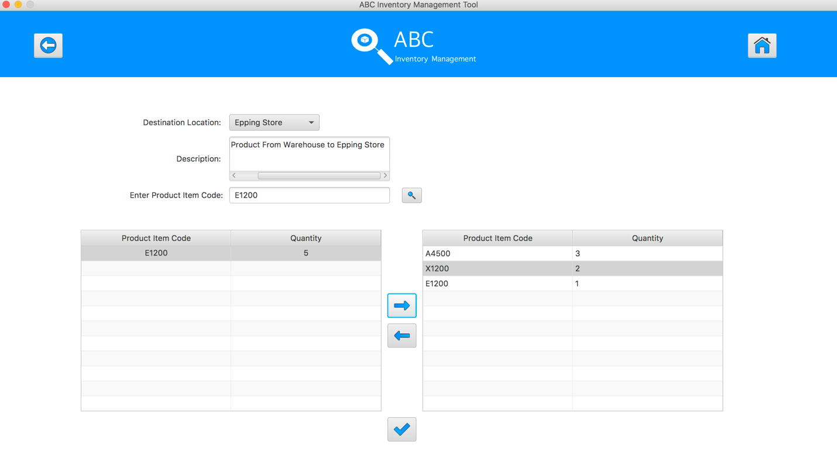
Step 19
Double click to the quantity cell in selected cart table

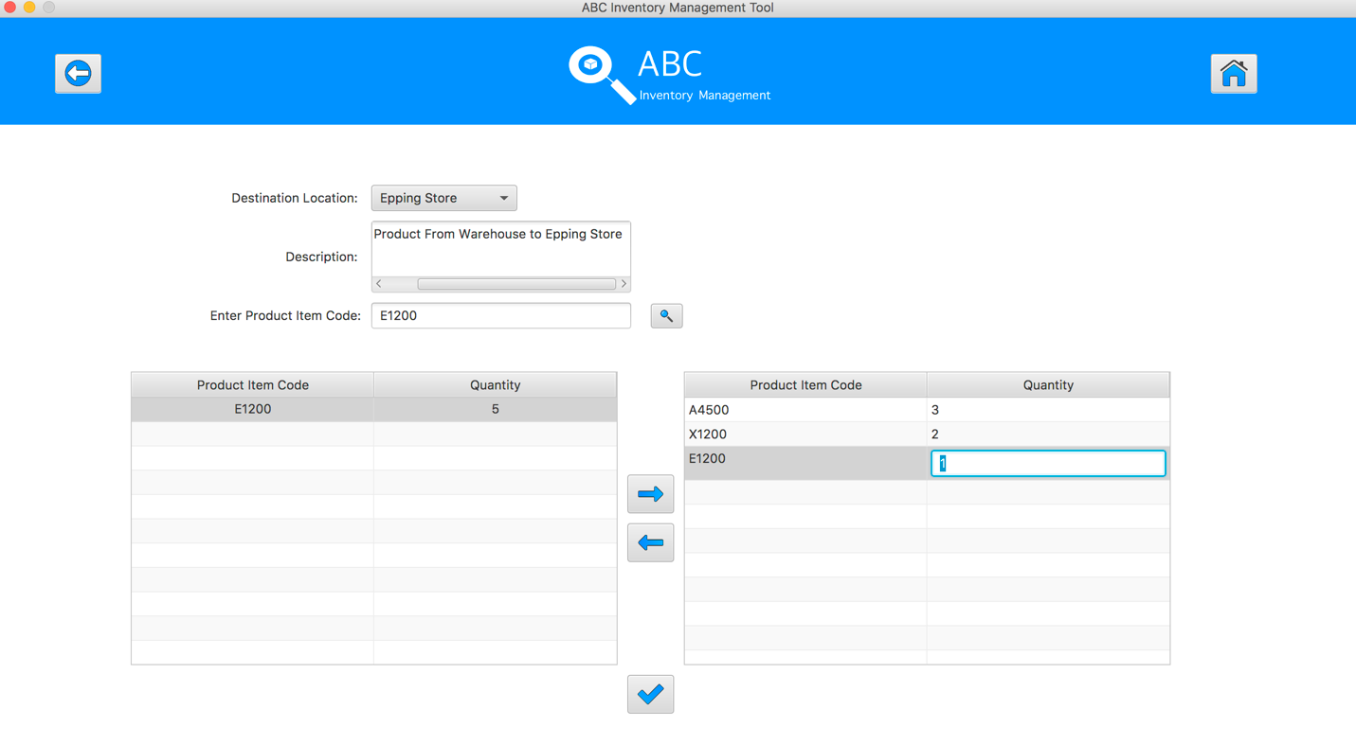
Step 20
Enter the desirable number
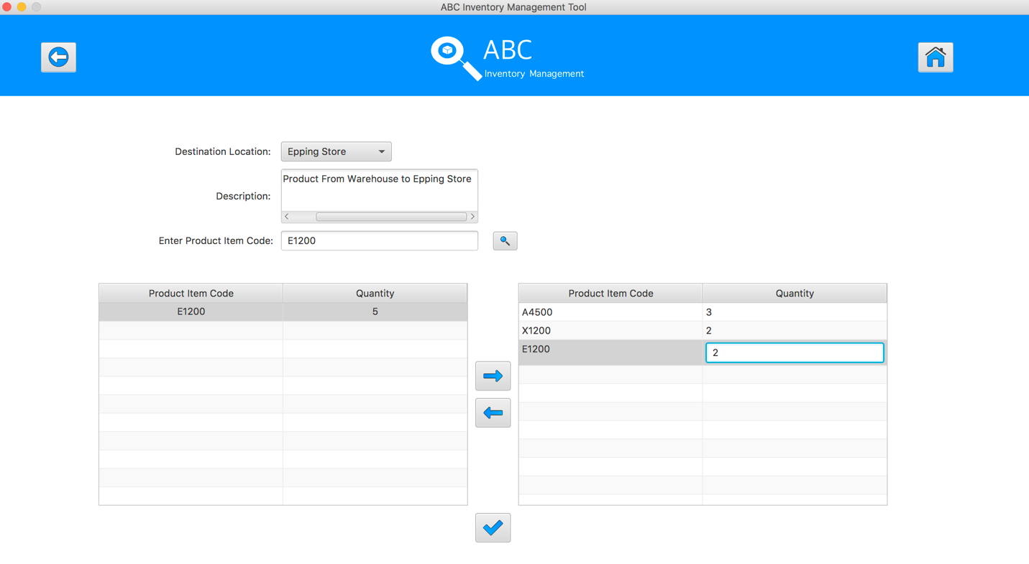
Step 21
Hit enter key to confirm this edited quantity
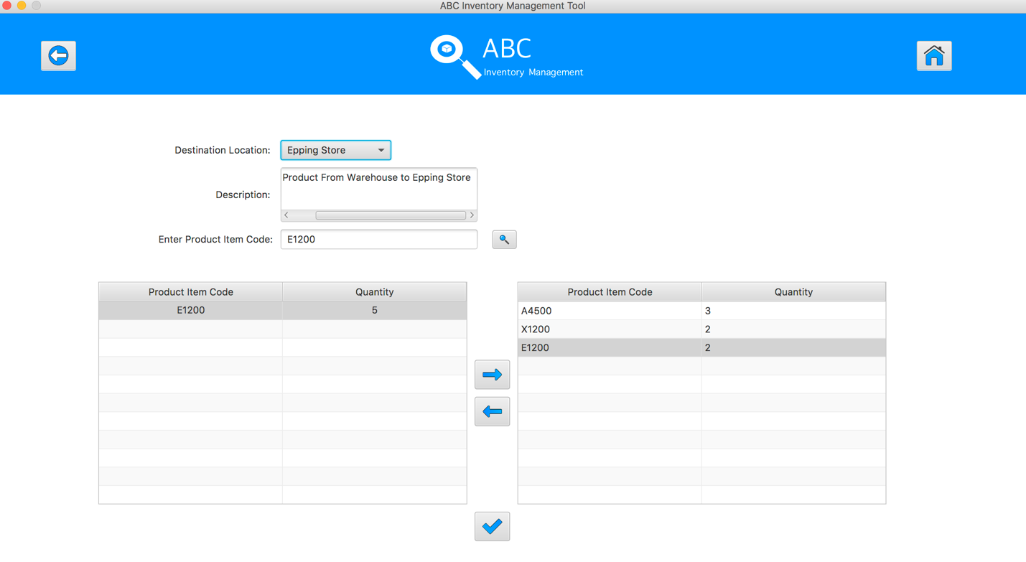
Step 22
After added the desirable items, hit the “Send Product” Button 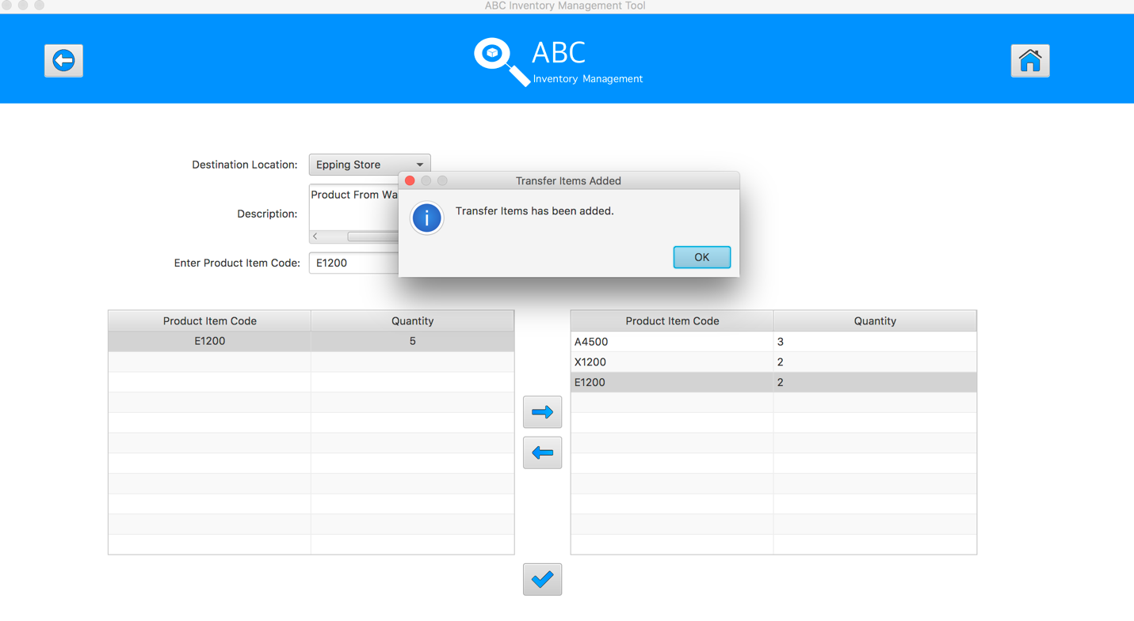
Step 23
Reset the interface for working with new transfer.

SPT003 – Test Send Correct Quantity Of Product By Searching Known Product Item Code To The Destination for Data Set 2: PASS

SPT004 - Send Correct Quantity Of Product By Searching Unknown Product Item Code To The Destination
Test Name |  | Send Correct Quantity Of Product By Searching Unknown Product Item Code To The Destination (Test Case SPT004)
Use Case Tested |  | Send Product
Test Description |  | This test tests if the system can search the unknown product item code, an alert will be displayed if product does not exist in current location.
Pre-Conditions |  | Meta data must exist, product and product details like product item code, location ID and product quantity.
Post-Conditions |  | Appropriate Alert Message is displayed.
Notes |  | This test assumes that the user does not know the destination name, product item code.
Result (Pass/Fail/Warning/ Incomplete) |  | Pass
 | Test Step |  | Expected Test Results | P | F
1. | Select Send Product Button from home page |  | Display the Send Product page | P
2. | Select the destination location |  | Destination location combo box changes to the selected location name | P
3. | Enter the description for this transfer |  | Description text area displays user inputs | P
4. | Enter the unknown product item code in search field and hit search button |  | System display the alert message to notify user that the product does not exist in current location | P

Data Set 1
Test Data Table
Destination Location | Oxford Store
Description | Send Product From Warehouse to Oxford Store
Product Item Code | S2100 | abc | 2300
Quantity | N/A | N/A | N/A

Result Screenshots
The screenshots of the result on each test step for each data set are given below:

Step 1
Select the destination location
Step 2
Enter the description for this transfer
Step 3
Select the product item code in the table on the left
Step 4
Enter the product item code in search field and hit search button, an alert message will be displayed.
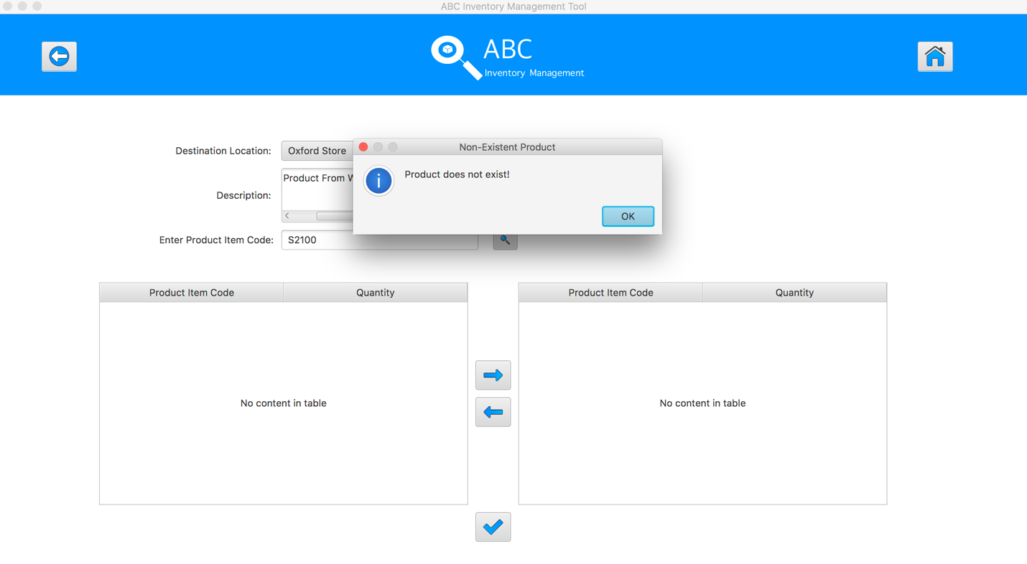

Step 5
Enter the product item code in search field and hit search button, an alert message will be displayed.
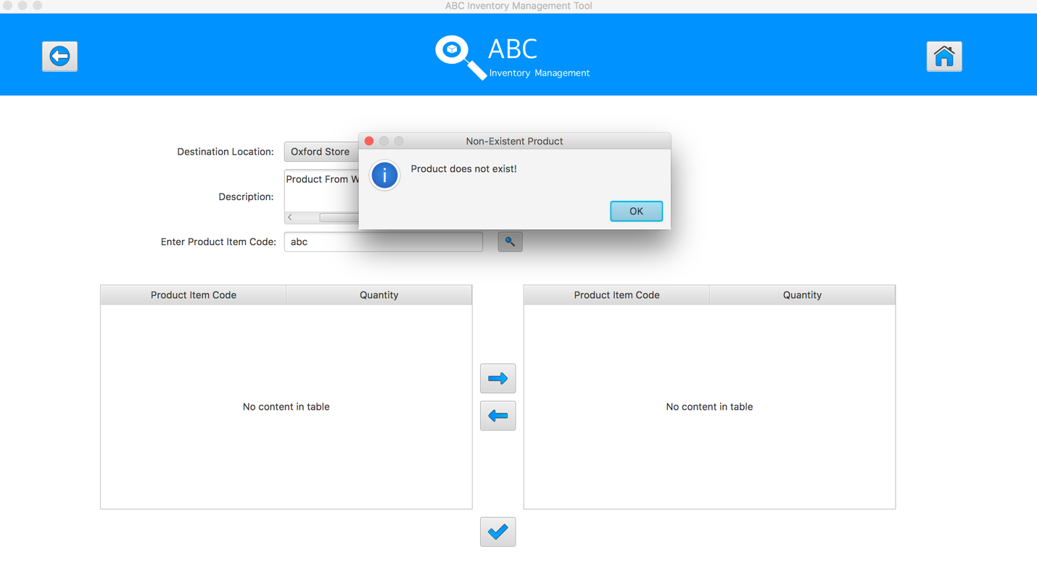

Step 6
Enter the product item code in search field and hit search button, an alert message will be displayed.
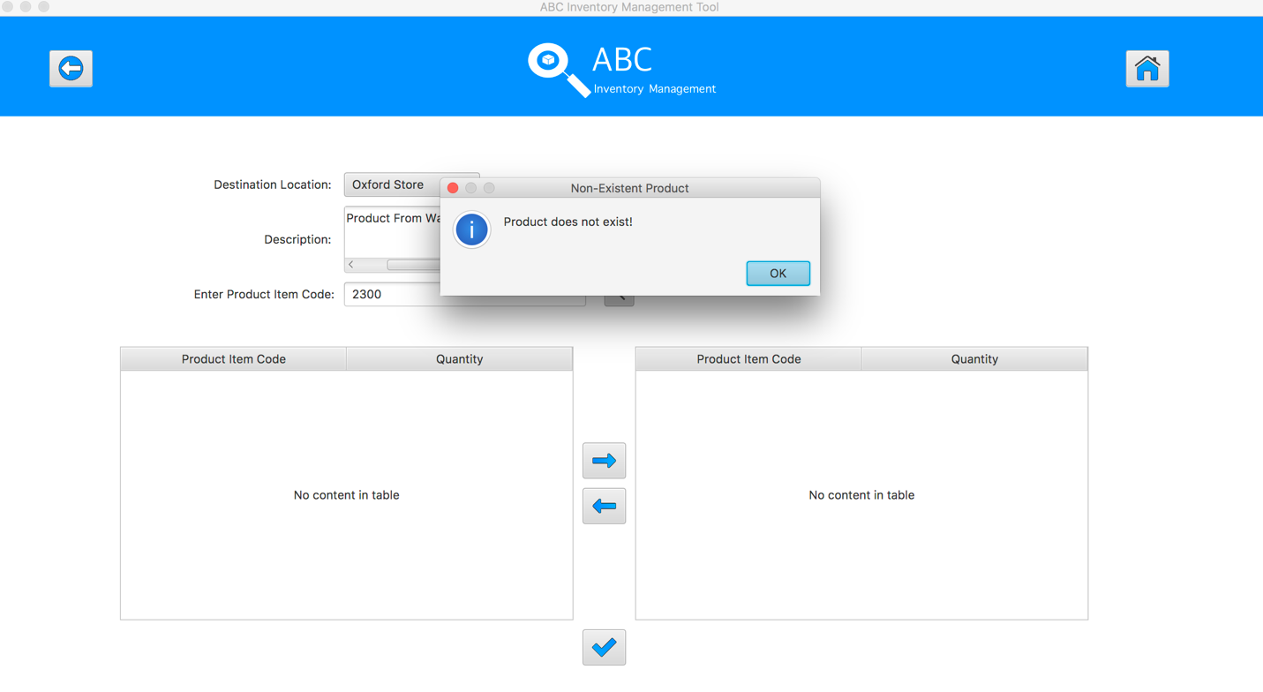
SPT004 – Send Correct Quantity Of Product By Searching Unknown Product Item Code To The Destination for Data Set 1: PASS

Data Set 2
Test Data Table
Destination Location | Epping Store
Description | Send Product From Warehouse to Epping Store
Product Item Code | -345 | SA222 | “leave blank”
Quantity | N/A | N/A | N/A

Result Screenshots
The screenshots of the result on each test step for each data set are given below:

Step 1
Select the destination location
Step 2
Enter the description for this transfer
Step 3
Select the product item code in the table on the left
Step 4
Enter the product item code in search field and hit search button, an alert message will be displayed.
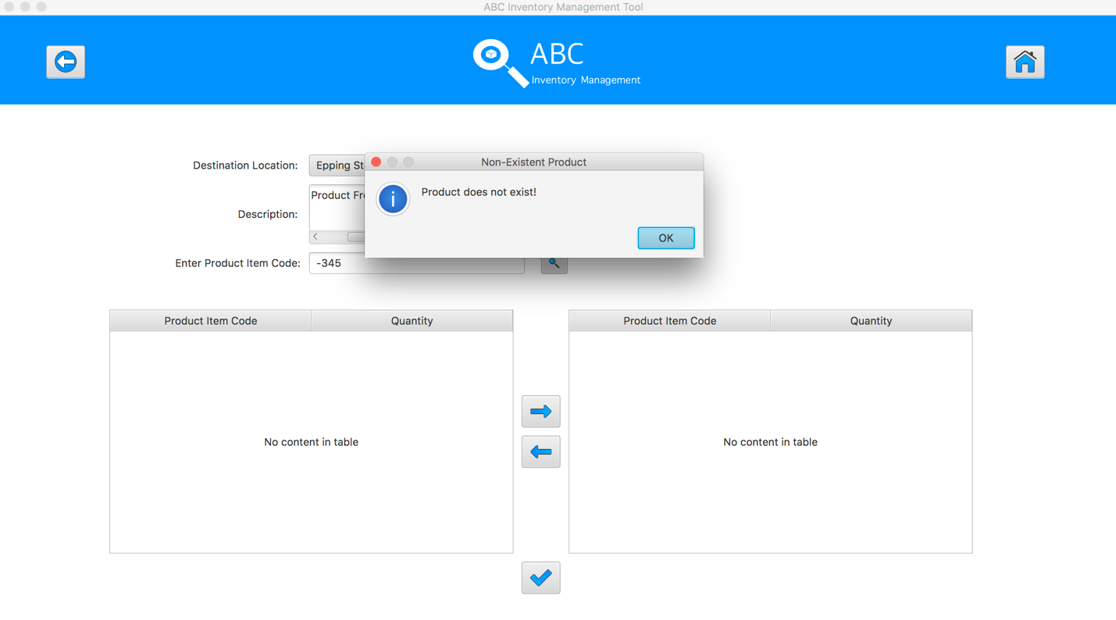

Step 5
Enter the product item code in search field and hit search button, an alert message will be displayed.
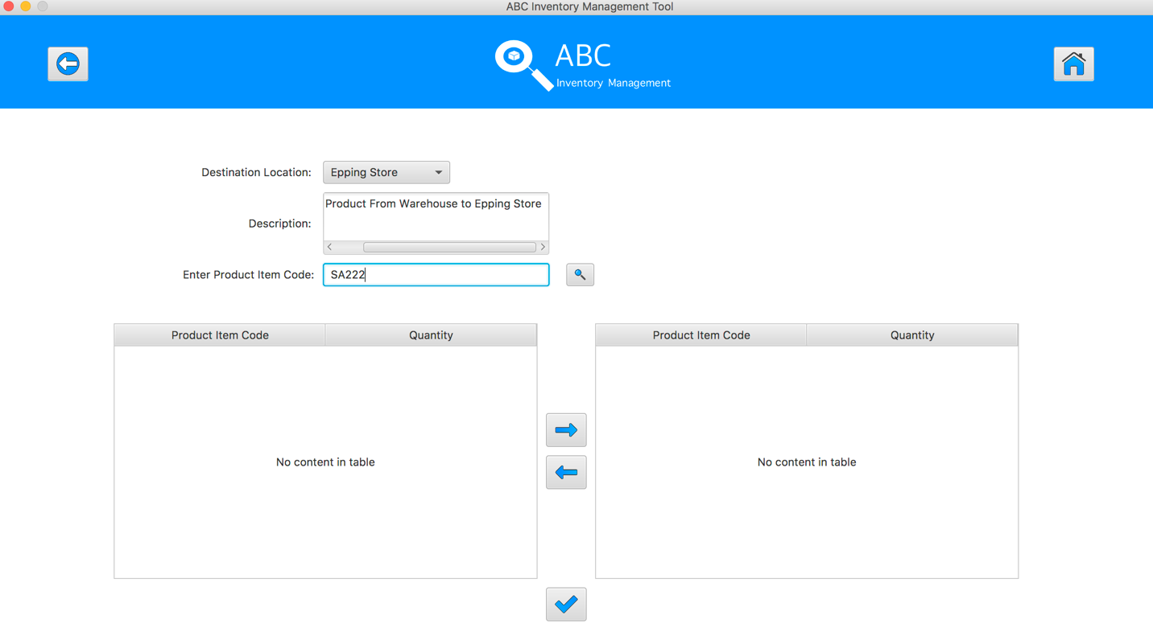

Step 6
Does not enter anything in search field and hit search button, the system will show all the products of sending location.
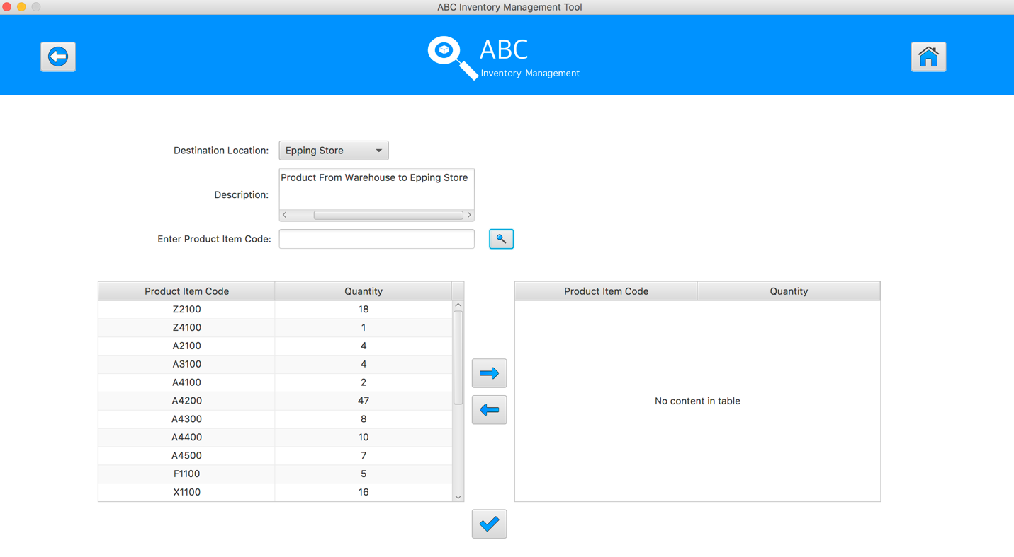
SPT004 – Test Send Correct Quantity Of Product By Searching Unknown Product Item Code To The Destination for Data Set 2: PASS

SPT005 – Send Duplicate Product To The Destination
Test Name |  | Send Duplicate Product To The Destination (Test Case SPT005)
Use Case Tested |  | Send Product
Test Description |  | This test tests if the system can send duplicate product items and its normal quantity in current location to destination location.
Pre-Conditions |  | Meta data must exist, product and product details like product item code, location ID and product quantity.
Post-Conditions |  | Sending Products should be sent to the destination, the status of transfer change to “Sending” to wait for the receiver accept it, the quantity of sending product from sending location should be reduced. Appropriate Alert message is displayed for the duplicate product when adding to the cart table.
Notes |  | This test assumes that the user knows the destination name, product item code.
Result (Pass/Fail/Warning/ Incomplete) |  | Pass
 | Test Step |  | Expected Test Results | P | F
1. | Select Send Product Button from home page |  | Display the Send Product page
2. | Select the destination location |  | Destination location combo box changes to the selected location name | P
3. | Enter the description for this transfer |  | Description text area displays user inputs | P
4. | Select the product item code in the table on the left |  | System waits for hitting the “Add to Cart” Button | P
5. | Click on the “Add To Cart” Button |  | The selected item displayed in the right table (cart table) with default quantity is 1 | P
6. | Double click to the quantity cell in selected cart table |  | System change the cell of double clicked cell to be editable | P
7. | Enter the desirable number |  | System waits for hitting enter key from user. | P
8. | Hit enter key to confirm this edited quantity |  | System waits for adding other product items and hitting the “Send Product” Button | P
9. | Select the same product item code which is added to the cart and add to the cart again |  | System displays an alert message to notify that user cannot add this product to the cart again. | P
10. | After added the desirable items, hit the “Send Product” Button |  | An message pops up to notify that the products in the cart table are sent to the destination.  Reset the interface for working with new transfer. | P

Data Set 1
Test Data Table
Destination Location | Oxford Store
Description | Send Product From Warehouse to Oxford Store
Product Item Code | Z2100 | Z2100
Quantity | 2 | N/a

Result Screenshots
The screenshots of the result on each test step for each data set are given below:

Step 1
Select the destination location
Step 2
Enter the description for this transfer
Step 3
Select the product item code in the table on the left
Step 4
Select the product item code in the table on the left
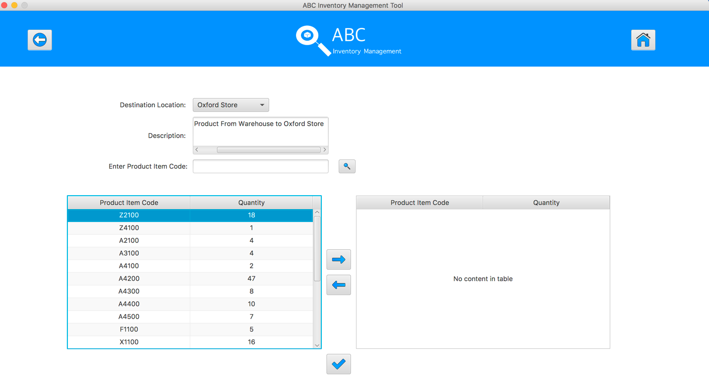
Step 5
Click on the “Add To Cart” Button
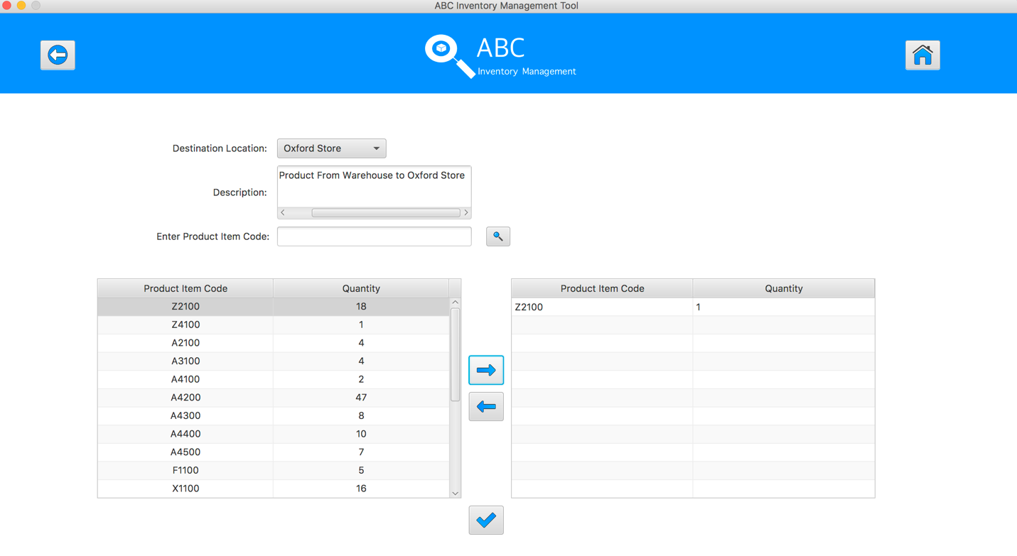
Step 6
Double click to the quantity cell in selected cart table
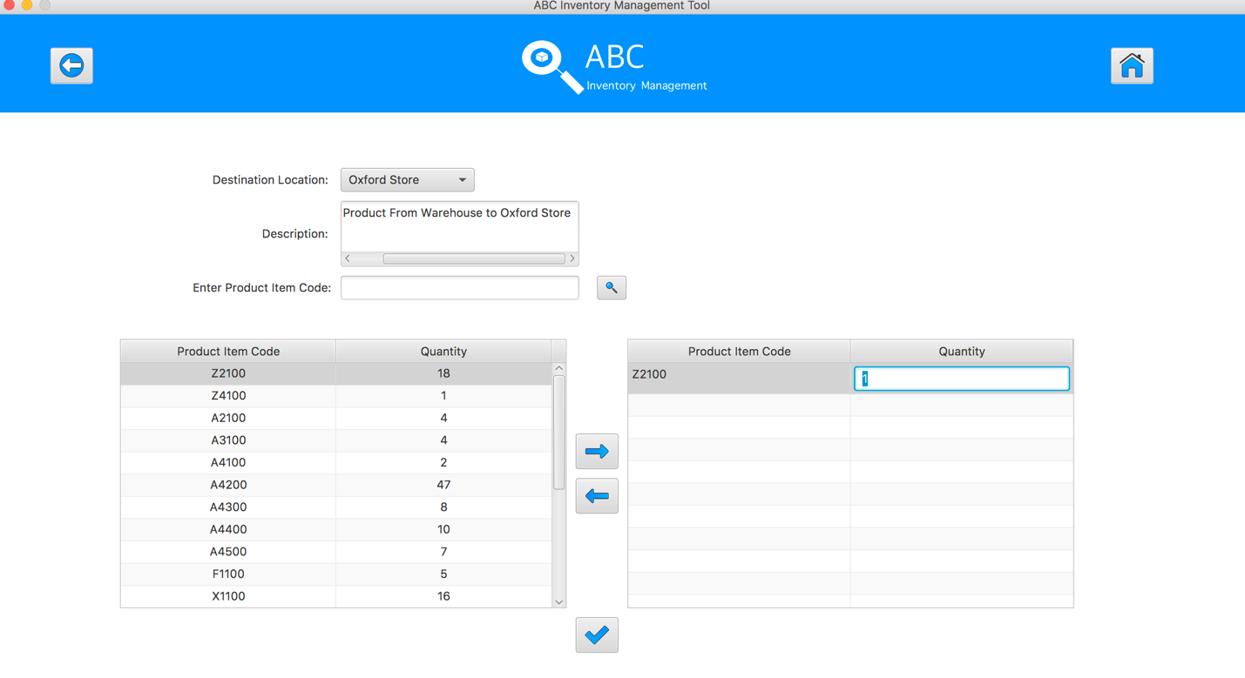
Step 7
Enter the desirable number
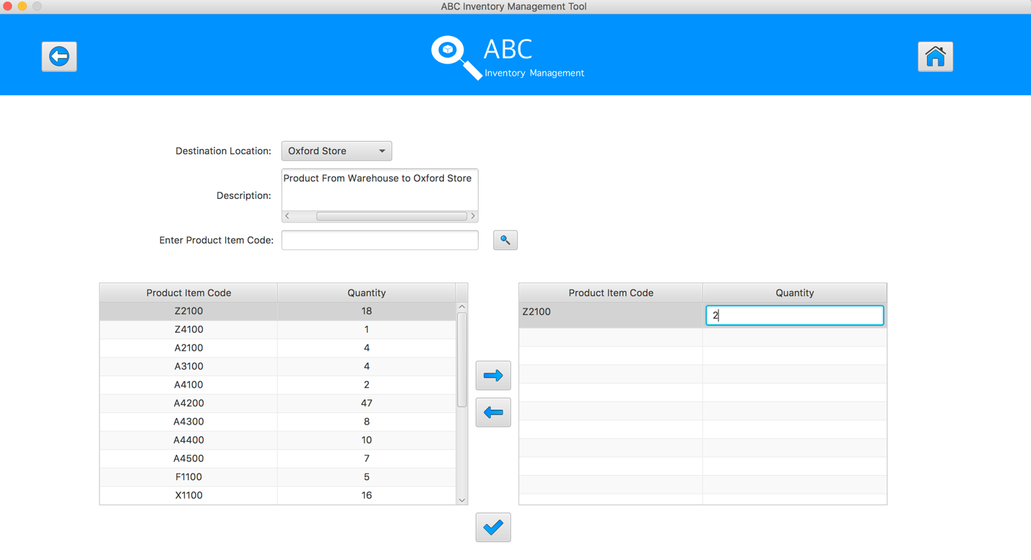
Step 8
Hit enter key to confirm this edited quantity
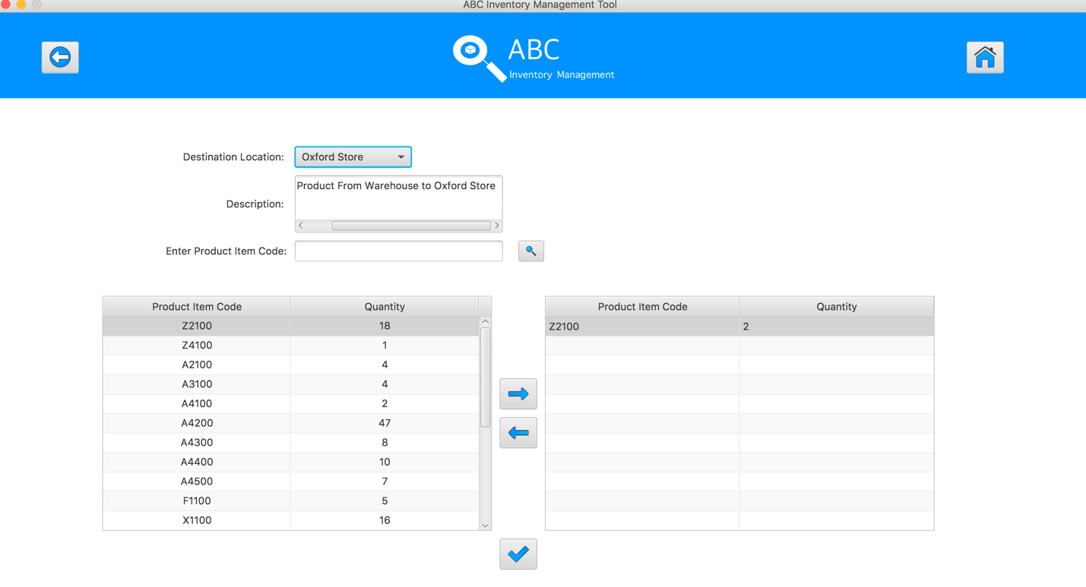
Step 9
Select the same product item code which was added to cart table in the table on the left
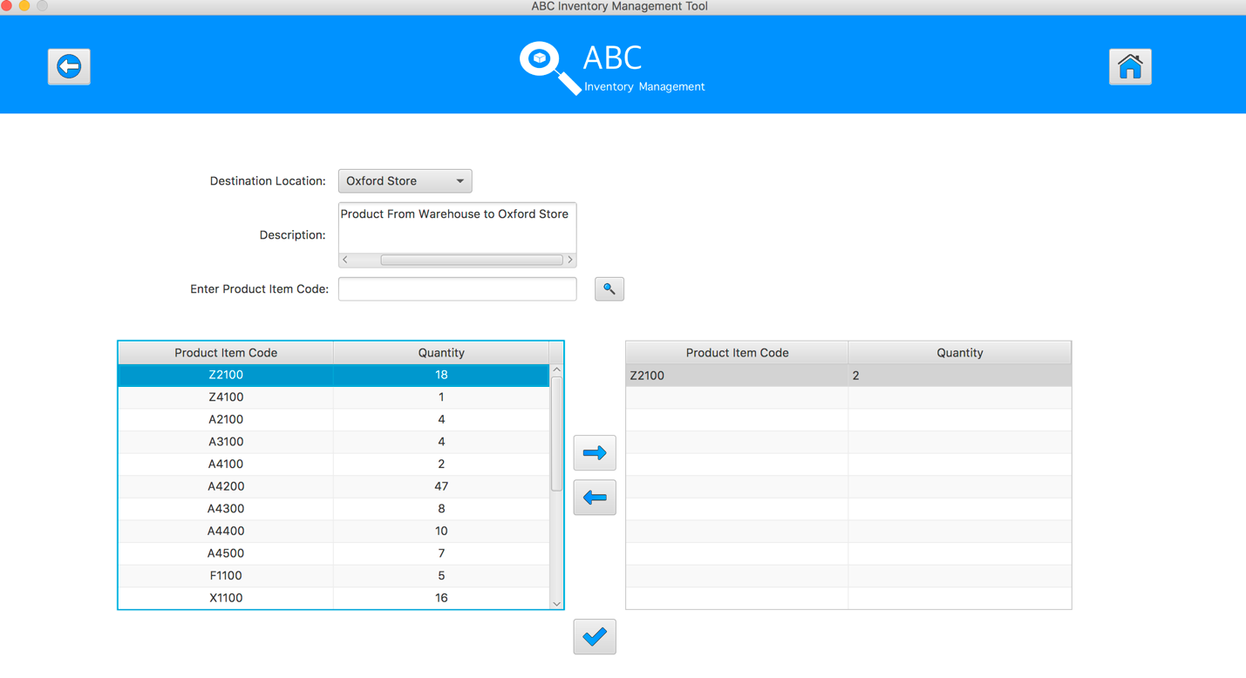
Step 10
System displays an alert message to notify that user cannot add this product to the cart again.
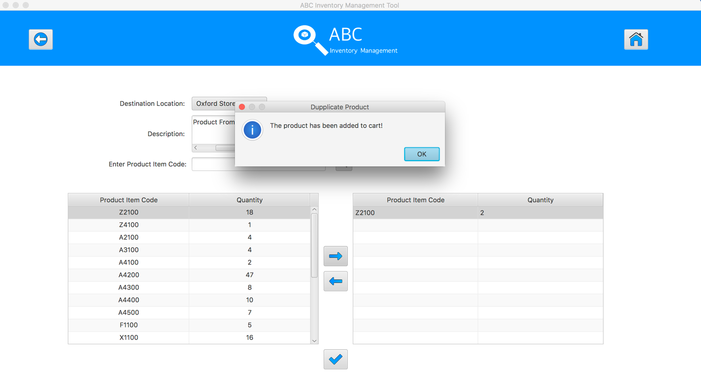
Step 11
After added the desirable items, hit the “Send Product” Button 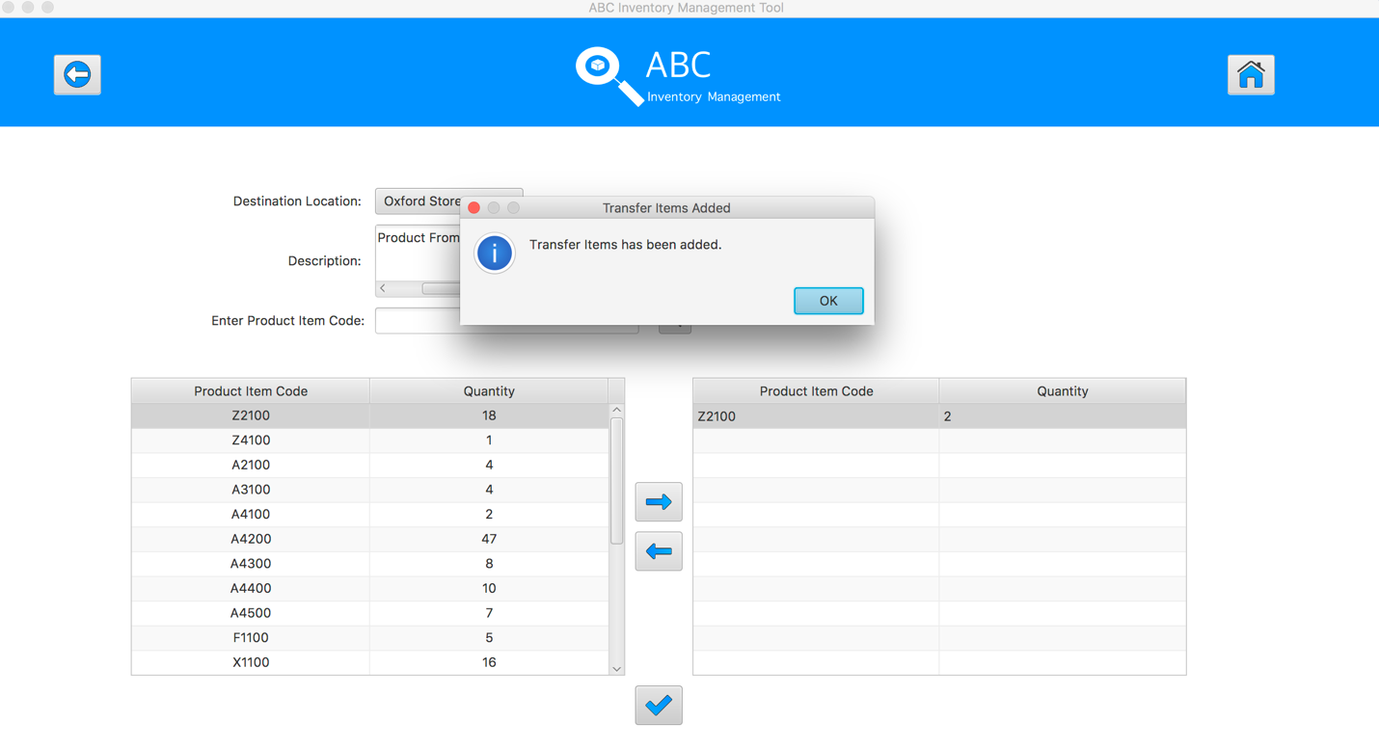
Step 12
Reset the interface for working with new transfer.
SPT005 – Test Send Duplicate Product To The Destination for Data Set 1: PASS

Data Set 2
Test Data Table
Destination Location | Epping Store
Description | Send Product From Warehouse to Epping Store
Product Item Code | A4500 | A4500 | A4200
Quantity | 2 | N/A | 6

Result Screenshots
The screenshots of the result on each test step for each data set are given below:

Step 1
Select the destination location
Step 2
Enter the description for this transfer
Step 3
Select the product item code in the table on the left
Step 4
Select the product item code in the table on the left
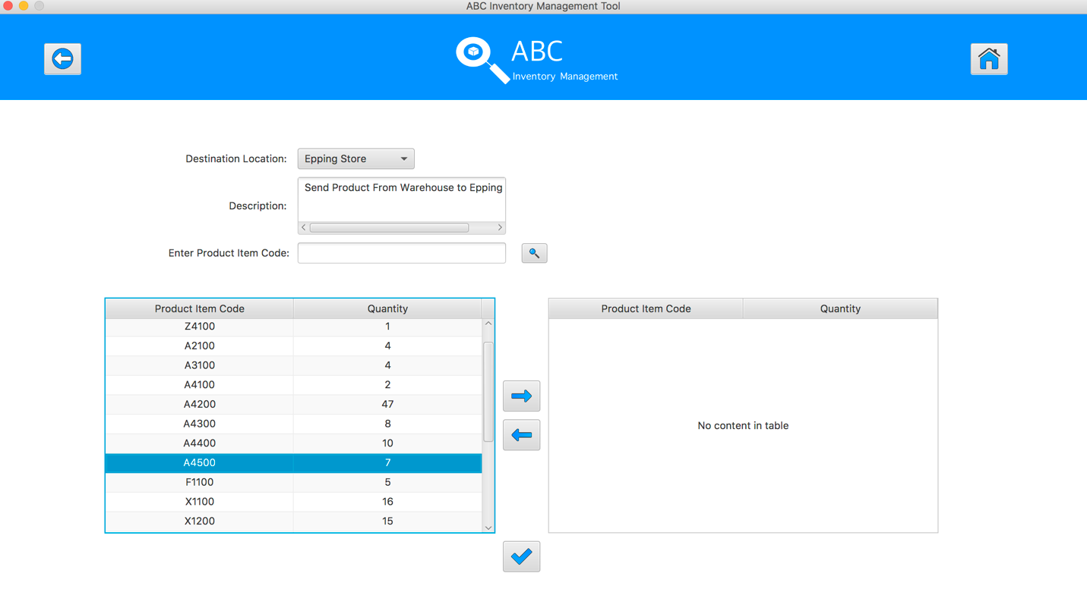
Step 5
Click on the “Add To Cart” Button
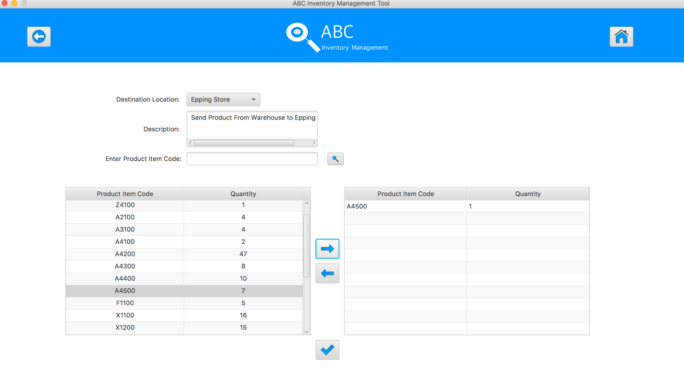
Step 6
Double click to the quantity cell in selected cart table
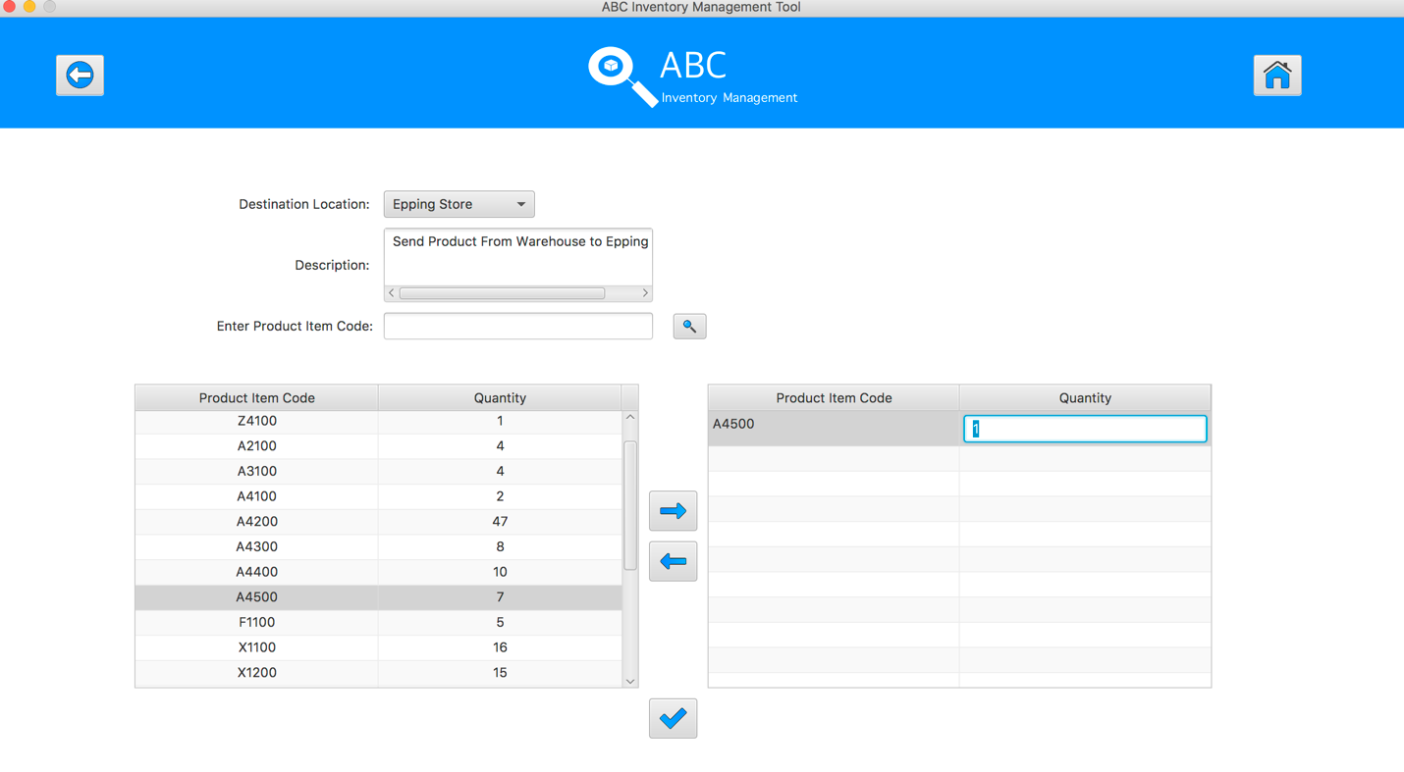
Step 7
Enter the desirable number
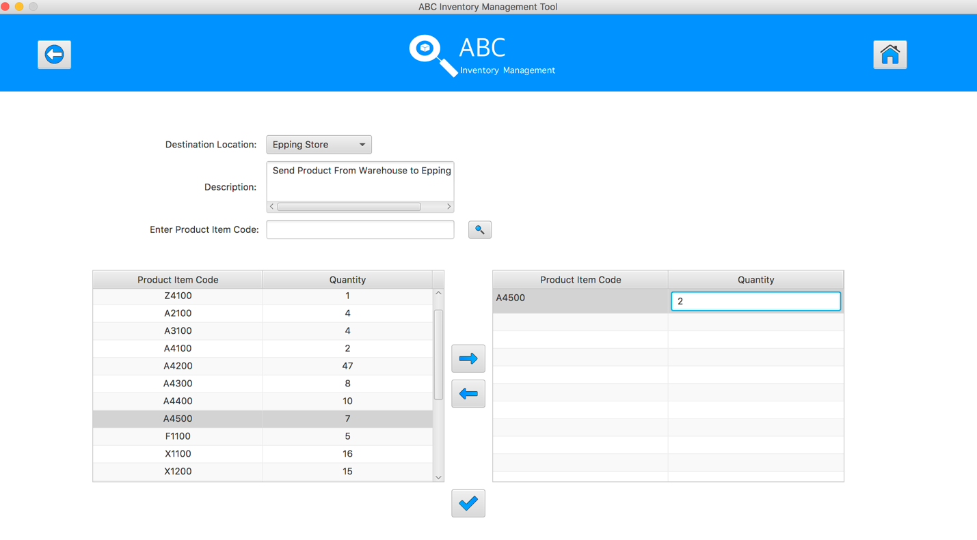
Step 8
Hit enter key to confirm this edited quantity
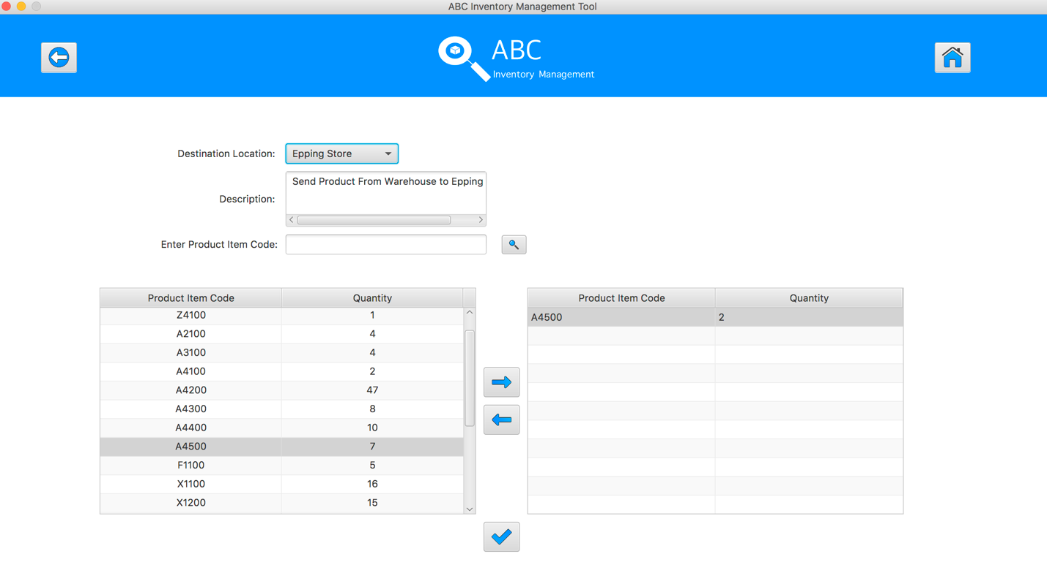
Step 9
Select the same product item code which was added to cart table in the table on the left
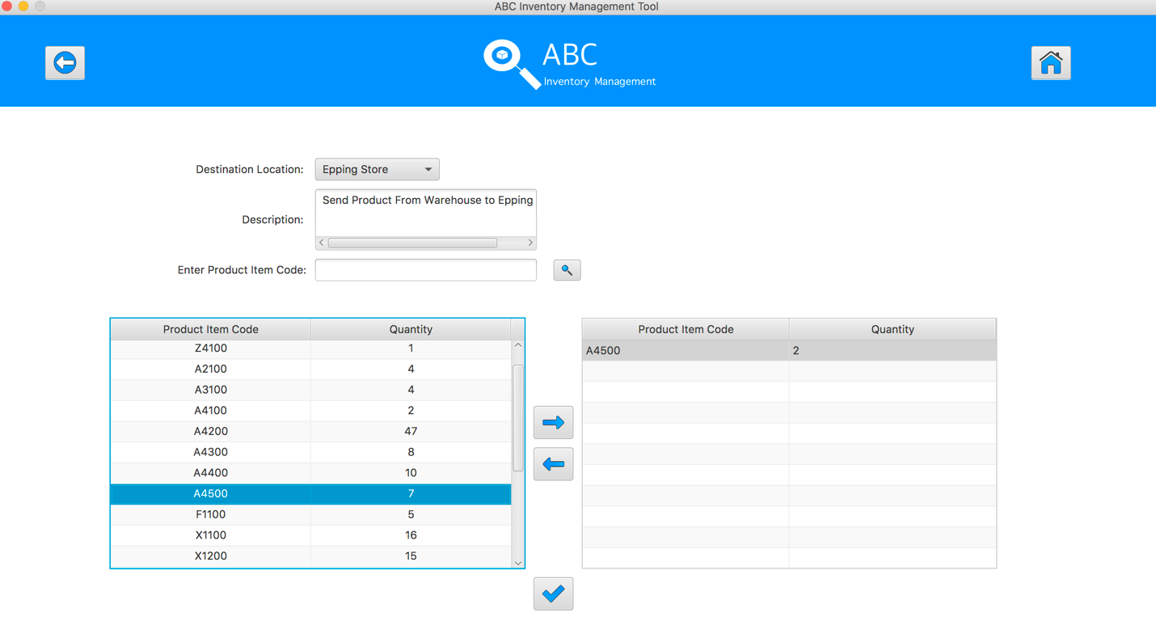
Step 10
System displays an alert message to notify that user cannot add this product to the cart again.
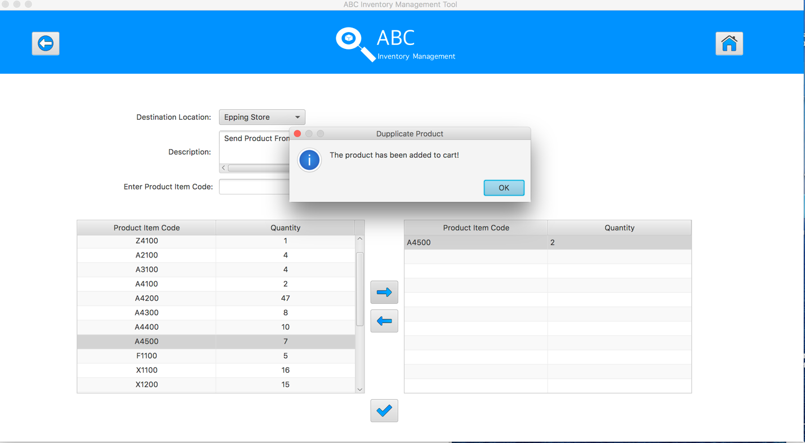

Step 11
Select the product item code in the table on the left
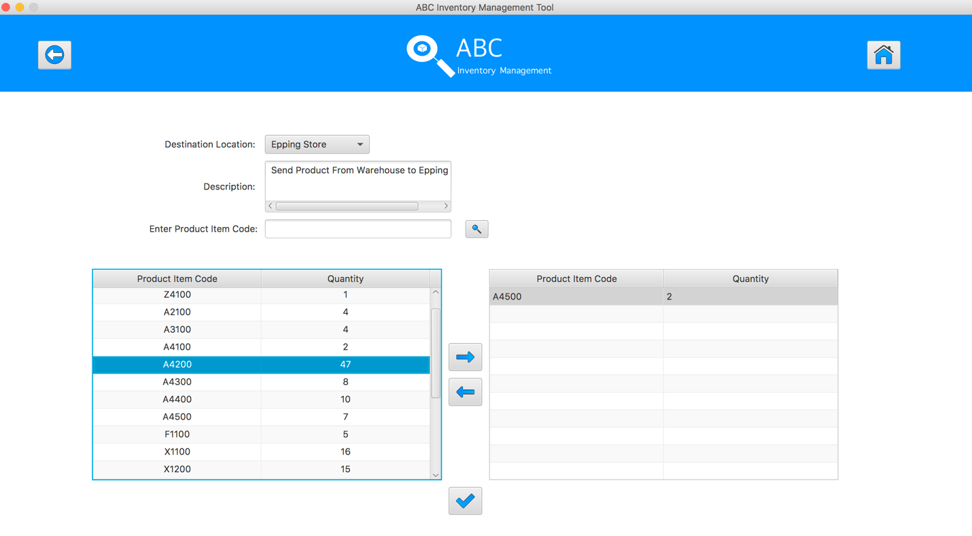
Step 12
Click on the “Add To Cart” Button

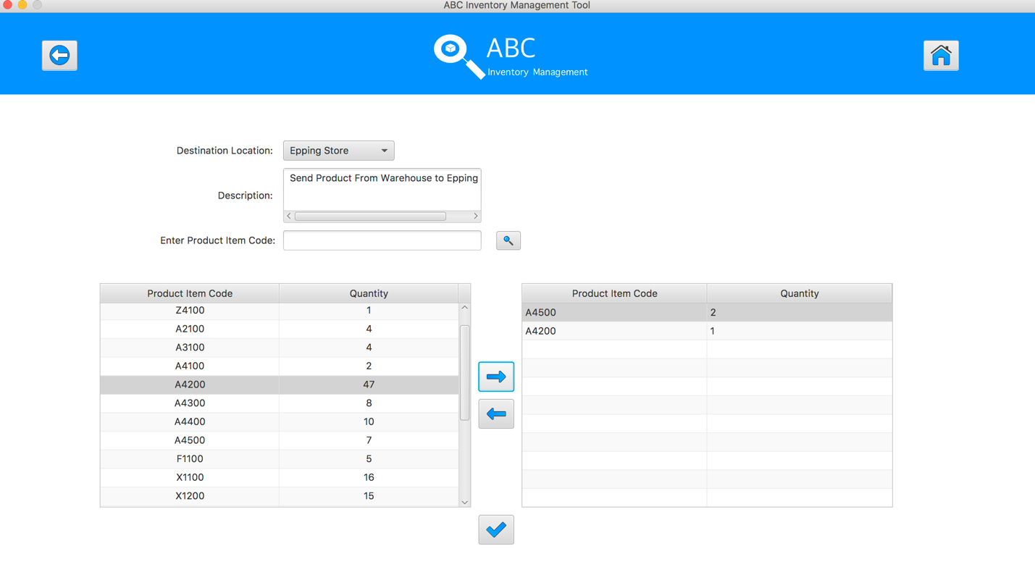
Step 13
Double click to the quantity cell in selected cart table
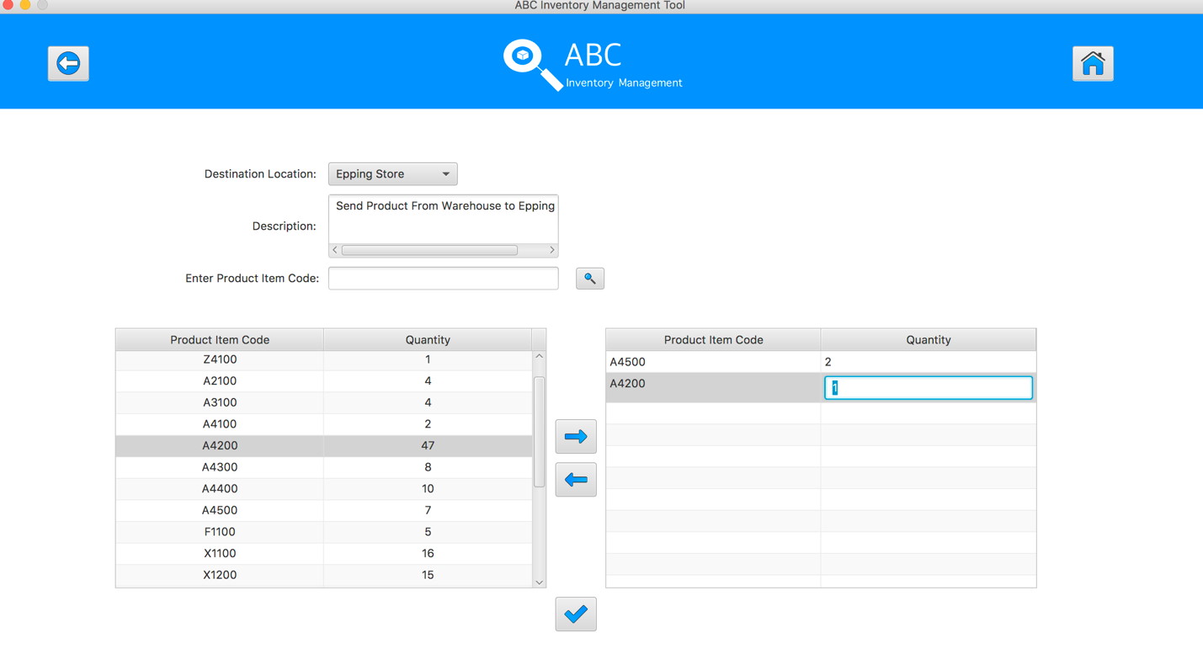
Step 14
Enter the desirable number
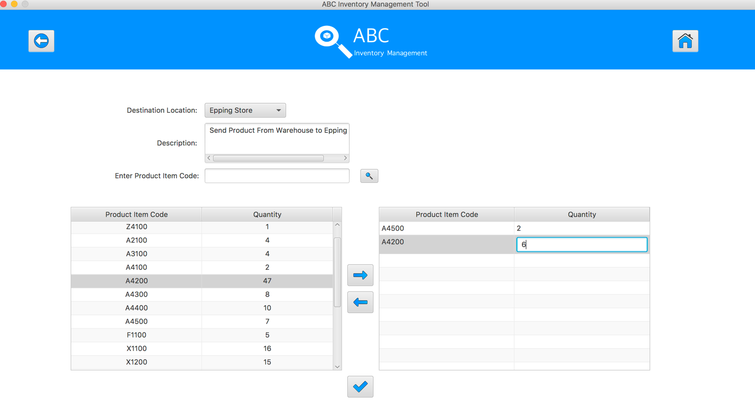
Step 15
Hit enter key to confirm this edited quantity
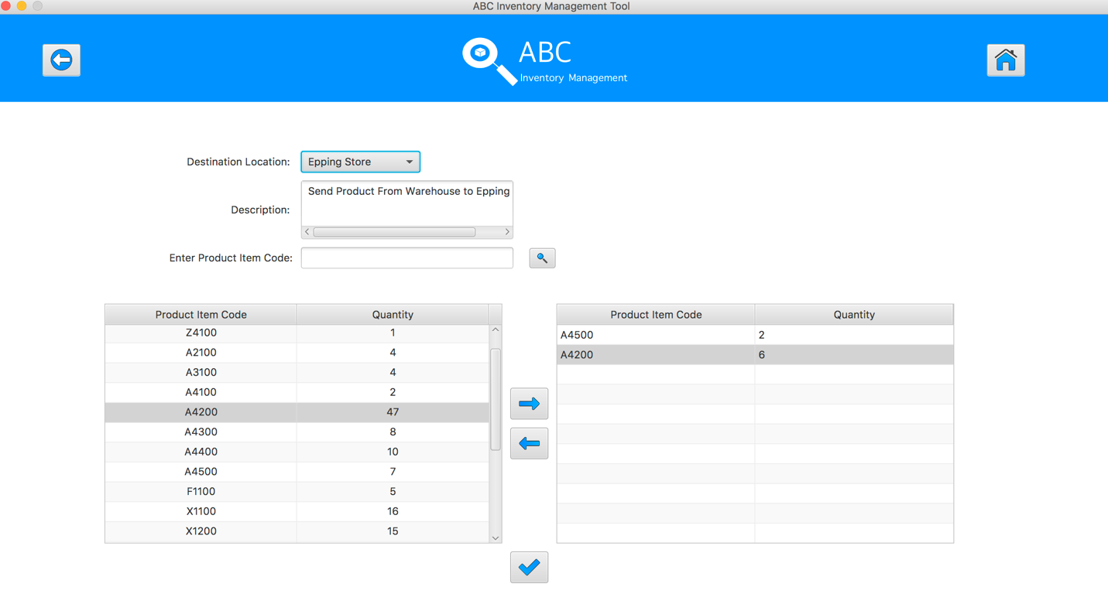
Step 16
After added the desirable items, hit the “Send Product” Button 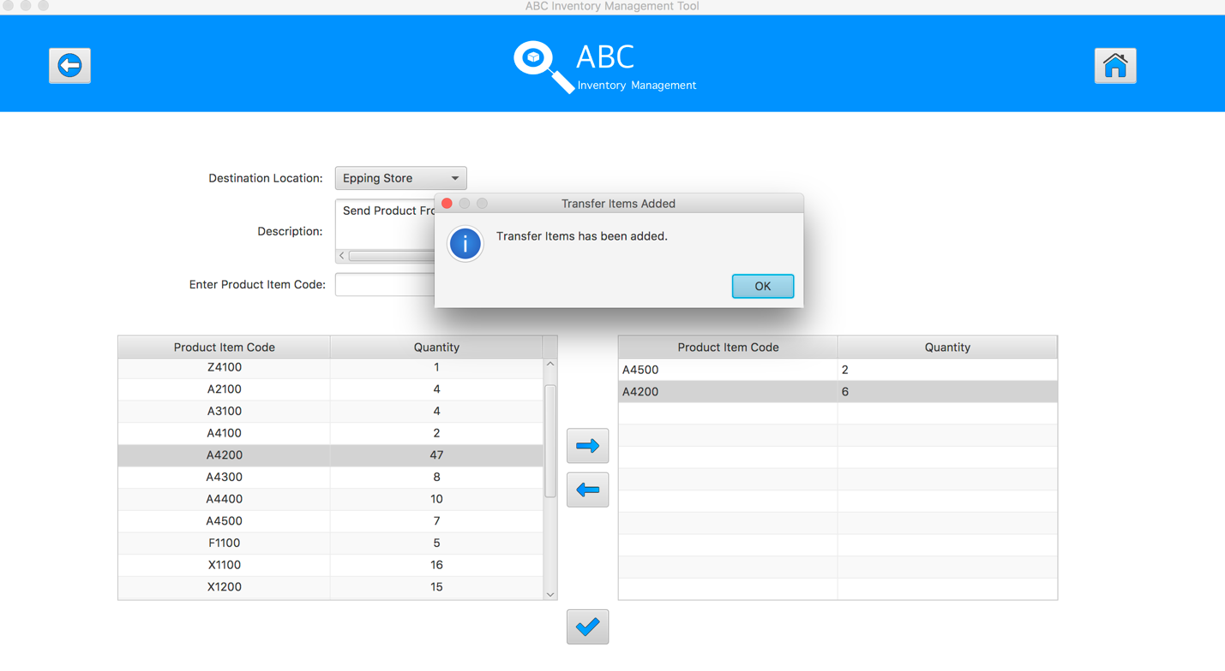
Step 17
Reset the interface for working with new transfer.
SPT005 – Test Send Duplicate Product To The Destination for Data Set 2: PASS

SPT006 – Send Product Without Choosing Destination
Test Name |  | Send Product Without Choosing Destination (Test Case SPT006)
Use Case Tested |  | Send Product
Test Description |  | This test tests if the system can send product and its normal quantity without selecting the destination.
Pre-Conditions |  | Meta data must exist, product and product details like product item code, location ID and product quantity.
Post-Conditions |  | Appropriate Alert message is displayed
Notes |  | This test assumes that the user knows the destination name, product item code.
Result (Pass/Fail/Warning/ Incomplete) |  | Pass
 | Test Step |  | Expected Test Results | P | F
1. | Select Send Product Button from home page |  | Display the Send Product page | P
2. | Do not select any destination location |  |  | P
3. | Enter the description for this transfer |  | Description text area displays user inputs | P
4. | Select the product item code in the table on the left |  | System waits for hitting the “Add to Cart” Button | P
5. | Click on the “Add To Cart” Button |  | Appropriate Alert message is displayed and asking for choosing the destination | P

Data Set 1
Test Data Table
Destination Location | N/a
Description | Send Product From Warehouse to Oxford Store
Product Item Code | Z2100
Quantity | N/A

Result Screenshots
The screenshots of the result on each test step for each data set are given below:

Step 1
Don’t select the destination location
Step 2
Enter the description for this transfer
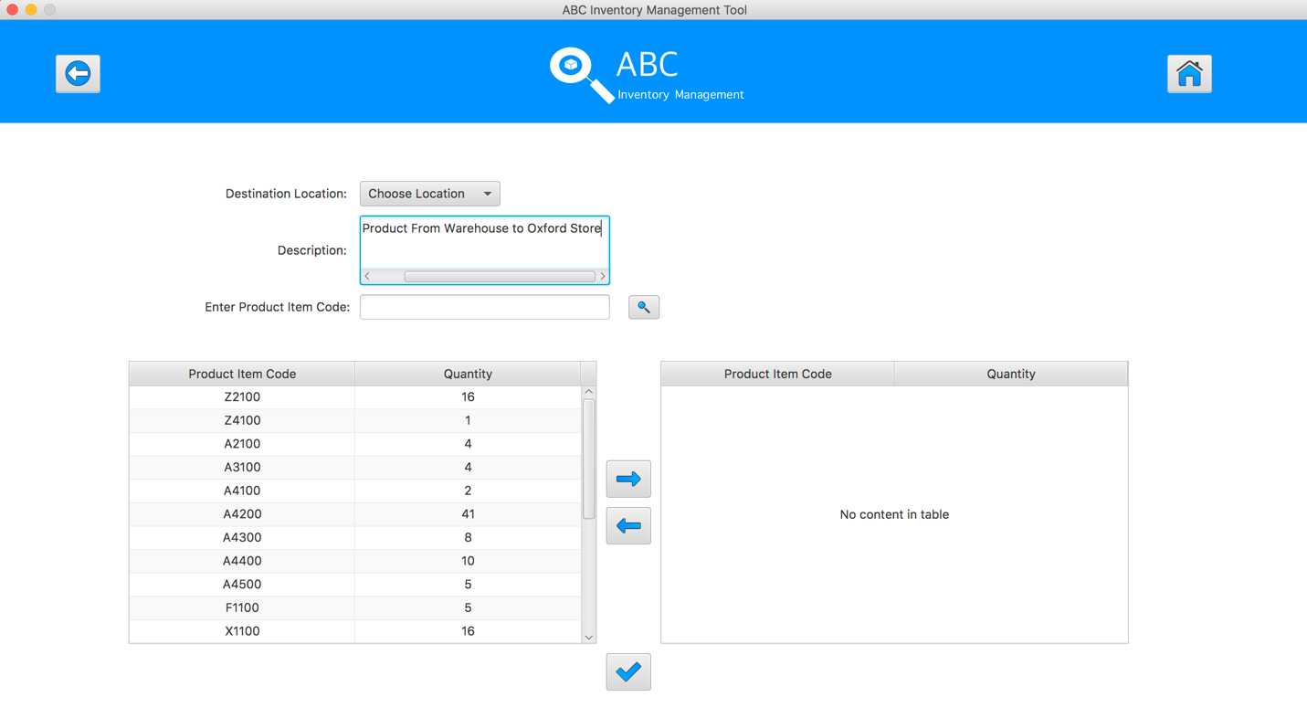
Step 3
Select the product item code in the table on the left
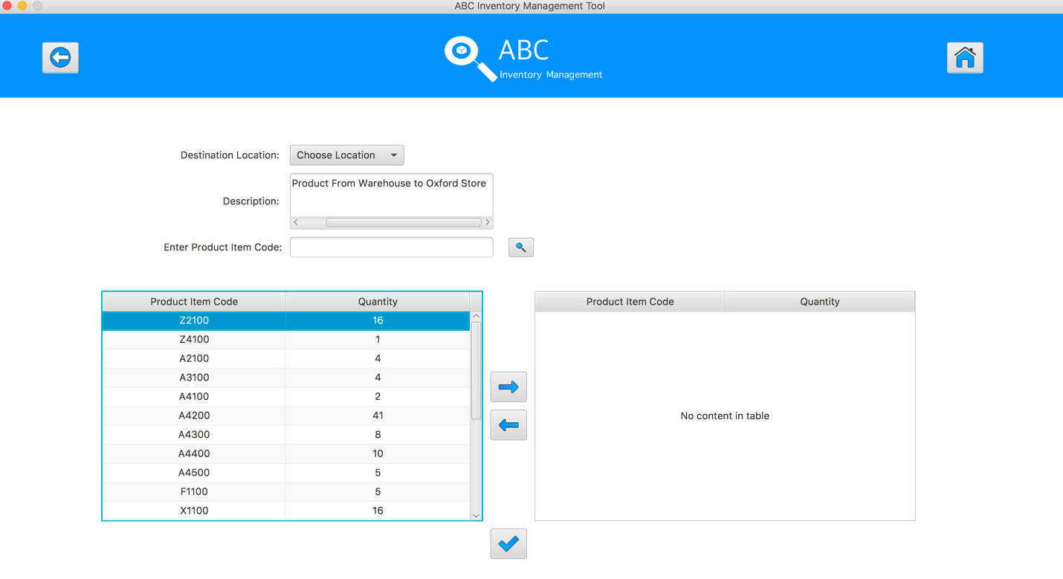
Step 4
Click on the “Add To Cart” Button. An alert notify that user need to choose the destination before adding product items to cart
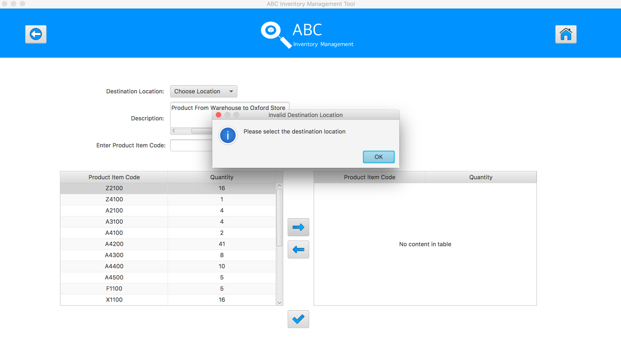
SPT006 – Test Send Product Without Choosing Destination for Data Set 1: PASS

Data Set 2
Test Data Table
Destination Location | Epping Store
Description | Send Product From Warehouse to Epping Store
Product Item Code | A4500 | A4500 | A4200
Quantity | 2 | N/A | 6

Result Screenshots
The screenshots of the result on each test step for each data set are given below:

Step 1
Select the destination location
Step 2
Enter the description for this transfer
Step 3
Select the product item code in the table on the left
Step 4
Select the product item code in the table on the left
Step 5
Click on the “Add To Cart” Button
Step 6
Double click to the quantity cell in selected cart table
Step 7
Enter the desirable number
Step 8
Hit enter key to confirm this edited quantity
Step 9
Select the same product item code which was added to cart table in the table on the left
Step 10
System displays an alert message to notify that user cannot add this product to the cart again.

Step 11
Select the product item code in the table on the left
Step 12
Click on the “Add To Cart” Button

Step 13
Double click to the quantity cell in selected cart table
Step 14
Enter the desirable number
Step 15
Hit enter key to confirm this edited quantity
Step 16
After added the desirable items, hit the “Send Product” Button
Step 17
Reset the interface for working with new transfer.

SPT006 – Test Send Product Without Choosing Destination for Data Set 2: PASS

